**Action Hooks:**

1. **init**: Fired after WordPress has finished loading but before any headers are sent. Often used for custom post type and taxonomy registrations.
2. **wp\_loaded**: Fired after WordPress has fully loaded.
3. **widgets\_init**: Used to register widgets and sidebars.
4. **wp\_head**: Allows you to add code or scripts to the **<head>** section of the HTML document.
5. **wp\_footer**: Used to add code or scripts just before the closing **</body>** tag.
6. **admin\_init**: Similar to **init**, but specifically for the admin area.
7. **admin\_menu**: Used to add or modify items in the WordPress admin menu.
8. **save\_post**: Fired when a post or page is saved in the admin panel.
9. **shutdown**: Fired just before PHP execution ends.
10. **template\_redirect**: Fired just before WordPress determines which template page to load.
11. **wp\_enqueue\_scripts**: Used to enqueue scripts and styles on the front end of the site.
12. **admin\_enqueue\_scripts**: Similar to **wp\_enqueue\_scripts**, but specifically for the admin area.
13. **wp\_ajax\_{action}**: Used for handling AJAX requests on the front end.
14. **admin\_post\_{action}**: Used for handling AJAX requests in the admin area.
15. **pre\_get\_posts**: Allows modification of the main query before it is executed.
16. **wp\_insert\_post\_data**: Used to filter and modify post data before it's inserted into the database.
17. **wp\_login**: Fired when a user logs in.
18. **wp\_logout**: Fired when a user logs out.
19. **wp\_before\_admin\_bar\_render**: Allows modification of the admin toolbar (admin bar).
20. **publish\_post**: Fired when a post is published.
21. **transition\_post\_status**: Fired when a post transitions from one status to another (e.g., from draft to published).
22. **widgets\_admin\_page**: Used to add content to the widgets admin page.
23. **comment\_post**: Fired after a comment is posted.
24. **admin\_notices**: Used to display notices in the WordPress admin area.
25. **wp\_dashboard\_setup**: Used to add widgets and elements to the WordPress dashboard.
26. **admin\_print\_scripts**: Fired when scripts are printed in the admin area.
27. **admin\_print\_styles**: Fired when stylesheets are printed in the admin area.
28. **load-{page}**: Fired when a specific admin page is loaded (e.g., **load-post.php**).
29. **auth\_redirect**: Fired when authentication is required for a user to access a page.
30. **all**: A catch-all hook that fires on every WordPress page load.

**Filter Hooks:**

1. **the\_content**: Used to filter the content of a post or page before it's displayed.
2. **the\_title**: Filters the title of a post or page before it's displayed.
3. **widget\_text\_content**: Filters the content of a text widget.
4. **wp\_nav\_menu\_items**: Used to modify the items in a navigation menu.
5. **excerpt\_length**: Allows you to modify the length of excerpts.
6. **wp\_insert\_post\_data**: Used to filter and modify post data before it's inserted into the database.
7. **the\_excerpt**: Filters the post excerpt.
8. **the\_meta\_key**: Used to filter the meta key when retrieving post metadata.
9. **widget\_text\_content**: Filters the content of a text widget.
10. **comment\_text**: Filters the text of a comment before it's displayed.
11. **comment\_form\_defaults**: Used to modify the default settings for the comment form.
12. **widget\_text\_content**: Filters the content of a text widget.
13. **wp\_mail\_content\_type**: Allows you to modify the content type of emails sent via the **wp\_mail()** function.
14. **pre\_get\_posts**: Allows modification of the main query before it is executed.
15. **the\_permalink**: Filters the post or page permalink before it's displayed.
16. **wp\_get\_attachment\_image\_attributes**: Filters the attributes of an image added via **wp\_get\_attachment\_image()**.
17. **login\_redirect**: Used to filter the URL where users are redirected after logging in.
18. **the\_author**: Filters the author's display name.
19. **the\_time**: Filters the time or date format of a post's publish date.
20. **wp\_calculate\_image\_srcset**: Filters the image srcset attributes.
21. **wp\_kses\_allowed\_html**: Allows customization of the allowed HTML elements and attributes when using **wp\_kses()**.
22. **upload\_mimes**: Used to filter allowed file types for uploads.
23. **wp\_editor\_settings**: Filters the settings used for the WordPress visual editor (TinyMCE).
24. **wp\_dropdown\_categories**: Filters the arguments used in the dropdown category select box.
25. **wp\_title**: Filters the title displayed in the HTML **<title>** tag.
26. **the\_archive\_description**: Filters the archive description text.
27. **the\_category**: Filters the category display for a post.
28. **image\_send\_to\_editor**: Filters the HTML markup of images when added to the editor.
29. **wp\_insert\_attachment\_data**: Used to filter attachment data before it's inserted into the database.
30. **get\_search\_form**: Filters the HTML markup of the search form.

**Add filter hook**

**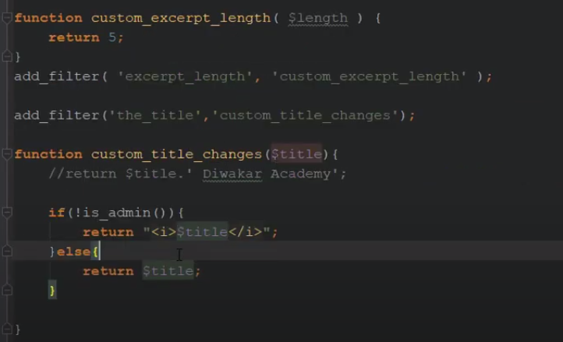**

**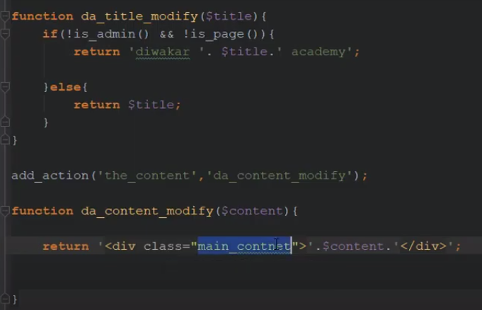**

**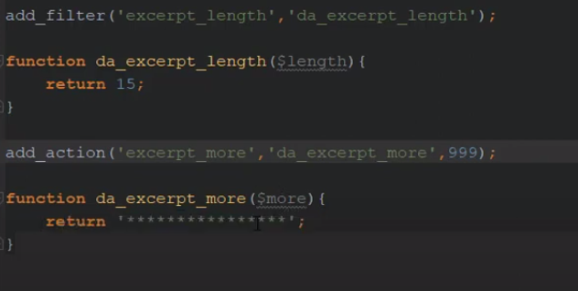**

**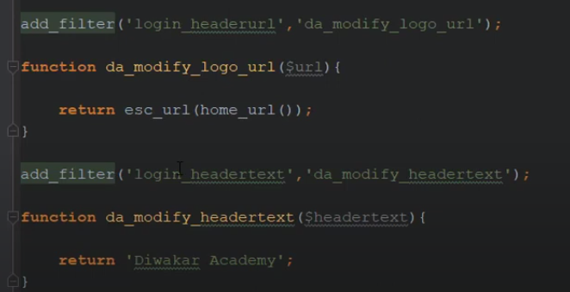**

**Custom Action Hook**

**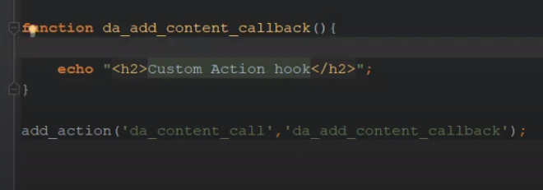**

**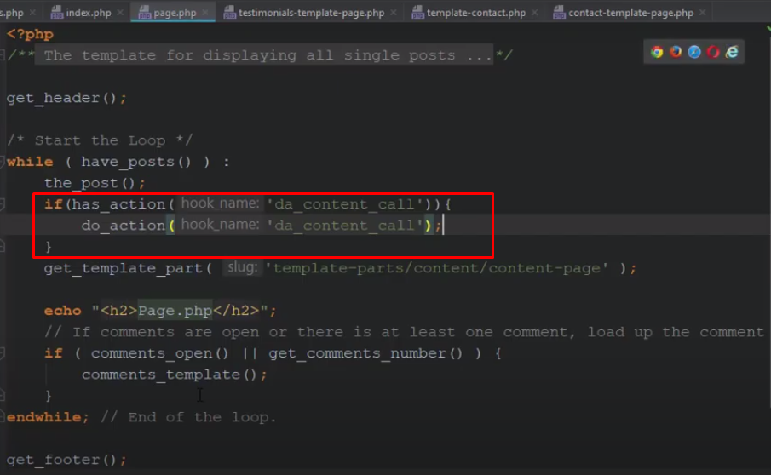**

**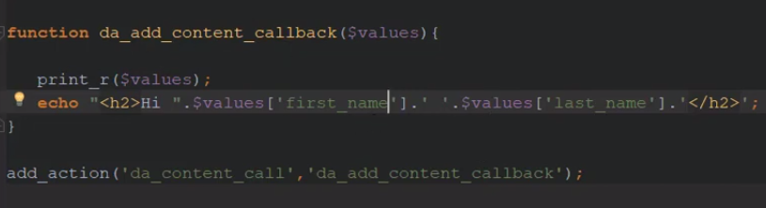**

**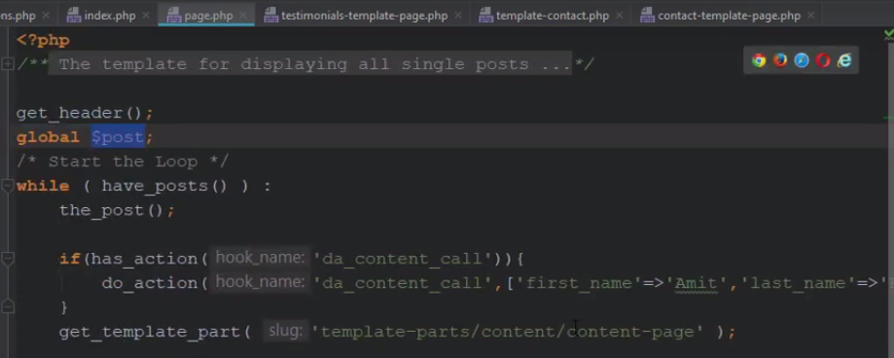Custom filter**

**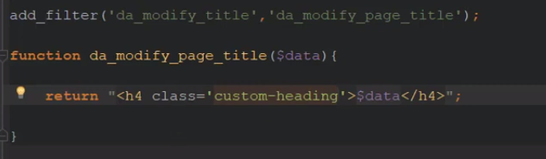**

**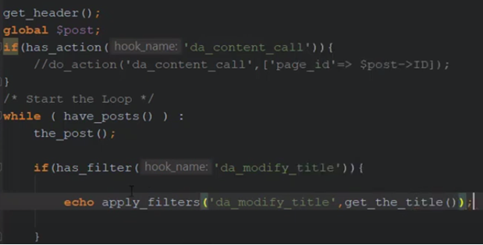**

**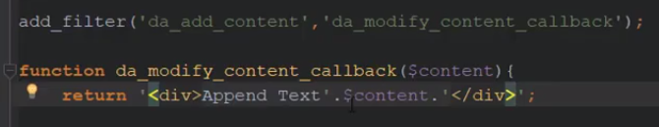**

**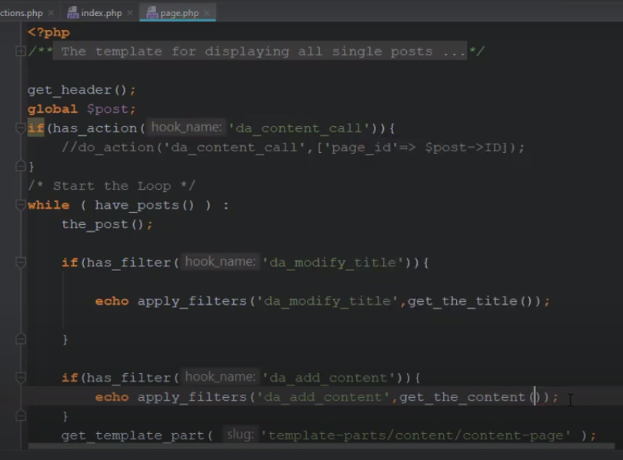**

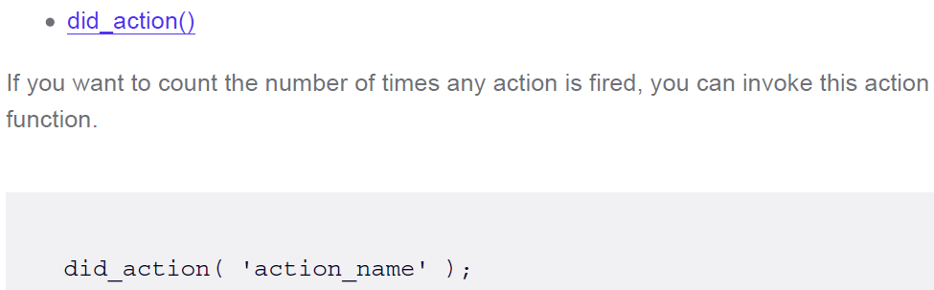

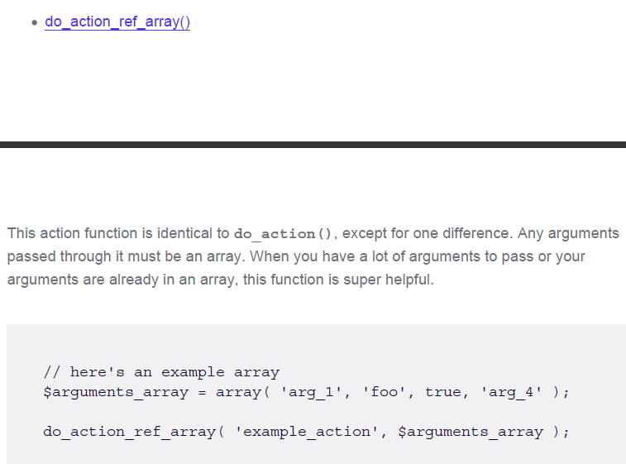

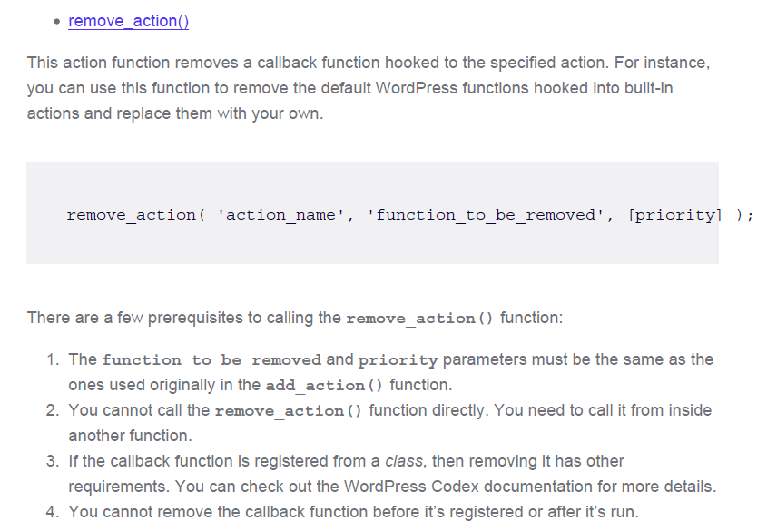

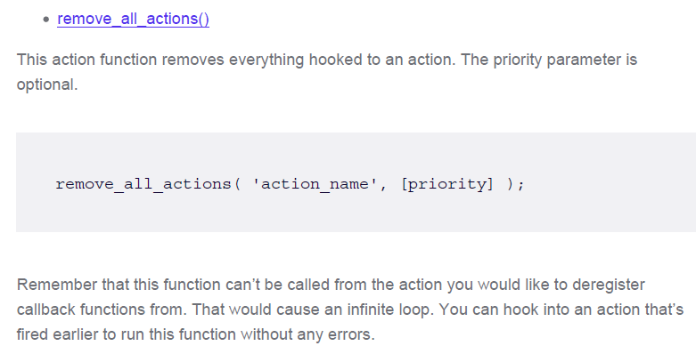

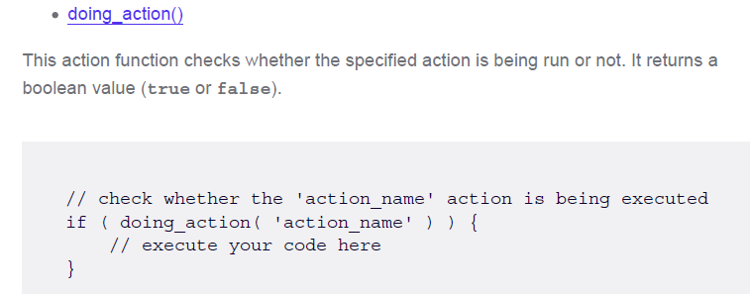

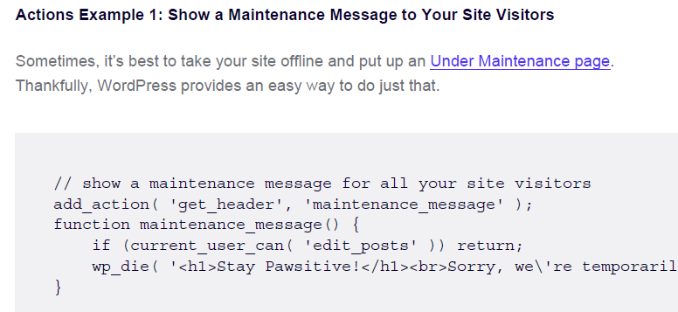

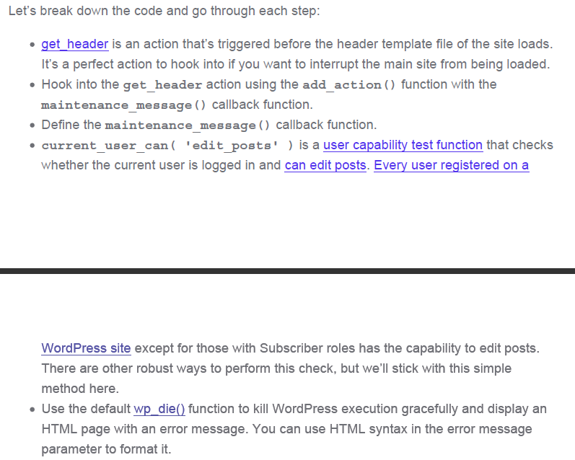

**Hide Dashboard Menu Items from Non-Admin Users**

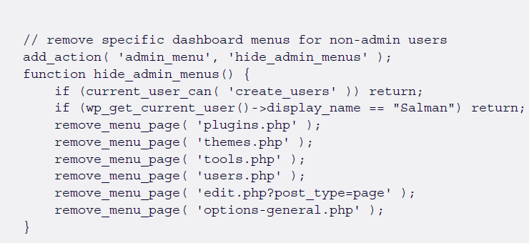

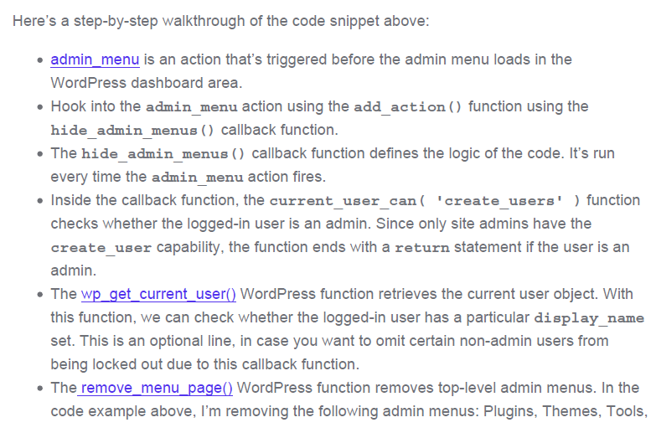

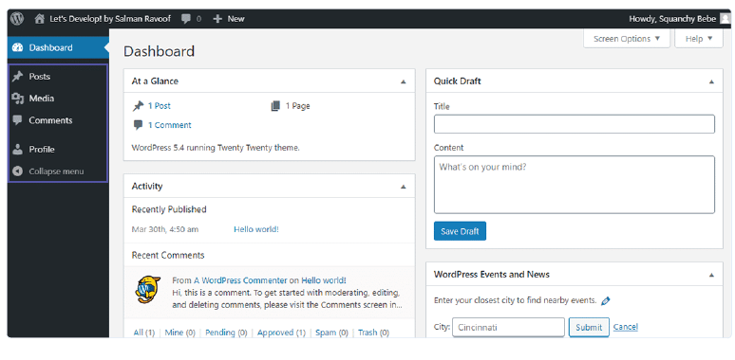

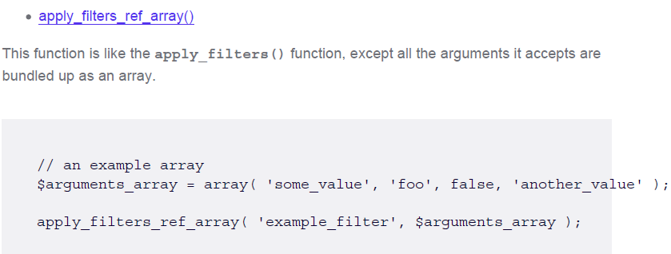

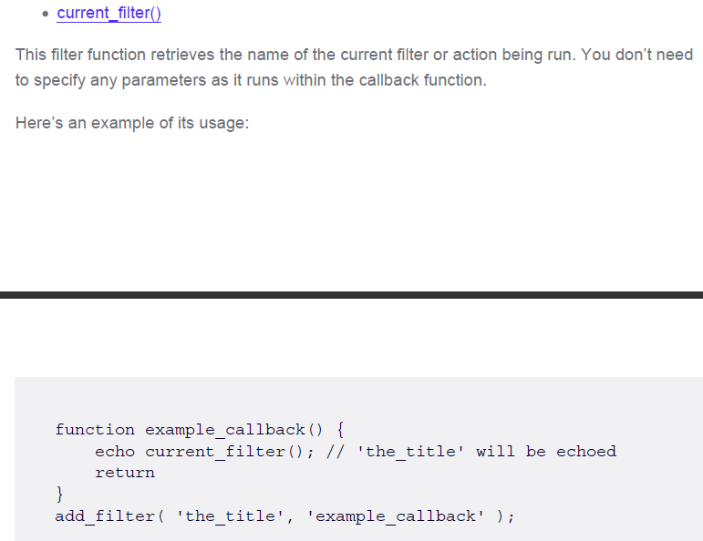

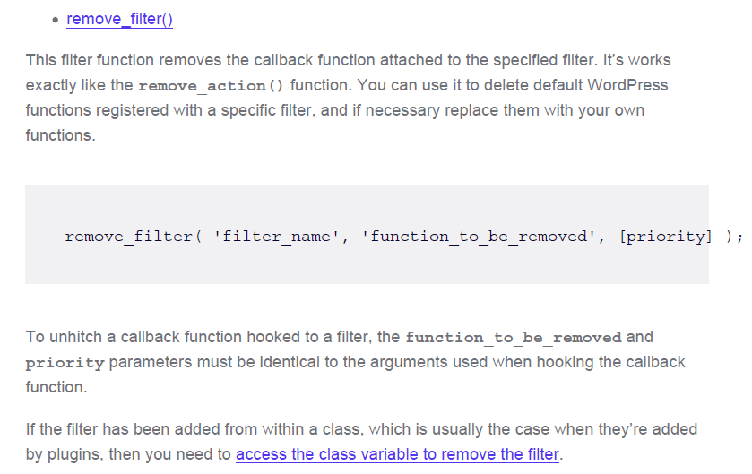

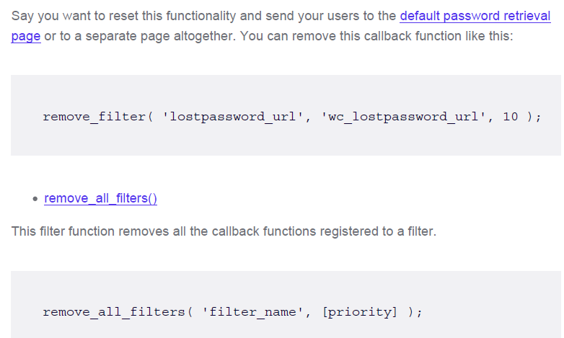

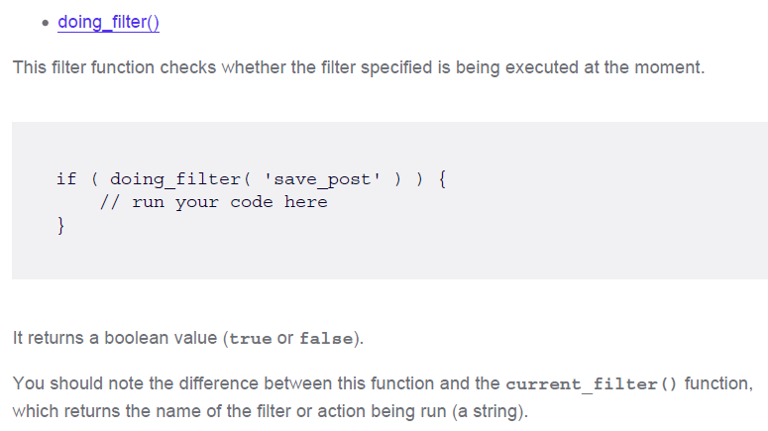

**Remove action hook**

**remove\_action** function is used to remove actions that have been previously added using the **add\_action** function.

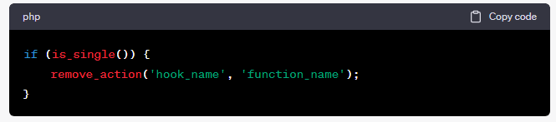

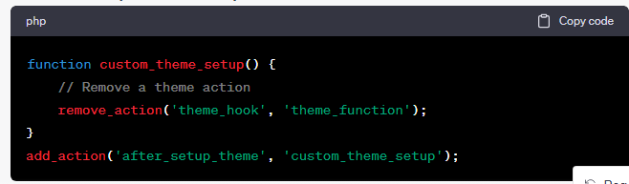

**Remove filter hook**

the **remove\_filter** function is used to remove filters that have been previously added using the **add\_filter** function.

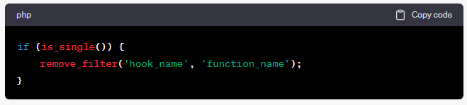

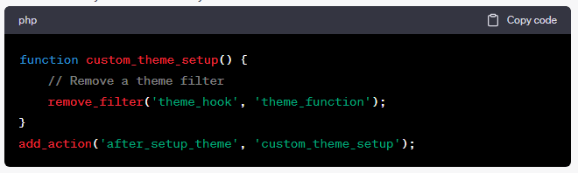

**Remove Filter Hook**

In WordPress, you can remove filter hooks using the **remove\_filter** function. This function allows you to detach a specific callback function from a filter hook, preventing it from modifying the data or content passed through that hook. Here's how to use **remove\_filter** to remove a filter hook:

Syntax:

**remove\_filter($hook\_name, $function\_to\_remove, $priority);**

* **$hook\_name** (string): The name of the filter hook from which you want to remove the callback function.
* **$function\_to\_remove** (callable): The callback function you want to remove.
* **$priority** (int, optional): The priority at which the callback was originally added. This is optional and should only be specified if the callback was added with a specific priority.

**// Callback function to add a filter.**

**function custom\_filter\_function($content) {**

**return $content . '<p>Additional content added by the filter.</p>';**

**}**

**// Attach the callback function to the 'the\_content' filter with a priority of 10.**

**add\_filter('the\_content', 'custom\_filter\_function', 10);**

**// ... Later in your code, you decide to remove the filter.**

**// Remove the filter.**

**remove\_filter('the\_content', 'custom\_filter\_function', 10);**

1.We initially attach the **custom\_filter\_function** callback to the **the\_content** filter with a priority of 10 using **add\_filter**.

2.Later, if we decide to remove this filter, we use **remove\_filter** with the same filter hook name, callback function name, and priority (if applicable).

**Uses of remove\_action hook**

The **remove\_action** hook is used in WordPress to remove or unregister an action hook that was previously added using the **add\_action** function. It's particularly useful when you want to prevent certain actions from executing or modify the behavior of a theme or plugin without directly editing its code. Here's how you can use the **remove\_action** hook with an example:

**add\_action('wp\_footer', 'my\_custom\_function');**

This action hook, **wp\_footer**, is commonly used to add content or scripts to the footer of a WordPress site. The **my\_custom\_function** function is the callback function that will be executed when this action hook is triggered.

Now, if you want to remove or prevent **my\_custom\_function** from executing on the **wp\_footer** action hook, you can use the **remove\_action** hook. Here's how to do it:

**function remove\_my\_custom\_function() {**

**remove\_action('wp\_footer', 'my\_custom\_function');**

**}**

**add\_action('init', 'remove\_my\_custom\_function');**

1.We create a custom function called **remove\_my\_custom\_function**.

2.Inside **remove\_my\_custom\_function**, we use the **remove\_action** function to remove the **my\_custom\_function** callback from the **wp\_footer** action hook.

3.We add our custom function **remove\_my\_custom\_function** to the **init** action hook. This ensures that it runs early enough in the WordPress loading process to remove the action before it's executed.

By using **remove\_action** in this way, the **my\_custom\_function** will no longer be triggered when the **wp\_footer** action hook is fired. This can be useful for disabling or modifying the behavior of themes or plugins without editing their source code directly, making your customizations more maintainable and compatible with future updates.

Remember that you need to specify the exact same callback function and action hook that you want to remove, as well as ensure that your **remove\_action** call occurs after the original **add\_action** call.

**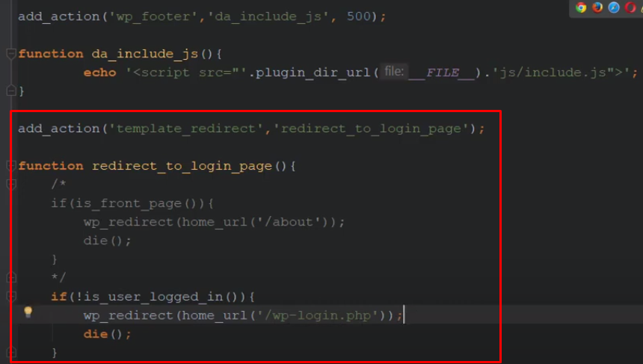**

**Nonce in WordPress**

**A WordPress nonce is a “number used once” security token to protect URLs and forms from malicious attacks. It helps WordPress to determine whether a request is valid, preventing unauthorized actions and inputs.**

**These nonce-related functions are essential for adding security to WordPress forms, AJAX requests, and other actions to protect against Cross-Site Request Forgery (CSRF) attacks. Depending on your specific use case, you'll choose the appropriate function to generate and verify nonces in your WordPress code.**

1. **wp\_nonce\_field()**: Generates a nonce and outputs it as a hidden form field. This function is often used in HTML forms to include a nonce for verification when the form is submitted.
2. **wp\_create\_nonce($action)**: Generates a nonce for a specific action. You provide a unique identifier (action) to associate the nonce with a particular operation.
3. **wp\_verify\_nonce($nonce, $action)**: Verifies that a nonce matches the provided action. It returns **true** if the nonce is valid and **false** if it is not.
4. **check\_admin\_referer($action, $query\_arg)**: Verifies a nonce used in the administration area. It checks if the nonce in the request matches the one associated with the given action.
5. **check\_ajax\_referer($action, $query\_arg, $die)**: Similar to **check\_admin\_referer()**, but specifically designed for AJAX requests. It verifies that the nonce in the request matches the one associated with the given action.
6. **wp\_nonce\_url($url, $action, $name)**: Adds a nonce to a URL. This function can be used to create secure URLs for actions that require nonces.
7. **wp\_nonce\_ays($action)**: Outputs a "Are you sure you want to do this?" message along with a nonce verification field. It's often used in confirmation dialogs before performing critical actions.
8. **wp\_nonce\_tick()**: Returns the current "tick" value, which is used to generate and validate nonces. It's primarily an internal function and is not typically used directly in plugins or themes.

**Use cases for nonces**

* **Form submissions (e.g., saving settings, updating a post).**
* **AJAX requests that modify data.**
* **Logins and password resets.**
* **Actions related to user authentication and authorization.**
* **REST API**
* **against Cross-Site Request Forgery (CSRF) attacks**

**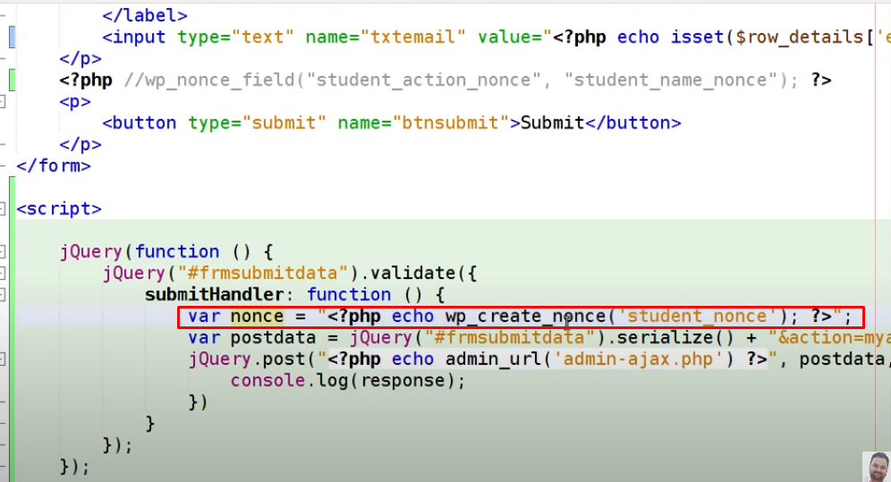**

**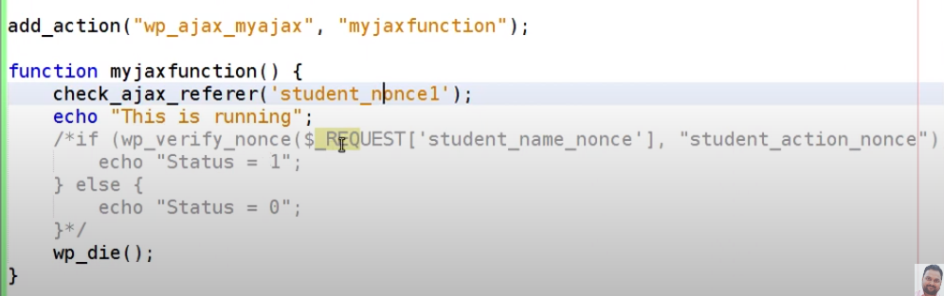**

**How to use nonce in wp**

**1.Generate a Nonce**:

**2. Include the Nonce in Your Form or Request**

**<form method="post" action="">**

**<!-- Other form fields -->**

**<?php wp\_nonce\_field('my\_action', 'my\_nonce'); ?>**

**<input type="submit" value="Submit">**

**</form>**

In an AJAX request:

**var myNonce = '<?php echo $nonce; ?>';**

**var data = {**

**action: 'my\_ajax\_action',**

**nonce: myNonce,**

**// Other data to send**

### };

**3. Verify the Nonce**: When processing the form submission or handling the AJAX request on the server side, you should verify the nonce to ensure that the request is legitimate and authorized. Use the **check\_admin\_referer()** or **check\_ajax\_referer()** function to do this.

**if ( ! isset( $\_POST['my\_nonce'] ) || ! wp\_verify\_nonce( $\_POST['my\_nonce'], 'my\_action' ) ) {**

**// Nonce verification failed, handle the error or exit.}**

**Or for AJAX:**

**if ( ! check\_ajax\_referer( 'my\_action', 'nonce', false ) ) {**

**// Nonce verification failed, handle the error or exit.**

**}**

**4.Perform the Authorized Action**: If the nonce verification passes, you can proceed to perform the authorized action, such as saving data, updating settings, or any other operation.

**Sanitizing input data to enhance security**

WordPress provides several built-in functions for sanitizing input data to enhance security and prevent various types of vulnerabilities, such as SQL injection and Cross-Site Scripting (XSS) attacks. Here is a list of some of the key sanitization functions in WordPress:

**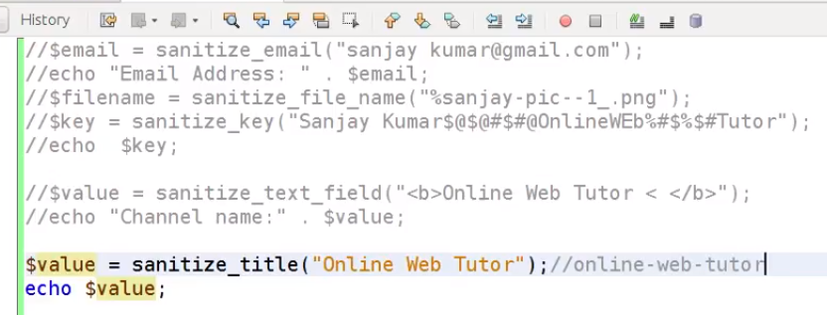**

**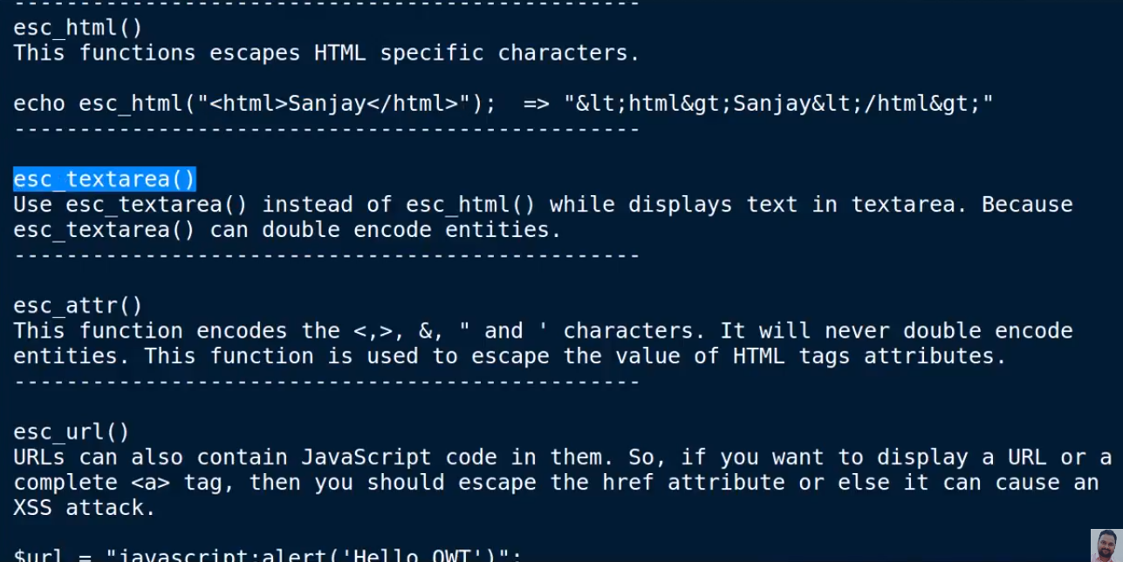**

1. **sanitize\_text\_field($str)**: Sanitizes a string by removing potentially harmful characters and tags. This function is often used to sanitize user input from text fields.
2. **sanitize\_email($email)**: Sanitizes an email address by removing potentially harmful characters and validating the email format.
3. **sanitize\_file\_name($filename)**: Sanitizes a file name by removing potentially harmful characters and ensuring it adheres to the allowed file name characters.
4. **sanitize\_title($title)**: Sanitizes a title or post name by removing potentially harmful characters and transforming it into a URL-friendly slug.
5. **sanitize\_title\_for\_query($title)**: Sanitizes a title for use in database queries, ensuring it is safe to include in SQL statements.
6. **sanitize\_key($key)**: Sanitizes a key or identifier by removing potentially harmful characters, making it suitable for use in array keys or query variables.
7. **esc\_html($text)**: Escapes a string for use in HTML content, preventing XSS attacks by encoding special characters.
8. **esc\_attr($text)**: Escapes a string for use in HTML attributes, ensuring that special characters do not disrupt the HTML structure.
9. **esc\_url($url)**: Escapes a URL to prevent potential security issues, such as injecting malicious links.
10. **esc\_sql($sql)**: Escapes a SQL query string to prevent SQL injection attacks when building custom database queries.
11. **wp\_kses($data, $allowed\_html)**: Sanitizes and validates HTML content based on an array of allowed HTML elements and attributes.
12. **wp\_kses\_data($data)**: Sanitizes and validates HTML content, allowing only safe tags and attributes.
13. **wp\_strip\_all\_tags($string, $remove\_breaks)**: Strips all HTML and PHP tags from a string. You can choose to keep or remove line breaks.
14. **balanceTags($text, $force)**: Ensures that HTML tags in a string are properly balanced, preventing broken or mismatched tags.
15. **filter\_var($variable, $filter, $options)**: PHP's built-in function for filtering and validating data. WordPress developers may use this function in custom code to validate various types of input.
16. **intval($var, $base)**: Casts a variable to an integer, which can be useful for sanitizing numeric input.
17. **absint($maybeint)**: Casts a value to an absolute integer, ensuring it's a non-negative integer.

**Escaping output**

**Escaping output is a crucial security practice to prevent Cross-Site Scripting (XSS) attacks and maintain the integrity of your website. When you output data to the browser, it's important to make sure that any potentially unsafe content is properly escaped to prevent malicious code execution. WordPress provides several functions to help you escape output in different contexts. Here are some of the key functions:**

**esc\_html($text)**: Use this function to escape and sanitize text for output in HTML content. It encodes special characters like **<**, **>**, **&**, and quotes (**"**) to their HTML entities.

**echo esc\_html($text);**

**esc\_attr($text)**: This function is used to escape text for use in HTML attributes. It encodes special characters and ensures that the content is safe within an attribute.

**echo '<input type="text" value="' . esc\_attr($value) . '">';**

**esc\_url($url)**: Use this function to escape URLs to prevent any potential security issues. It ensures that URLs are properly formatted and safe for use in links and attributes.

**echo '<a href="' . esc\_url($url) . '">Link</a>';**

**esc\_js($javascript)**: When outputting JavaScript code, use this function to escape it properly. It can help prevent script injection vulnerabilities.

**echo '<script>' . esc\_js($javascript\_code) . '</script>';**

**esc\_textarea($text)**: Use this function to escape text for output within a **<textarea>** element. It ensures that line breaks and special characters are properly encoded.

**echo '<textarea>' . esc\_textarea($text) . '</textarea>';**

**esc\_sql($sql)**: When constructing custom database queries, use **esc\_sql()** to escape and sanitize SQL query strings. This helps prevent SQL injection attacks.

**$query = "SELECT \* FROM {$wpdb->prefix}my\_table WHERE name = " . esc\_sql($name);**

**wp\_kses($data, $allowed\_html)**: Use this function to sanitize and validate HTML content based on an array of allowed HTML elements and attributes. This is useful when you want to allow certain HTML tags while disallowing others.

**echo wp\_kses($data, $allowed\_html);**

**wp\_kses\_post($data)**: Similar to **wp\_kses()**, this function is specifically designed to sanitize and validate HTML content within WordPress posts, preserving certain tags allowed in posts.

**echo wp\_kses\_post($data);**

**sanitize\_text\_field($text)**: Although primarily used for sanitizing input, this function can also be used to escape and sanitize text for output in HTML content.

**echo sanitize\_text\_field($text);**

When working with WordPress themes or plugins, it's important to choose the appropriate escaping function based on the context of your output. Always use these functions to escape user-generated content and data coming from untrusted sources to ensure the security of your WordPress website.

**<?php**

**/\***

**Plugin Name: Escaping Functions Demo**

**Description: A simple plugin to demonstrate the use of escaping functions in WordPress.**

**\*/**

**// Display a user comment safely.**

**function display\_comment\_safely() {**

**$comment\_text = get\_comment\_text(); // Get the user's comment text from the database.**

**echo esc\_html($comment\_text); // Display the comment text safely.**

**}**

**add\_shortcode('display\_comment', 'display\_comment\_safely');**

**// Display a post title safely.**

**function display\_post\_title\_safely() {**

**$post\_title = get\_the\_title(); // Get the post title from the database.**

**echo esc\_html($post\_title); // Display the post title safely.**

**}**

**add\_shortcode('display\_post\_title', 'display\_post\_title\_safely');**

**// Display an image URL safely within an attribute.**

**function display\_image\_url\_safely() {**

**$image\_url = get\_post\_meta(get\_the\_ID(), '\_image\_url', true); // Get an image URL from custom field.**

**echo '<img src="' . esc\_url($image\_url) . '" alt="Image">';**

**}**

**add\_shortcode('display\_image', 'display\_image\_url\_safely');**

**// Display JavaScript code safely.**

**function display\_javascript\_safely() {**

**$javascript\_code = 'alert("Hello, world!");';**

**echo '<script>' . esc\_js($javascript\_code) . '</script>';**

**}**

**add\_shortcode('display\_javascript', 'display\_javascript\_safely');**

**// Display text content safely within a textarea.**

**function display\_textarea\_content\_safely() {**

**$textarea\_content = get\_user\_meta(get\_current\_user\_id(), 'description', true); // Get user description.**

**echo '<textarea>' . esc\_textarea($textarea\_content) . '</textarea>';**

**}**

**add\_shortcode('display\_textarea\_content', 'display\_textarea\_content\_safely');**

**// Custom database query with proper escaping.**

**function custom\_database\_query() {**

**$name = sanitize\_text\_field($\_GET['name']); // Sanitize user input.**

**global $wpdb;**

**$query = "SELECT \* FROM {$wpdb->prefix}my\_table WHERE name = " . esc\_sql($name);**

**// Execute the query and process the results.**

**}**

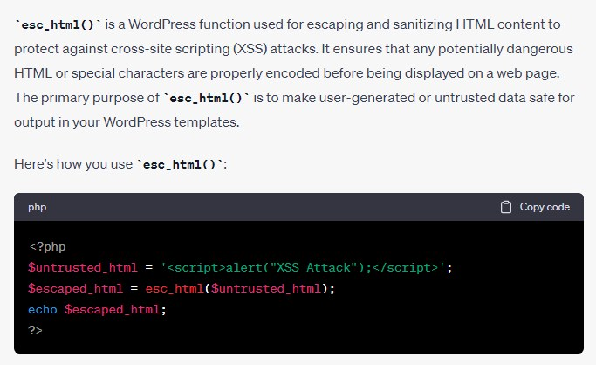

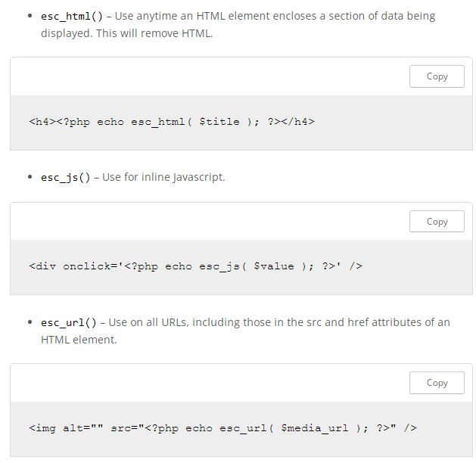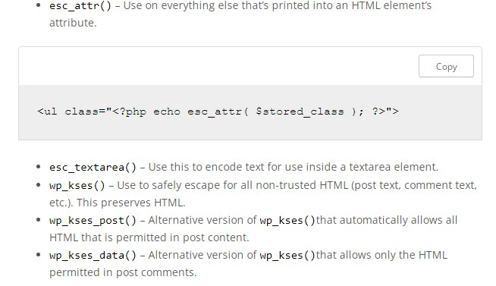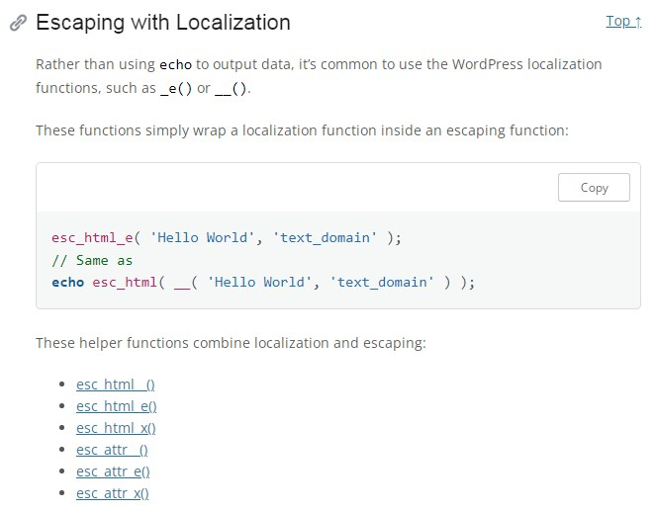

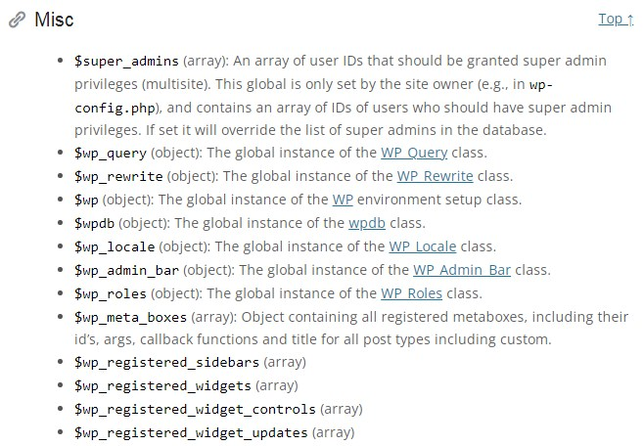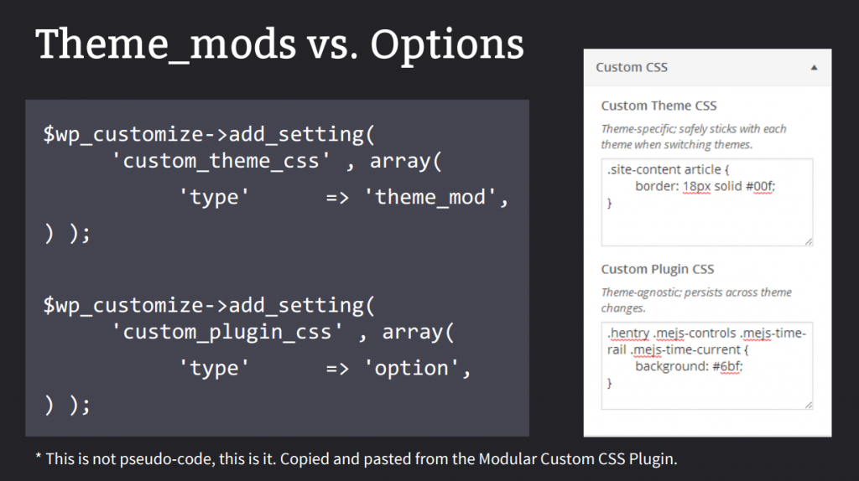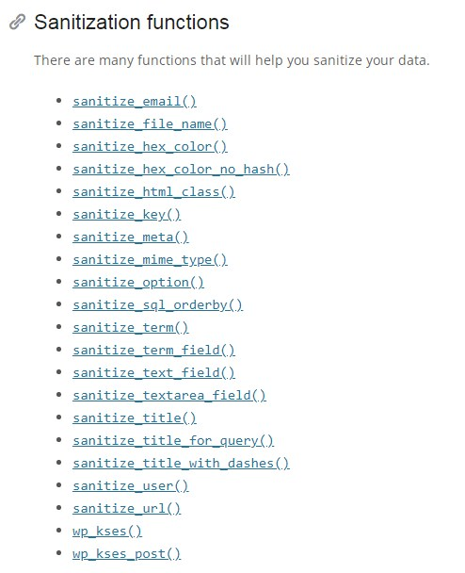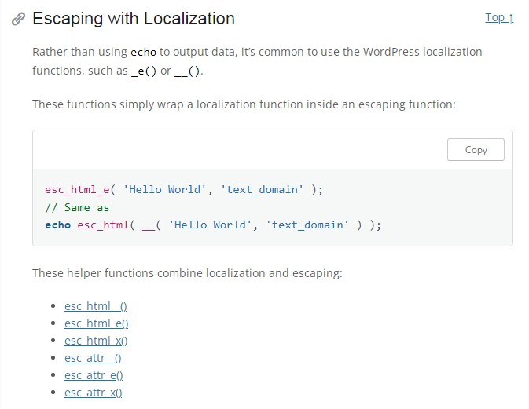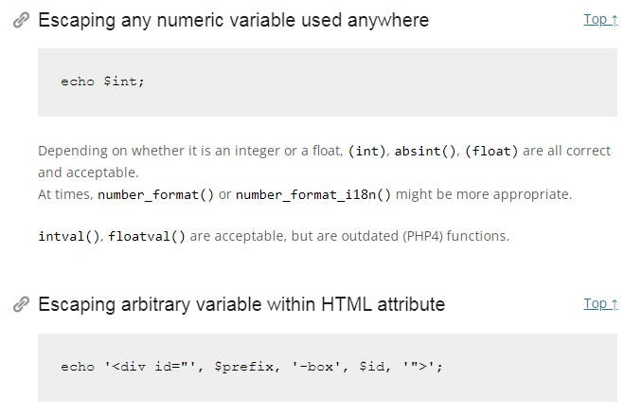

**Internationalization**

Internationalization (often abbreviated as i18n) is the process of making your WordPress plugin translatable, allowing it to be easily translated into different languages. This is done using the built-in localization functions provided by WordPress. Here's a step-by-step guide on how to add internationalization to a WordPress plugin:

**Prepare Your Plugin for Translation**:

Before you can translate your plugin, you need to make sure it's ready for localization. This involves wrapping all translatable text in your plugin with translation functions. Replace any hardcoded strings with these functions.

Example:

**// Hardcoded string (not translatable):**

**echo 'Hello, World!';**

**// Translatable string:**

**echo \_\_('Hello, World!', 'your-plugin-text-domain');**

Ensure that you replace all such strings with **\_\_()** or **\_e()** functions.

**Load Your Text Domain**:

In your plugin file (e.g., **your-plugin.php**), you need to load your plugin's text domain. This is typically done in the **init** or **plugins\_loaded** action hook. The text domain should match the unique identifier of your plugin.

Example:

**function load\_plugin\_textdomain() {**

**load\_plugin\_textdomain('your-plugin-text-domain', false, dirname(plugin\_basename(\_\_FILE\_\_)) . '/languages/');**

**}**

**add\_action('init', 'load\_plugin\_textdomain');**

In this example, replace **'your-plugin-text-domain'** with a unique identifier for your plugin. The third argument specifies the path to the directory where your translation files (**.mo** files) are stored.

**Create Translation Files**:

Next, you need to create translation files for your plugin. These files will contain translations for different languages. Use a tool like Poedit to create and manage translation files. Save these files with the **.po** extension.

Example file structure:

**/your-plugin-directory/**

**├── your-plugin.php**

**└── languages/**

**├── your-plugin-text-domain-en\_US.po (English)**

**└── your-plugin-text-domain-fr\_FR.po (French)**

**Generate .mo Files**:

After you've translated your strings in the **.po** files, you need to compile them into **.mo** files. Many translation tools, like Poedit, can do this for you. These **.mo** files contain the actual translated text.

**Add Translations to Your Plugin**:

Upload the compiled **.mo** files to the **languages/** directory of your plugin.

**Use Translation Functions in Your Plugin**:

Now that your plugin is set up for internationalization, use the translation functions (**\_\_()** and **\_e()**) to display text throughout your plugin.

Example:

**// Display a translatable string:**

**echo \_\_('Hello, World!', 'your-plugin-text-domain');**

**Create and Distribute Language Files**:

Encourage users to translate your plugin into their languages using translation tools like GlotPress or by editing the **.po** files directly. You can also contribute your translations to the WordPress.org translation community.

By following these steps, you've made your WordPress plugin translatable and ready for localization, allowing users from different regions to use your plugin in their preferred language.

**<?php**

**/\***

**Plugin Name: My Internationalization Plugin**

**Description: A simple internationalization example.**

**\*/**

**// Load the plugin's text domain for translation.**

**function load\_plugin\_textdomain() {**

**load\_plugin\_textdomain('my-i18n-plugin', false, dirname(plugin\_basename(\_\_FILE\_\_)) . '/languages/');**

**}**

**add\_action('plugins\_loaded', 'load\_plugin\_textdomain');**

**// Add a shortcode to display a translatable message.**

**function hello\_world\_shortcode() {**

**return \_\_('Hello, World!', 'my-i18n-plugin');**

**}**

**add\_shortcode('hello\_world', 'hello\_world\_shortcode');**

**1.Create a languages directory** inside your plugin folder to store translation files.

**2.Create a .pot file for your plugin**: You can use a tool like Poedit to create a **.pot** file, which serves as a template for translations.

**3.Generate translation files (.po and .mo)**: Use Poedit to create translation files (**.po** and **.mo**) for different languages based on the **.pot** file. Save them in the **languages** directory you created.

**4.Use the hello\_world shortcode**: In your WordPress posts or pages, you can use the **[hello\_world]** shortcode to display the "Hello, World!" message, which will be translatable into the user's language.

1.Activate it in your WordPress admin dashboard.

2.Create or upload translation files for your desired languages.

3.Use the **[hello\_world]** shortcode in a post or page to display the translatable message.

**Internationalization plugin code**

**<?php**

**/\*\***

**\* Plugin Name: Sample Plugin**

**\* Description: A sample WordPress plugin for internationalization.**

**\*/**

**// Load the text domain for translation**

**function sample\_plugin\_load\_textdomain() {**

**load\_plugin\_textdomain('sample-plugin', false, dirname(plugin\_basename(\_\_FILE\_\_)) . '/languages/');**

**}**

**add\_action('plugins\_loaded', 'sample\_plugin\_load\_textdomain');**

**// Add a sample filter that displays a translatable string**

**function sample\_plugin\_filter\_content($content) {**

**$translated\_text = \_\_('This is a sample plugin content.', 'sample-plugin');**

**return $content . '<p>' . $translated\_text . '</p>';**

**}**

**add\_filter('the\_content', 'sample\_plugin\_filter\_content');**

**Localization**

Ajax localization in WordPress refers to the process of dynamically loading and displaying translated content on a web page using the Asynchronous JavaScript and XML (Ajax) technique. It allows you to change the language or region of a WordPress site without requiring a full page reload. This is particularly useful for creating multilingual websites where users can switch between languages without experiencing interruptions in their browsing experience.

Here are the key components and steps involved in implementing Ajax localization in a WordPress site:

**1. Internationalization and Localization (i18n and l10n):**

Before implementing Ajax localization, you need to ensure that your WordPress theme and plugins support internationalization and localization (i18n and l10n). This involves using functions like **\_\_('text', 'textdomain')** for translatable strings and preparing translation files.

**2. Language Switcher:**

Create a user interface element, such as a dropdown menu or flags, that allows users to select their preferred language or region.

**3. Ajax Requests:**

Use JavaScript and Ajax to handle user interactions with the language switcher. When a user selects a different language, send an Ajax request to the server with the selected language as a parameter.

**4. Server-Side Handling:**

On the server side, handle the Ajax request by detecting the selected language and setting it for the current user's session or in a cookie. You can also store the selected language in the user's profile.

**5. Translation Loading:**

1.When a page is loaded or reloaded, check the user's language preference (from the session, cookie, or user profile) on the server side.

2.Load the appropriate translation files and set the WordPress locale to the user's selected language.

**6. Dynamically Translate Content:**

With the user's preferred language set, use WordPress localization functions like **\_\_('text', 'textdomain')** in your theme and plugins to dynamically translate content based on the current language.

**7. Update Content via Ajax:**

When a user switches the language using the language switcher, send another Ajax request to the server with the selected language.

1.On the server side, update the user's language preference, load the appropriate translation files, and return the translated content.

2.Use JavaScript to replace or update the content on the page without requiring a full page reload.

**8. Caching and Optimization:**

Implement caching mechanisms to optimize performance. Caching translated content can reduce the server load and improve page load times.

**9. Testing and Debugging:**

Thoroughly test your Ajax localization implementation to ensure that content is translated correctly, and there are no issues with user experience or functionality.

Implementing Ajax localization in WordPress can be complex, and it requires a good understanding of both WordPress development and JavaScript programming. There are also WordPress plugins available that can assist with multilingual functionality, such as WPML (WordPress Multilingual Plugin) and Polylang, which offer built-in support for Ajax-based language switching. These plugins can simplify the implementation process for multilingual WordPress websites.

**Any specific plugins or strategies for internationalization (i18n) and localization (l10n)?**

Internationalization (i18n) and localization (l10n) are essential for making your WordPress website accessible to users from different regions and languages. Here are specific plugins and strategies for implementing i18n and l10n in WordPress:

**1. Use the WordPress Built-in i18n/l10n Features:**

* WordPress comes with built-in support for internationalization and localization. Utilize functions like **\_\_()** and **\_e()** for translating text, and use the **load\_theme\_textdomain()** and **load\_plugin\_textdomain()** functions to load translation files.

**2. WPML (WordPress Multilingual Plugin):**

* WPML is a popular and feature-rich plugin for creating multilingual WordPress websites. It allows you to translate posts, pages, custom post types, and even theme and plugin texts. WPML also provides features for language switching and SEO optimization.

**3. Polylang:**

* Polylang is a free and user-friendly multilingual plugin for WordPress. It enables you to create multilingual content, translate posts, pages, categories, tags, and more. Polylang is known for its simplicity and integration with popular page builders.

**4. TranslatePress:**

* TranslatePress is another user-friendly translation plugin. It provides a visual translation editor that allows you to translate content directly from the front end of your website. TranslatePress supports SEO-friendly URLs and multilingual SEO optimization.

**5. Weglot:**

* Weglot is a cloud-based translation service that offers a WordPress plugin for automatic translation of your website content. It's known for its ease of use and ability to translate content into multiple languages quickly.

**6. Loco Translate:**

* Loco Translate is a free and lightweight plugin that enables you to translate and manage translations of your theme and plugins directly from your WordPress dashboard. It's ideal for developers and site owners who want more control over translations.

**7. Poedit:**

* Poedit is a standalone translation software that is widely used by developers for creating and managing translation files (PO and MO files) for WordPress themes and plugins. You can use it in conjunction with gettext functions in your code.

**8. GlotPress:**

* GlotPress is an open-source translation management tool developed by the WordPress community. It's used for translating WordPress core, themes, and plugins. Some companies and projects host their own GlotPress installations for collaborative translation efforts.

**9. Language Switcher Plugins:**

* Consider using language switcher plugins like "Polylang for WooCommerce" or "WooCommerce Multilingual" (for e-commerce sites) to provide seamless language switching and currency conversion features.

**10. RTL (Right-to-Left) Language Support:** - For languages that are written from right to left (e.g., Arabic, Hebrew), ensure that your theme and content are compatible with RTL layouts. Many popular themes and plugins provide RTL support out of the box.

**11. Custom Styles for Different Languages:** - If your website uses CSS styles specific to languages or regions, consider using a plugin or custom code to load different stylesheets based on the selected language.

**12. Translation Quality Assurance:** - Use professional translators or translation services for critical content to ensure accuracy. Automated translations are convenient but may not always provide the desired quality.

**13. SEO for Multilingual Sites:** - Implement hreflang tags to inform search engines about the language and regional targeting of your pages. This helps with SEO and ensures the right content is displayed to users based on their language preferences.

**Razorpay integration**

**Donation button example**

**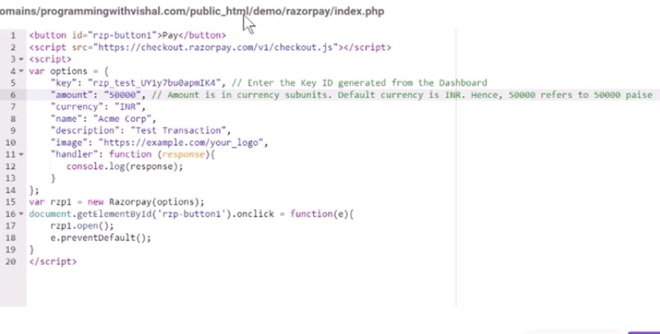**

**Database Method Integration**

**index.php**

<script src="https://code.jquery.com/jquery-3.5.1.min.js"></script>

<script src="https://checkout.razorpay.com/v1/checkout.js"></script>

<form>

    <input type="textbox" name="name" id="name" placeholder="Enter your name"/><br/><br/>

    <input type="textbox" name="amt" id="amt" placeholder="Enter amt"/><br/><br/>

    <input type="button" name="btn" id="btn" value="Pay Now" onclick="pay\_now()"/>

</form>

<script>

    function pay\_now(){

        var name=jQuery('#name').val();

        var amt=jQuery('#amt').val();

         jQuery.ajax({

               type:'post',

               url:'payment\_process.php',

               data:"amt="+amt+"&name="+name,

               success:function(result){

                   var options = {

                        "key": "key",

                        "amount": amt\*100,

                        "currency": "INR",

                        "name": "Acme Corp",

                        "description": "Test Transaction",

                        "image": "https://image.freepik.com/free-vector/logo-sample-text\_355-558.jpg",

                        "handler": function (response){

                           jQuery.ajax({

                               type:'post',

                               url:'payment\_process.php',

                               data:"payment\_id="+response.razorpay\_payment\_id,

                               success:function(result){

                                   window.location.href="thank\_you.php";

                               }

                           });

                        }

                    };

                    var rzp1 = new Razorpay(options);

                    rzp1.open();

               }

           });

    }

</script>

**payment\_process.php**

<?php

session\_start();

include('db.php');

if(isset($\_POST['amt']) && isset($\_POST['name'])){

    $amt=$\_POST['amt'];

    $name=$\_POST['name'];

    $payment\_status="pending";

    $added\_on=date('Y-m-d h:i:s');

    mysqli\_query($con,"insert into payment(name,amount,payment\_status,added\_on) values('$name','$amt','$payment\_status','$added\_on')");

    $\_SESSION['OID']=mysqli\_insert\_id($con);

}

if(isset($\_POST['payment\_id']) && isset($\_SESSION['OID'])){

    $payment\_id=$\_POST['payment\_id'];

    mysqli\_query($con,"update payment set payment\_status='complete',payment\_id='$payment\_id' where id='".$\_SESSION['OID']."'");

}

?>

**db.php**

<?php

$con=mysqli\_connect('host','username','password','dbname');

?>

**thankyou.php**

<h1>Payment Complete</h1>

**Woocommerce Payment Gateway**

**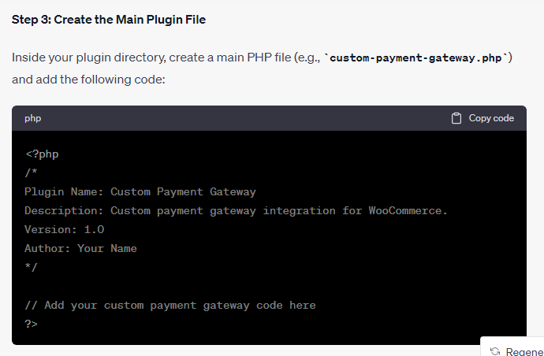**

**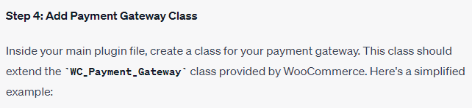**

**class Custom\_Payment\_Gateway extends WC\_Payment\_Gateway {**

**public function \_\_construct() {**

**$this->id = 'custom\_payment';**

**$this->icon = ''; // URL to an image for your gateway**

**$this->method\_title = 'Custom Payment Gateway';**

**$this->method\_description = 'Pay with Custom Payment Gateway';**

**$this->has\_fields = false;**

**$this->init\_settings();**

**$this->title = $this->get\_option('title');**

**$this->description = $this->get\_option('description');**

**add\_action('woocommerce\_update\_options\_payment\_gateways\_' . $this->id, array($this, 'process\_admin\_options'));**

**}**

**public function init\_form\_fields() {**

**$this->form\_fields = array(**

**'title' => array(**

**'title' => 'Title',**

**'type' => 'text',**

**'description' => 'Title displayed to customers during checkout.',**

**'default' => 'Custom Payment'**

**),**

**'description' => array(**

**'title' => 'Description',**

**'type' => 'textarea',**

**'description' => 'Description displayed to customers during checkout.',**

**'default' => 'Pay securely with Custom Payment Gateway.'**

**)**

**);**

**}**

**public function process\_payment($order\_id) {**

**// Handle payment processing here and return the result**

**}**

**}**

**function add\_custom\_payment\_gateway($methods) {**

**$methods[] = 'Custom\_Payment\_Gateway';**

**return $methods;**

**}**

**add\_filter('woocommerce\_payment\_gateways', 'add\_custom\_payment\_gateway');**

**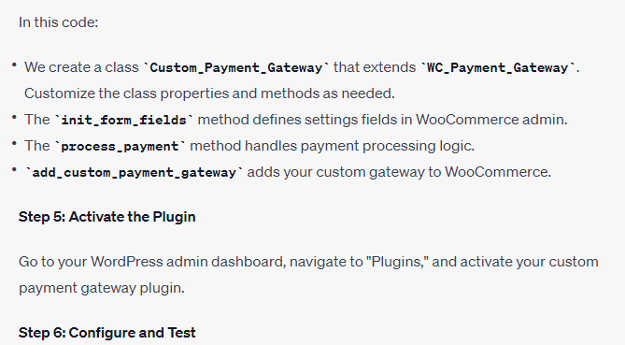**

**Costom plugin for payumoney**

**class Custom\_PayUmoney\_Gateway extends WC\_Payment\_Gateway {**

**public function \_\_construct() {**

**$this->id = 'custom\_payumoney';**

**$this->icon = ''; // URL to an image for your gateway**

**$this->method\_title = 'Custom PayUmoney Gateway';**

**$this->method\_description = 'Pay with Custom PayUmoney Gateway';**

**$this->has\_fields = false;**

**$this->init\_settings();**

**$this->title = $this->get\_option('title');**

**$this->description = $this->get\_option('description');**

**add\_action('woocommerce\_update\_options\_payment\_gateways\_' . $this->id, array($this, 'process\_admin\_options'));**

**}**

**public function init\_form\_fields() {**

**$this->form\_fields = array(**

**'title' => array(**

**'title' => 'Title',**

**'type' => 'text',**

**'description' => 'Title displayed to customers during checkout.',**

**'default' => 'Custom PayUmoney'**

**),**

**'description' => array(**

**'title' => 'Description',**

**'type' => 'textarea',**

**'description' => 'Description displayed to customers during checkout.',**

**'default' => 'Pay securely with Custom PayUmoney Gateway.'**

**),**

**'merchant\_key' => array(**

**'title' => 'Merchant Key',**

**'type' => 'text',**

**'description' => 'Your PayUmoney merchant key.',**

**'default' => ''**

**),**

**'salt' => array(**

**'title' => 'Salt',**

**'type' => 'text',**

**'description' => 'Your PayUmoney merchant salt.',**

**'default' => ''**

**),**

**);**

**}**

**public function process\_payment($order\_id) {**

**// Handle payment processing using the PayUmoney API here**

**}**

**}**

**function add\_custom\_payumoney\_gateway($methods) {**

**$methods[] = 'Custom\_PayUmoney\_Gateway';**

**return $methods;**

**}**

**add\_filter('woocommerce\_payment\_gateways', 'add\_custom\_payumoney\_gateway');**

**Costom plugin for CCavenue**

**class Custom\_CCAvenue\_Gateway extends WC\_Payment\_Gateway {**

**public function \_\_construct() {**

**$this->id = 'custom\_ccavenue';**

**$this->icon = ''; // URL to an image for your gateway**

**$this->method\_title = 'Custom CCAvenue Gateway';**

**$this->method\_description = 'Pay with Custom CCAvenue Gateway';**

**$this->has\_fields = false;**

**$this->init\_settings();**

**$this->title = $this->get\_option('title');**

**$this->description = $this->get\_option('description');**

**add\_action('woocommerce\_update\_options\_payment\_gateways\_' . $this->id, array($this, 'process\_admin\_options'));**

**}**

**public function init\_form\_fields() {**

**$this->form\_fields = array(**

**'title' => array(**

**'title' => 'Title',**

**'type' => 'text',**

**'description' => 'Title displayed to customers during checkout.',**

**'default' => 'Custom CCAvenue'**

**),**

**'description' => array(**

**'title' => 'Description',**

**'type' => 'textarea',**

**'description' => 'Description displayed to customers during checkout.',**

**'default' => 'Pay securely with Custom CCAvenue Gateway.'**

**),**

**'merchant\_id' => array(**

**'title' => 'Merchant ID',**

**'type' => 'text',**

**'description' => 'Your CCAvenue merchant ID.',**

**'default' => ''**

**),**

**'access\_code' => array(**

**'title' => 'Access Code',**

**'type' => 'text',**

**'description' => 'Your CCAvenue access code.',**

**'default' => ''**

**),**

**'working\_key' => array(**

**'title' => 'Working Key',**

**'type' => 'text',**

**'description' => 'Your CCAvenue working key.',**

**'default' => ''**

**),**

**);**

**}**

**public function process\_payment($order\_id) {**

**// Handle payment processing using the CCAvenue API here**

**}**

**}**

**function add\_custom\_ccavenue\_gateway($methods) {**

**$methods[] = 'Custom\_CCAvenue\_Gateway';**

**return $methods;**

**}**

**add\_filter('woocommerce\_payment\_gateways', 'add\_custom\_ccavenue\_gateway');**

**Wordpres installation on AWS**

1. **Create an AWS Account:** If you don't already have an AWS account, sign up for one at <https://aws.amazon.com/>. You will need to provide billing information, but you can use the AWS Free Tier to get started without incurring charges for the first 12 months.
2. **Launch an EC2 Instance:**
   * Sign in to your AWS Management Console.
   * Navigate to the EC2 Dashboard.
   * Click the "Launch Instance" button to create a new virtual server.
   * Choose an Amazon Machine Image (AMI) based on your requirements. You can use an Amazon Linux AMI, which is suitable for most purposes.
   * Select an instance type, which determines the server's hardware resources. The t2.micro instance is part of the Free Tier.
   * Configure instance details, such as the number of instances, network settings, and storage.
   * Add storage for your instance. You can use the default settings or adjust the storage size as needed.
   * Configure security groups to control incoming traffic to your instance. At a minimum, allow SSH (port 22) and HTTP/HTTPS (ports 80 and 443).
   * Review and launch the instance, and create a new key pair or use an existing one to securely connect to your instance.
3. **Connect to Your EC2 Instance:**
   * Once the instance is running, use SSH to connect to it. Use the private key from the key pair you selected during instance launch.
   * The command to connect will look like this:

**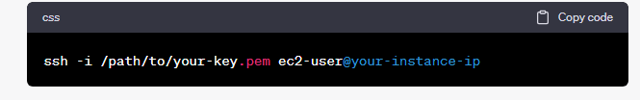**

**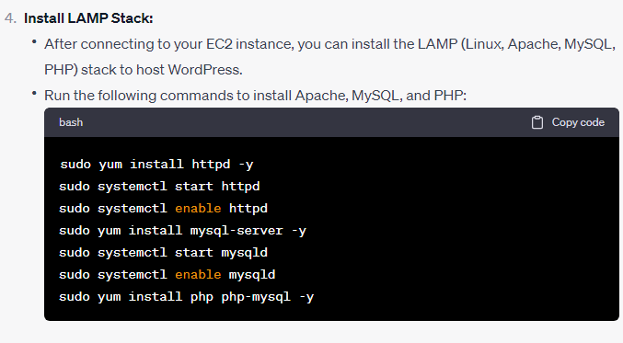**

**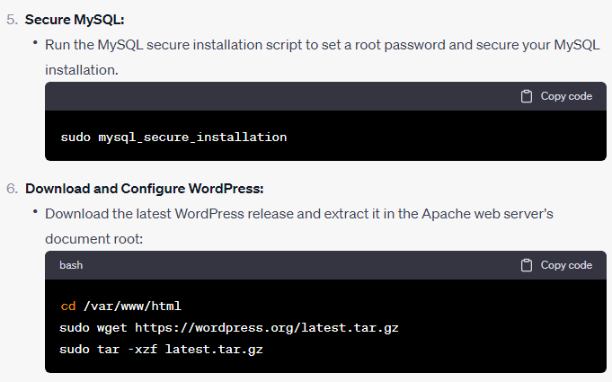**

**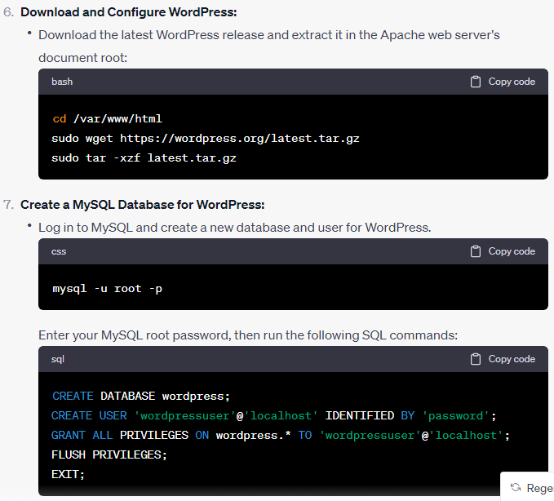**

**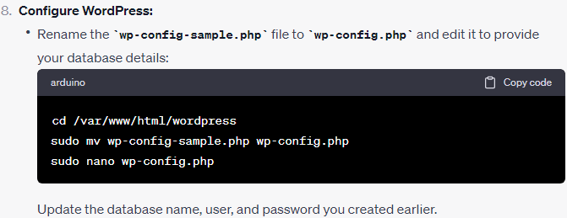**

**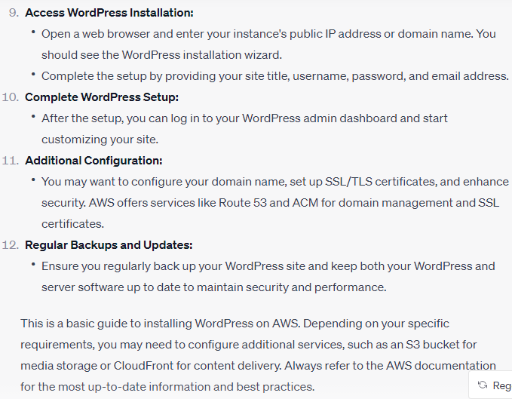**

**LAMP Setup**

[**https://www.digitalocean.com/community/tutorials/how-to-install-linux-apache-mysql-php-lamp-stack-on-ubuntu-20-04**](https://www.digitalocean.com/community/tutorials/how-to-install-linux-apache-mysql-php-lamp-stack-on-ubuntu-20-04)

**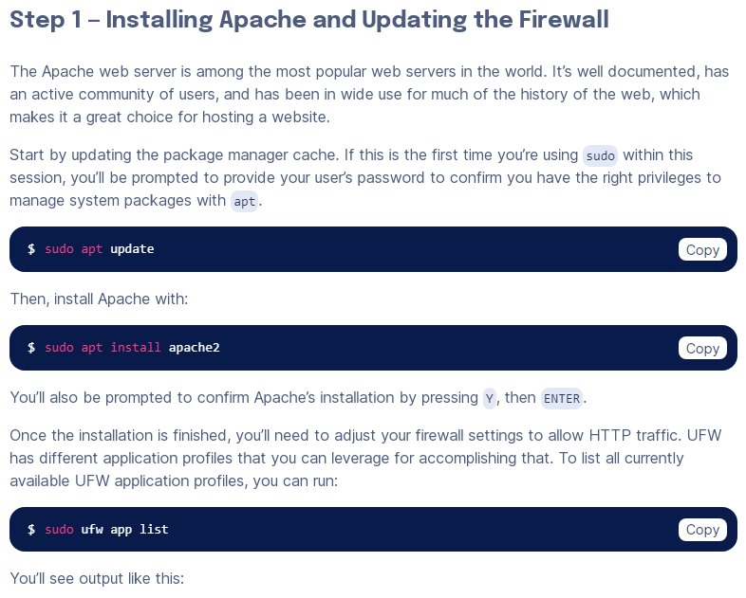 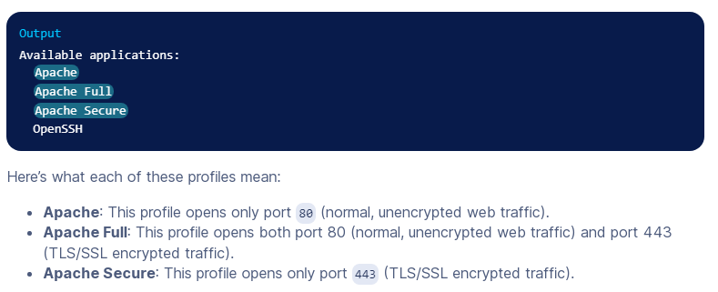**

**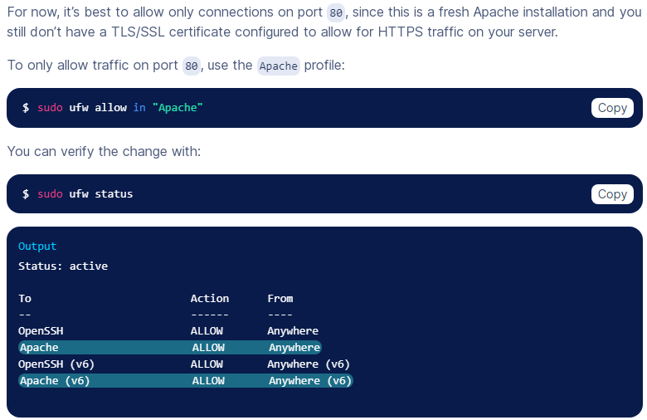**

**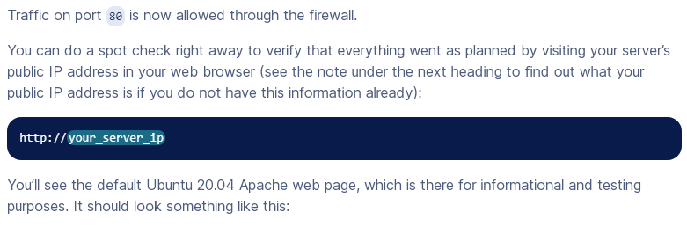**

**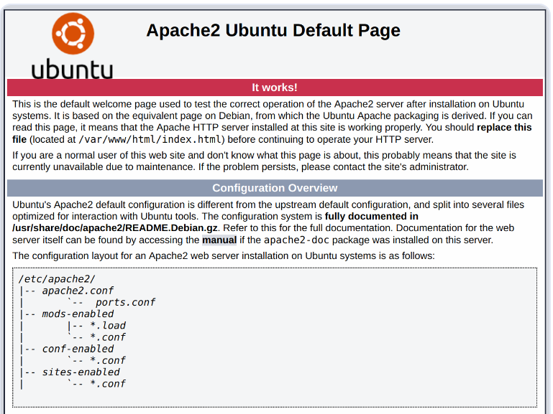 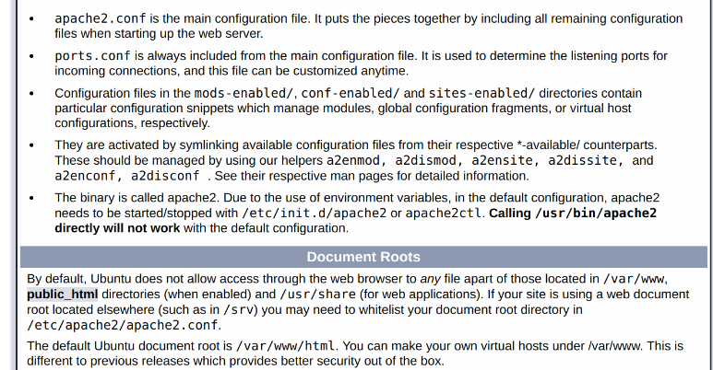 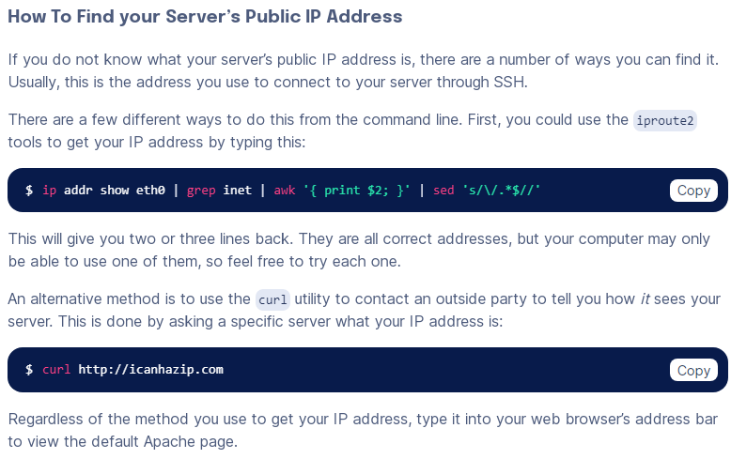 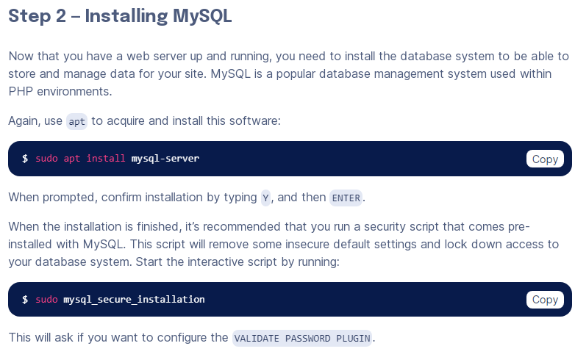 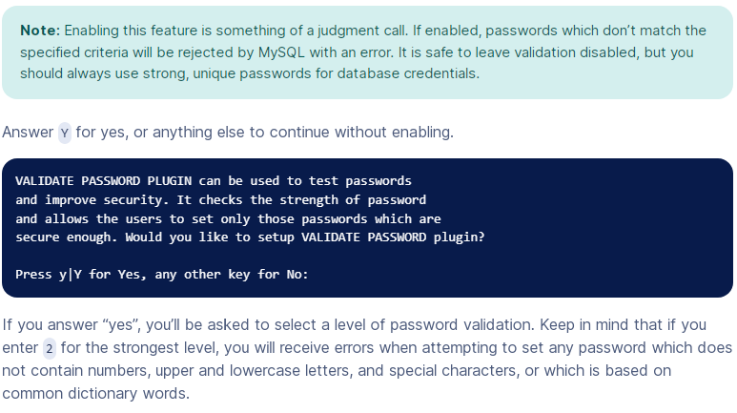 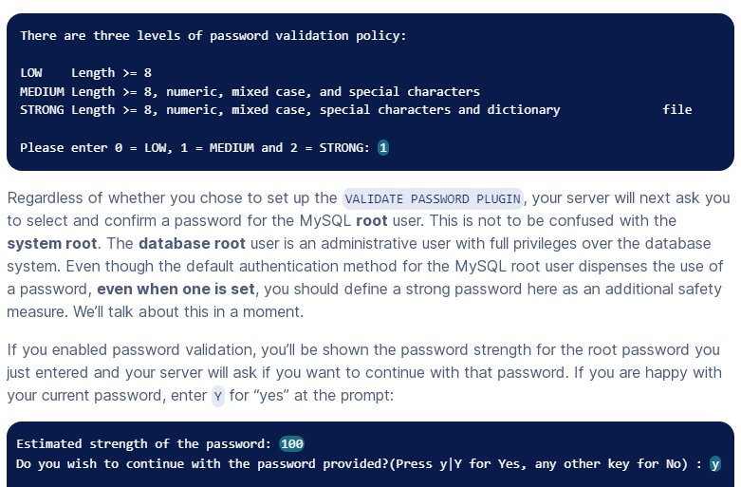 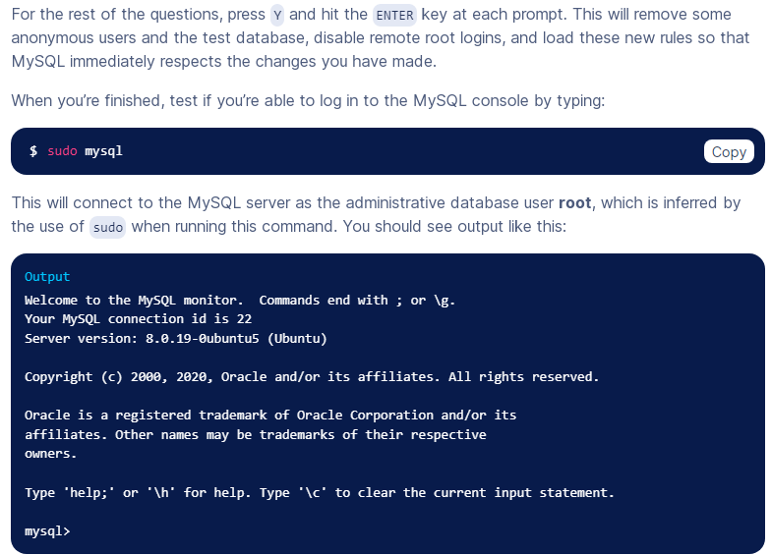 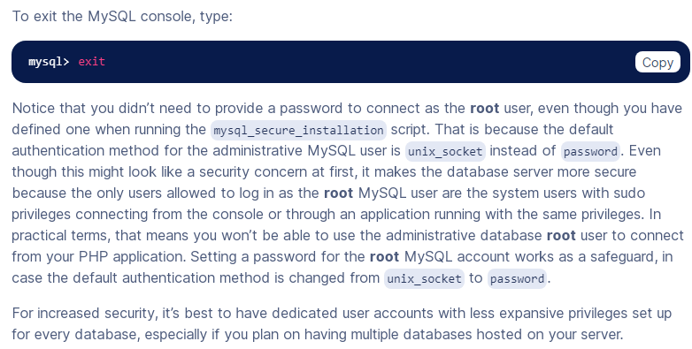 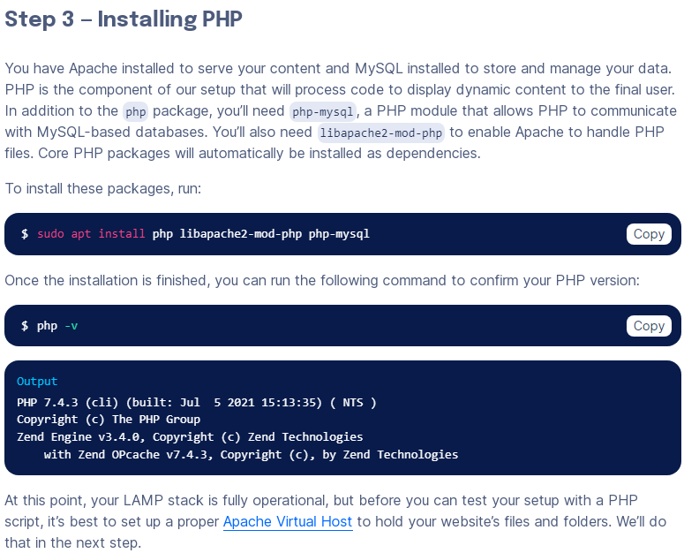**

**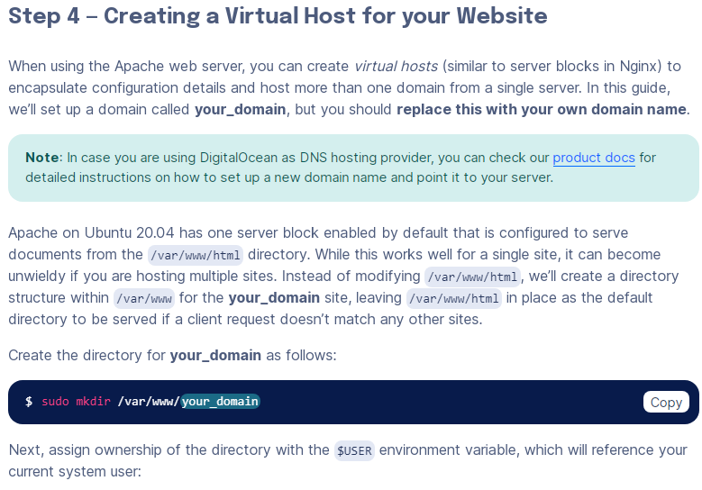**

**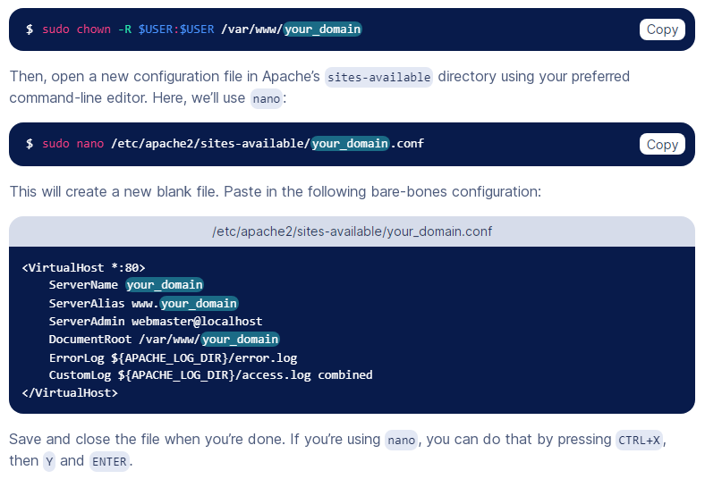**

**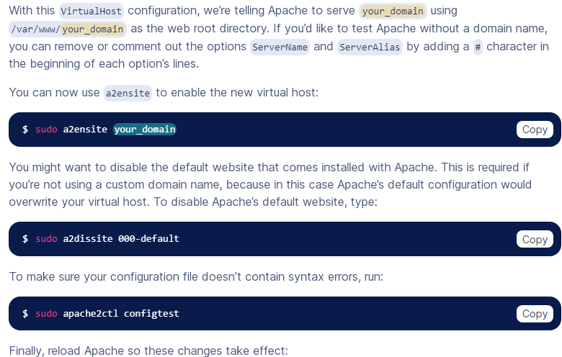 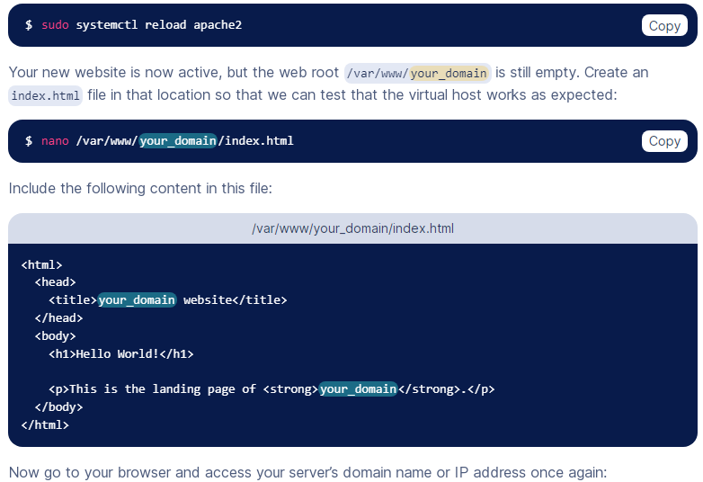 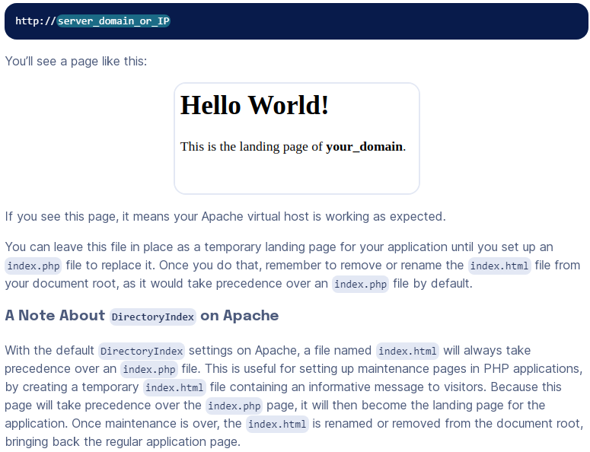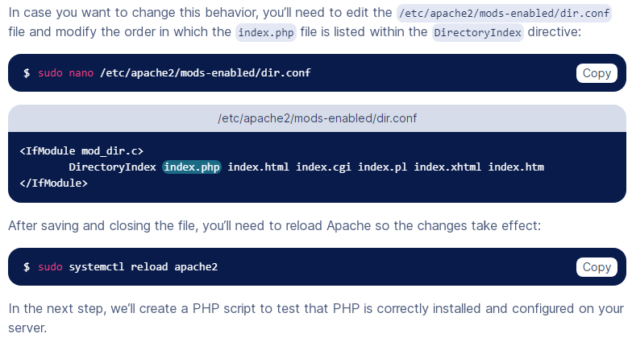 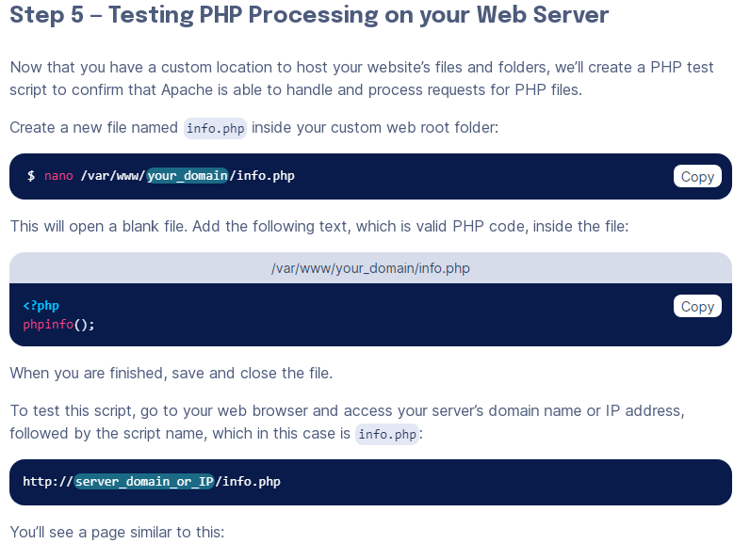 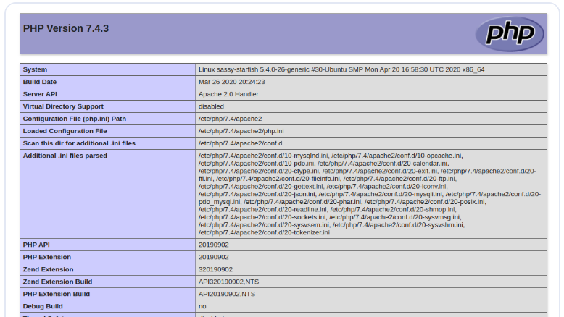 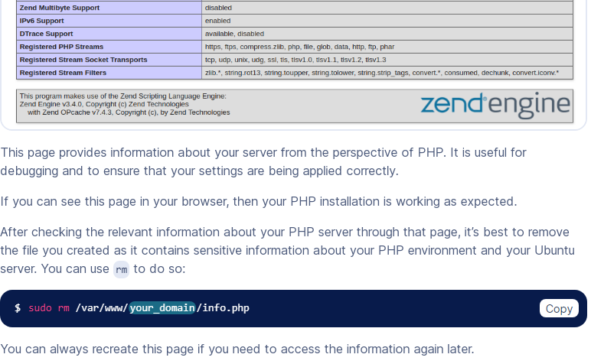 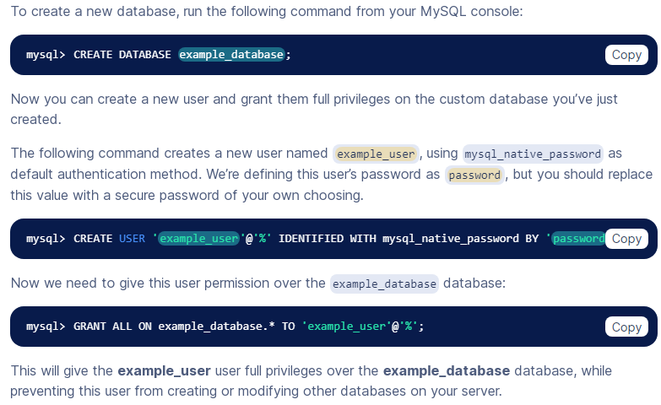**

**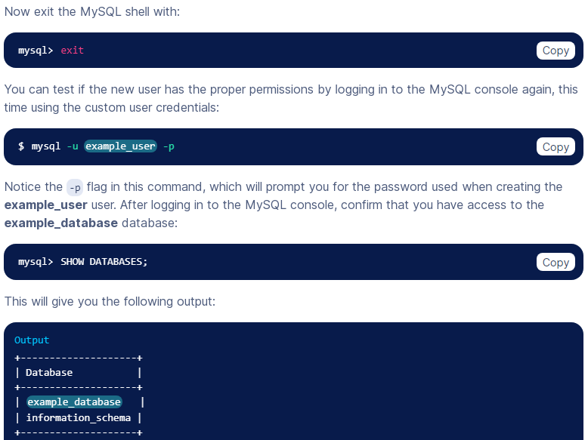**

**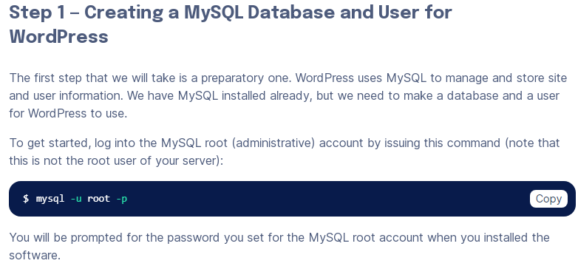 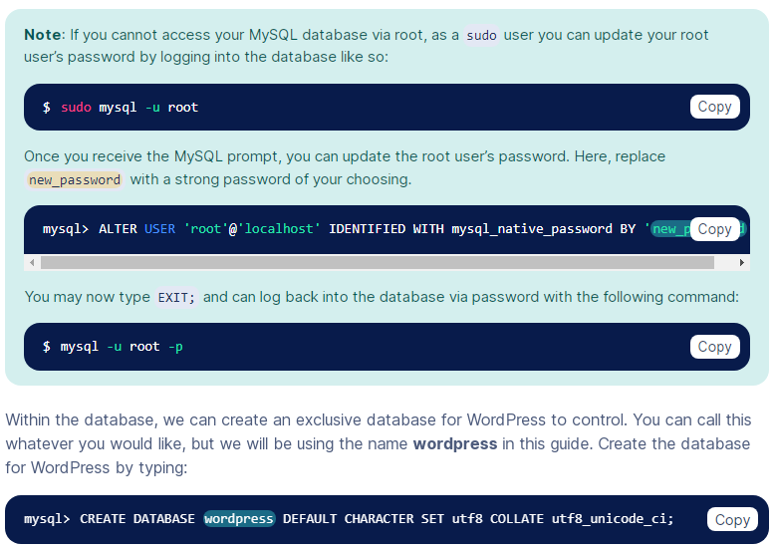**

**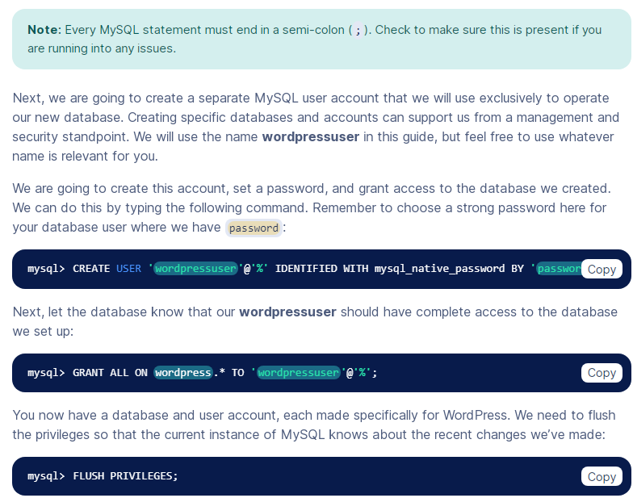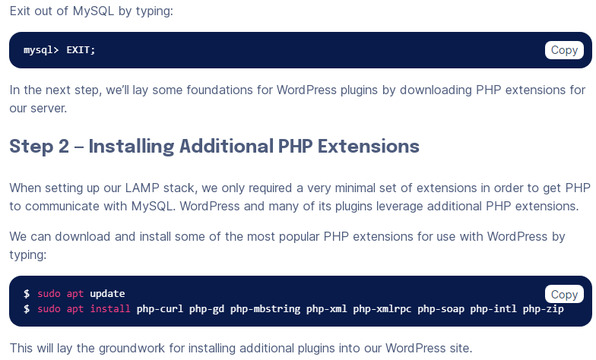**

**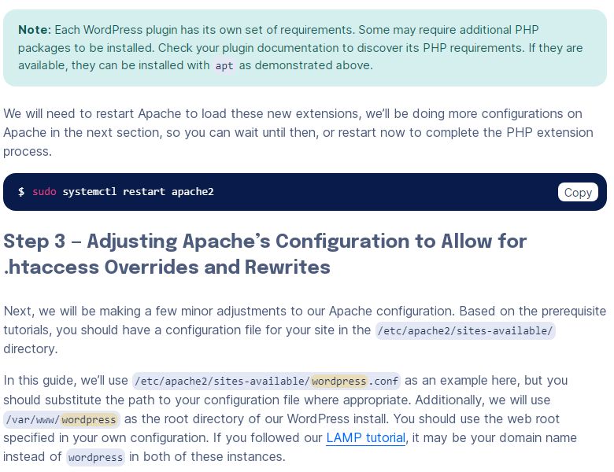 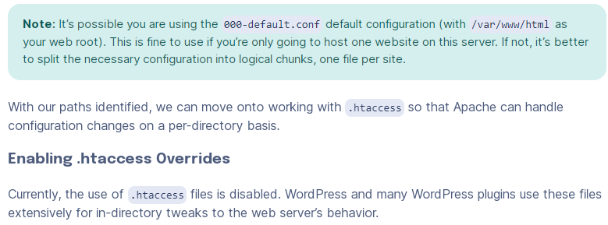**

**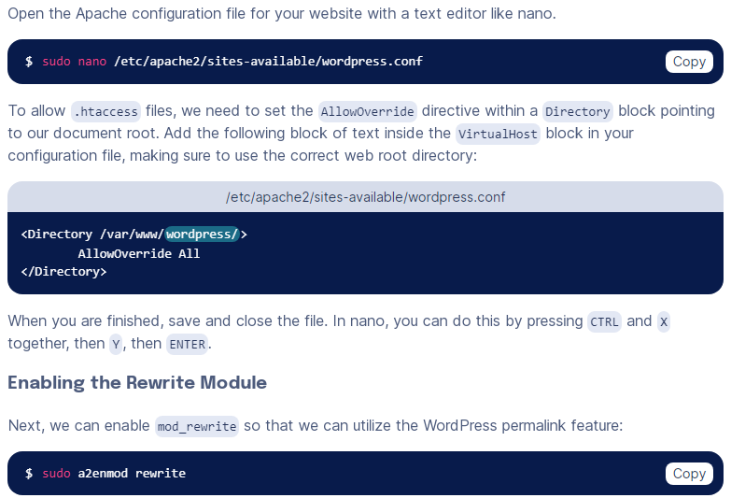 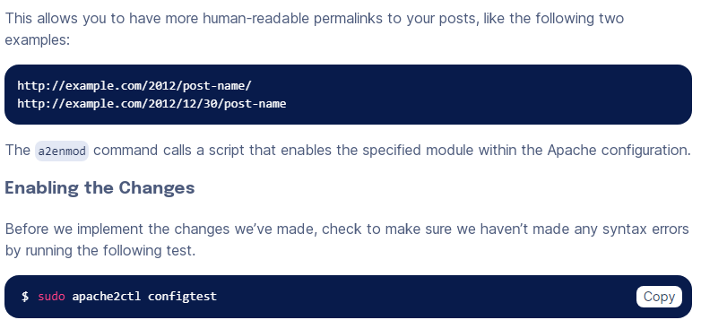**

**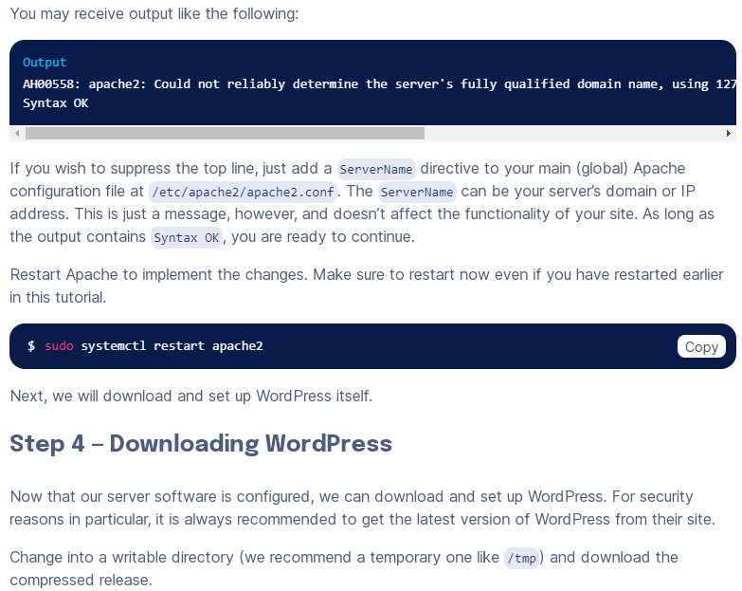 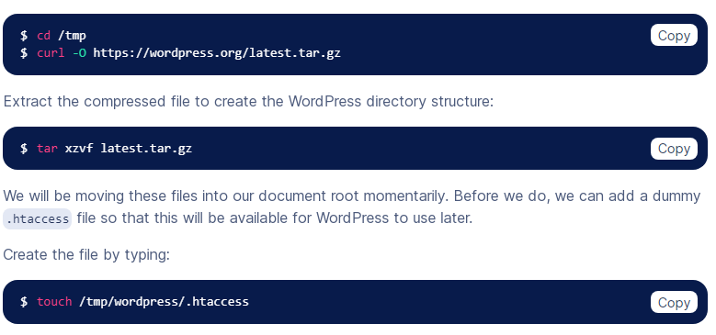**

**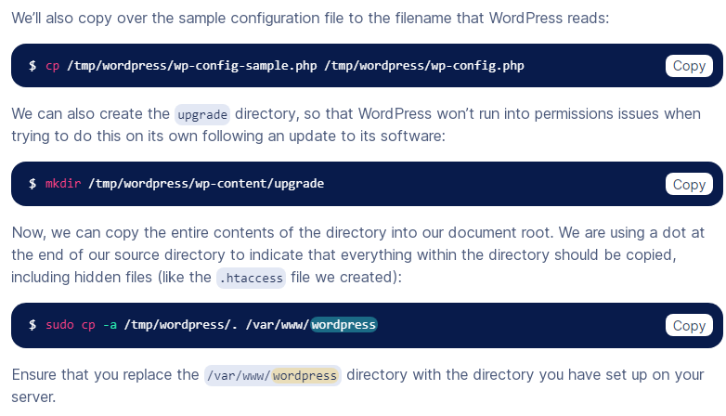 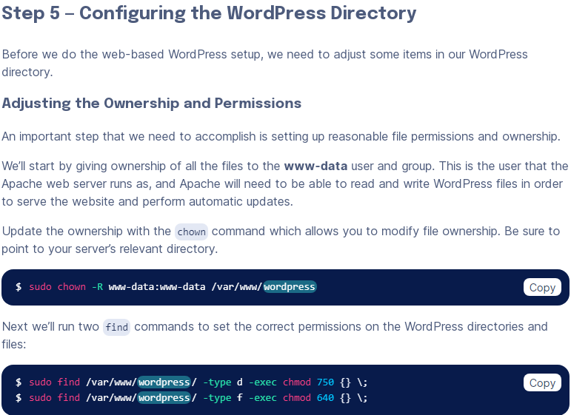**

**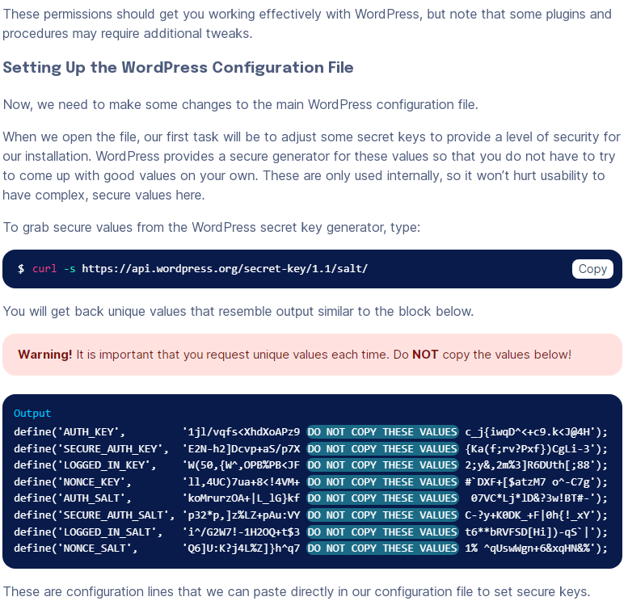 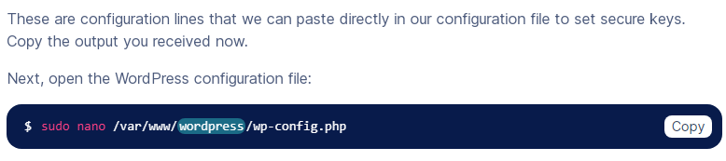**

**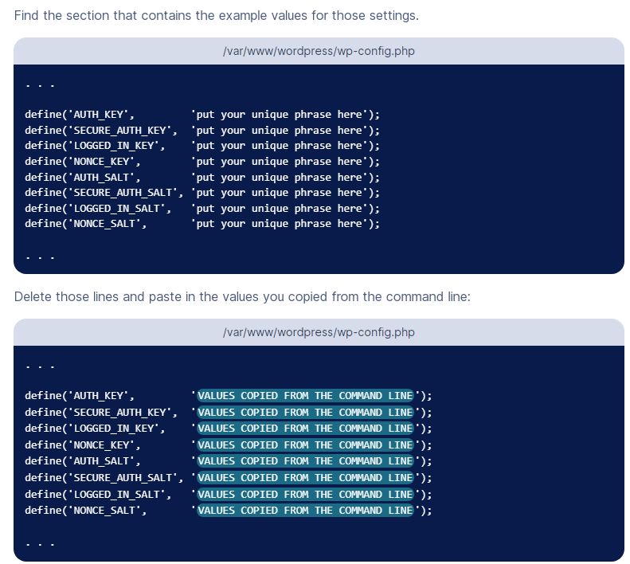 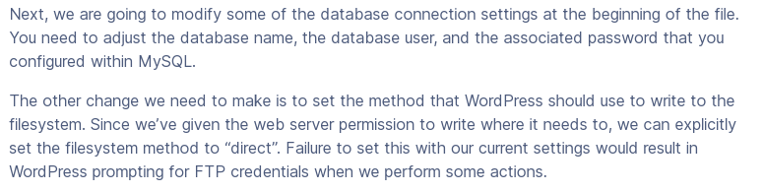 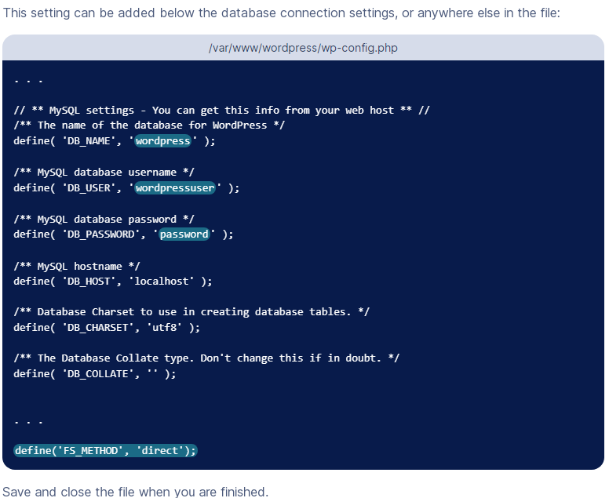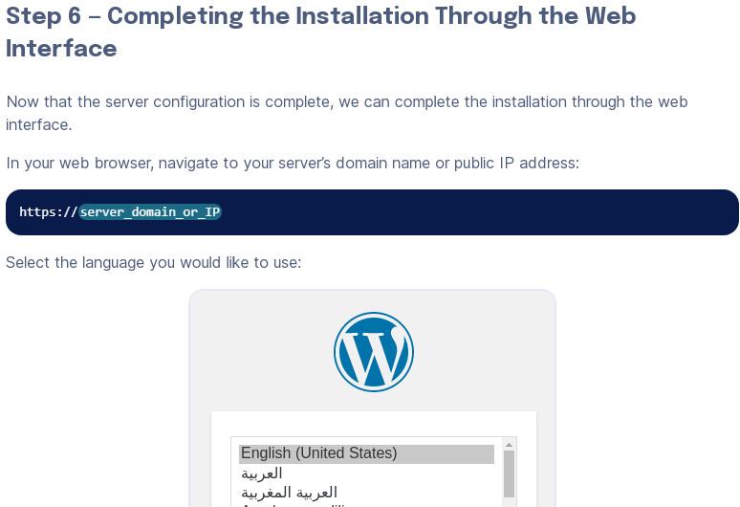**

**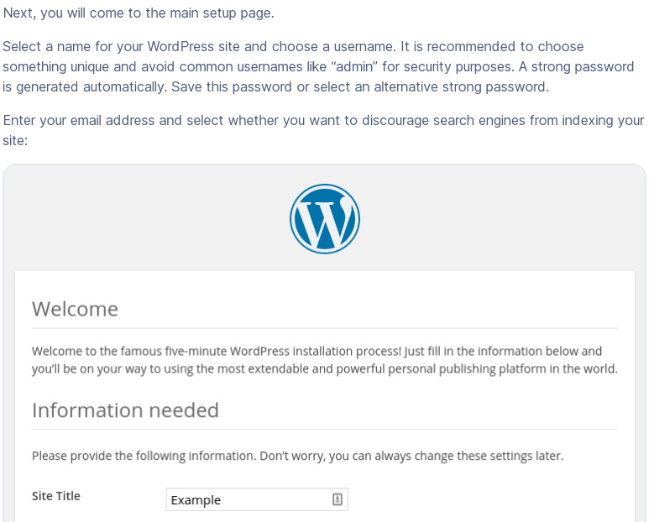 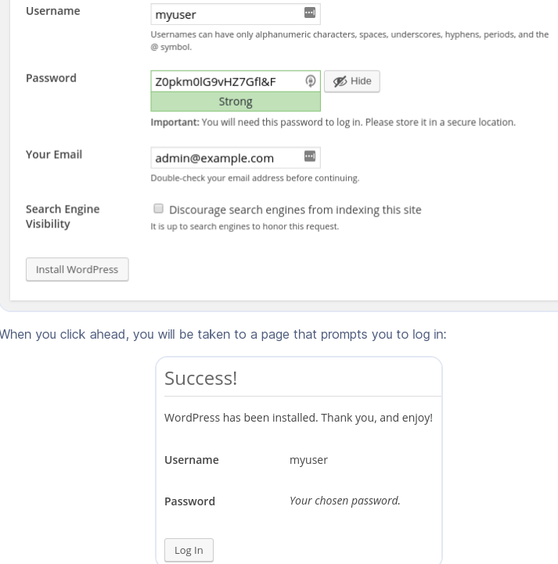 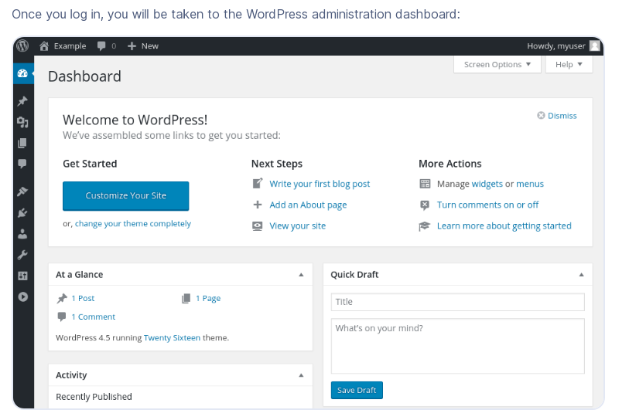**

**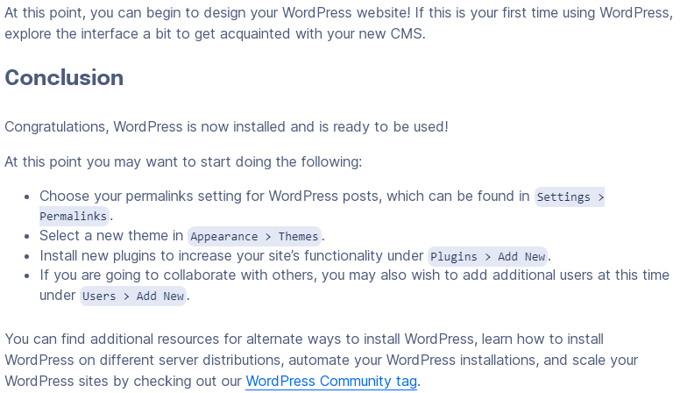**

# Initial Server Setup with Ubuntu 20.04

**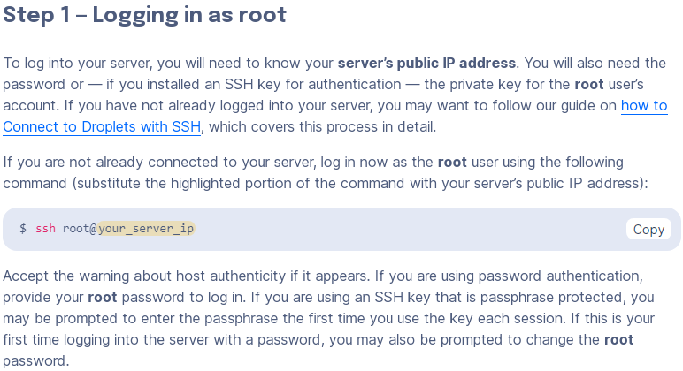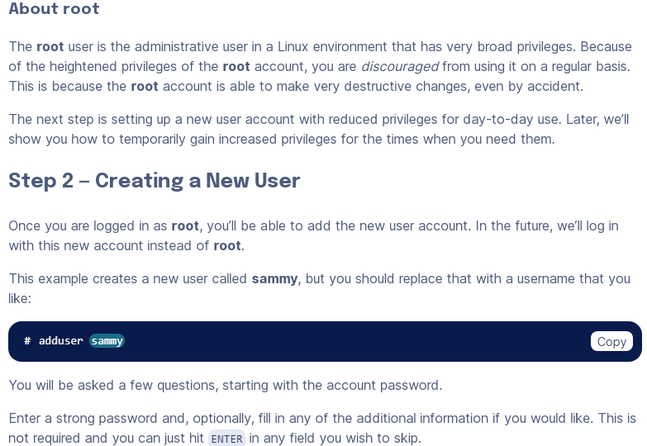**

**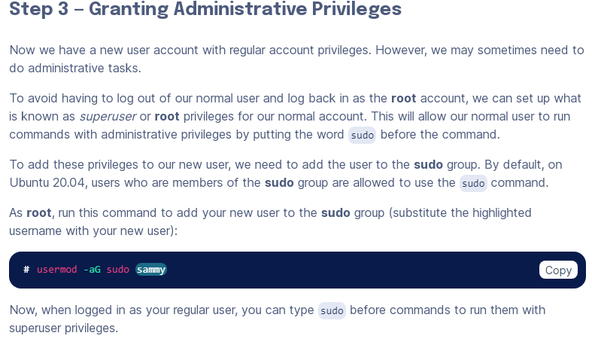 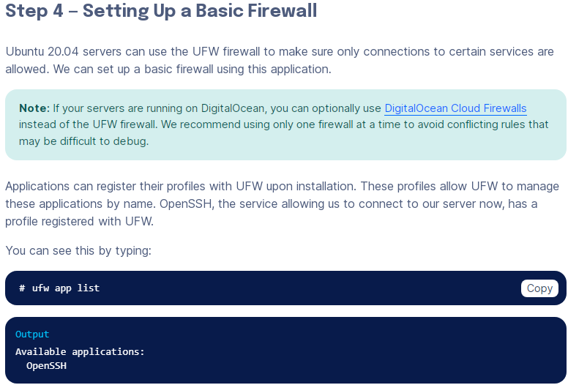 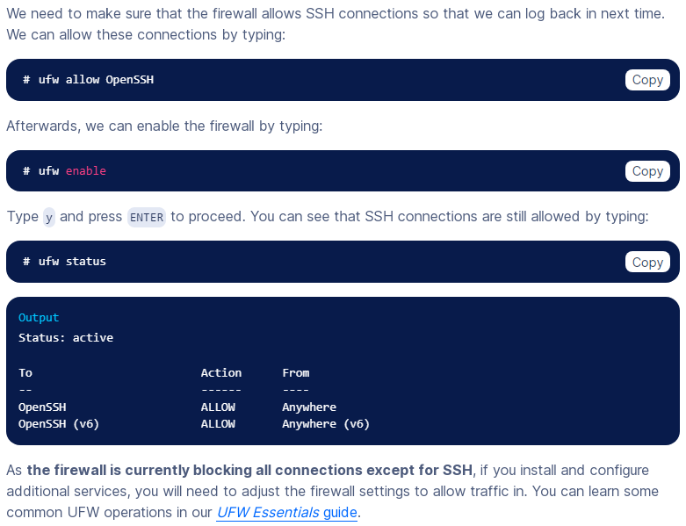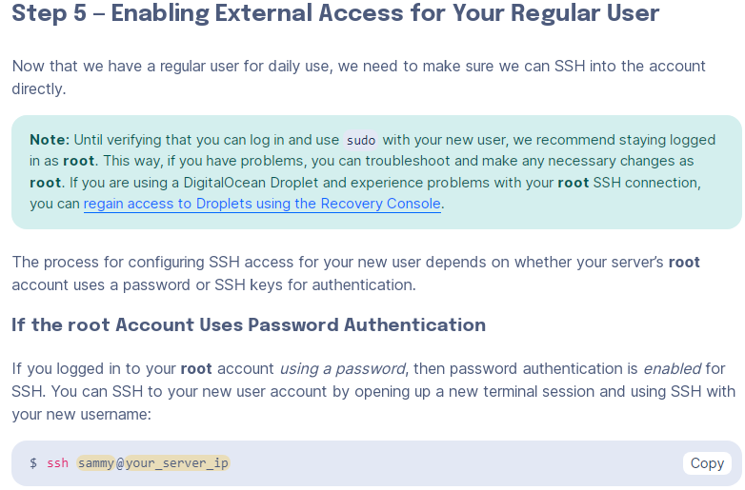**

**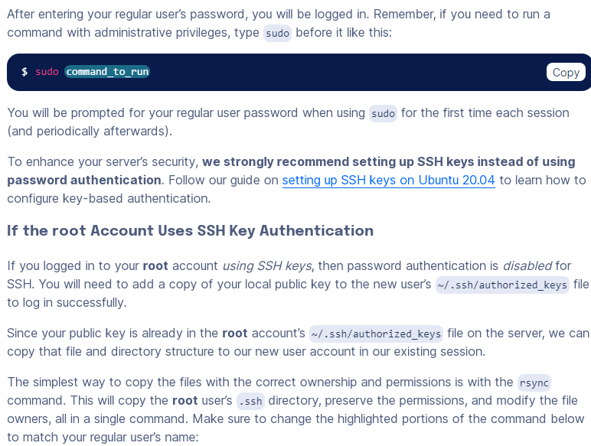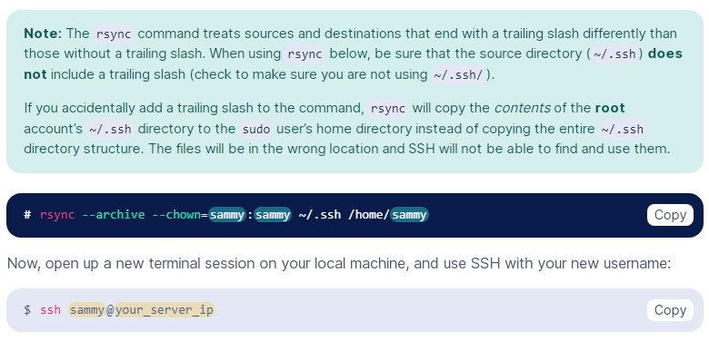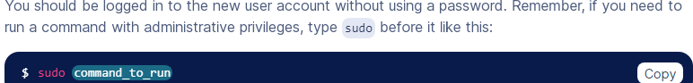**

**Install wordpress on windaw iis server**

**Step 1: Download WordPress**

1. Go to the official WordPress website (<https://wordpress.org/download/>) and download the latest version of WordPress in ZIP format.

**Step 2: Extract the WordPress Files**

1. Extract the contents of the ZIP file you downloaded to a directory on your Windows server where you want to host your WordPress site. This will be your website's root directory (e.g., **C:\inetpub\wwwroot\mywordpress**).

**Step 3: Create a MySQL Database**

1. You'll need a MySQL database to store WordPress data. Install MySQL on your Windows server if you haven't already.
2. Create a new MySQL database for WordPress. You can use a MySQL client like phpMyAdmin or the MySQL command line to create the database.
3. Create a MySQL user and grant it privileges on the WordPress database. Note down the database name, username, and password for later use.

**Step 4: Configure PHP on IIS**

1. Install PHP on your Windows server. You can use a package like XAMPP or install PHP manually.
2. Configure PHP to work with IIS by adding PHP as a FastCGI module. You can use the "Internet Information Services (IIS) Manager" to configure this.

**Step 5: Configure WordPress**

1. Rename the **wp-config-sample.php** file in your WordPress directory to **wp-config.php**.
2. Open **wp-config.php** and configure the database settings by entering the database name, username, and password you created earlier:

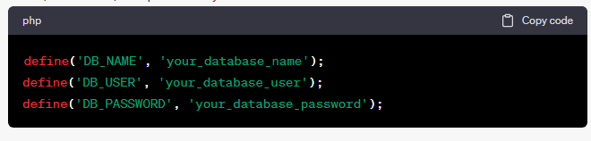

1. You may also want to define other constants like the authentication keys and salts. You can generate these keys by visiting the WordPress.org secret key generator (<https://api.wordpress.org/secret-key/1.1/salt/>).
2. Save your **wp-config.php** file.

**Step 6: Configure IIS for WordPress**

1. Open the "Internet Information Services (IIS) Manager."
2. In the Connections pane on the left, expand your server node and click on "Sites."
3. Right-click on "Default Web Site" or create a new site if needed, and select "Add Application."
4. Set an alias for your WordPress site (e.g., "mywordpress") and browse for the physical path where you extracted the WordPress files.
5. In the "Edit Application" dialog, go to the "Modules" section, and ensure that the "FastCgiModule" is installed and enabled.

**Step 7: Access Your WordPress Site**

1. Open a web browser and enter the URL to your WordPress site (e.g., **http://localhost/mywordpress**). Follow the WordPress installation instructions.
2. Complete the installation by providing your site title, username, password, and email address.
3. Once the installation is complete, you can log in to the WordPress admin dashboard and start customizing your site.

That's it! You've successfully installed WordPress on your Windows IIS server. You can now start building and managing your website using the WordPress platform.

**CRUD Oops Vishall programming**

**<?php**

**class database{**

**private $host;**

**private $dbusername;**

**private $dbpassword;**

**private $dbname;**

**protected function connect(){**

**$this->host='localhost';**

**$this->dbusername='wwwabcx\_abcuser';**

**$this->dbpassword='&;=mbh));6@{';**

**$this->dbname='wwwabcx\_oops\_crud\_vishal';**

**$con=new mysqli($this->host,$this->dbusername,$this->dbpassword,$this->dbname);**

**return $con;**

**}**

**}**

**class query extends database{**

**public function getData($table,$field='\*',$condition\_arr='',$order\_by\_field='',$order\_by\_type='desc',$limit=''){**

**$sql="select $field from $table ";**

**if($condition\_arr!=''){**

**$sql.=' where ';**

**$c=count($condition\_arr);**

**$i=1;**

**foreach($condition\_arr as $key=>$val){**

**if($i==$c){**

**$sql.="$key='$val'";**

**}else{**

**$sql.="$key='$val' and ";**

**}**

**$i++;**

**}**

**}**

**if($order\_by\_field!=''){**

**$sql.=" order by $order\_by\_field $order\_by\_type ";**

**}**

**if($limit!=''){**

**$sql.=" limit $limit ";**

**}**

**$result=$this->connect()->query($sql);**

**if($result->num\_rows>0){**

**$arr=array();**

**while($row=$result->fetch\_assoc()){**

**$arr[]=$row;**

**}**

**return $arr;**

**}else{**

**return 0;**

**}**

**}**

**public function insertData($table,$condition\_arr){**

**if($condition\_arr!=''){**

**foreach($condition\_arr as $key=>$val){**

**$fieldArr[]=$key;**

**$valueArr[]=$val;**

**}**

**$field=implode(",",$fieldArr);**

**$value=implode("','",$valueArr);**

**$value="'".$value."'";**

**$sql="insert into $table($field) values($value) ";**

**$result=$this->connect()->query($sql);**

**}**

**}**

**public function deleteData($table,$condition\_arr){**

**if($condition\_arr!=''){**

**$sql="delete from $table where ";**

**$c=count($condition\_arr);**

**$i=1;**

**foreach($condition\_arr as $key=>$val){**

**if($i==$c){**

**$sql.="$key='$val'";**

**}else{**

**$sql.="$key='$val' and ";**

**}**

**$i++;**

**}**

**$result=$this->connect()->query($sql);**

**}**

**}**

**public function updateData($table,$condition\_arr,$where\_field,$where\_value){**

**if($condition\_arr!=''){**

**$sql="update $table set ";**

**$c=count($condition\_arr);**

**$i=1;**

**foreach($condition\_arr as $key=>$val){**

**if($i==$c){**

**$sql.="$key='$val'";**

**}else{**

**$sql.="$key='$val', ";**

**}**

**$i++;**

**}**

**$sql.=" where $where\_field='$where\_value' ";**

**$result=$this->connect()->query($sql);**

**}**

**}**

**public function get\_safe\_str($str){**

**if($str!=''){**

**return mysqli\_real\_escape\_string($this->connect(),$str);**

**}**

**}**

**}**

**?>**

**Database.php**

**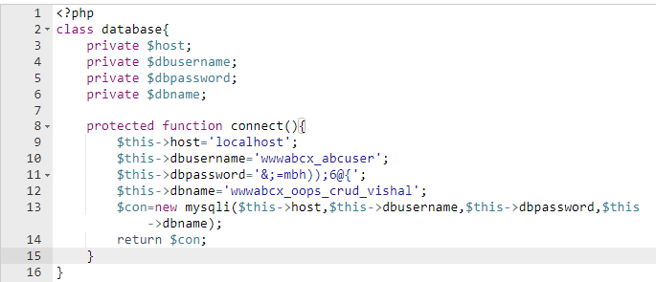**

**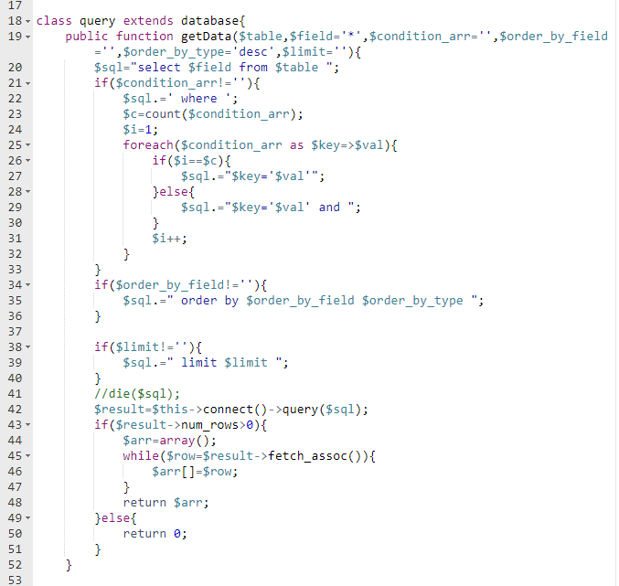**

**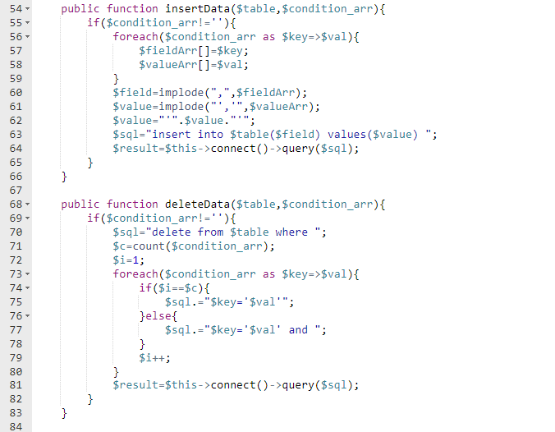**

**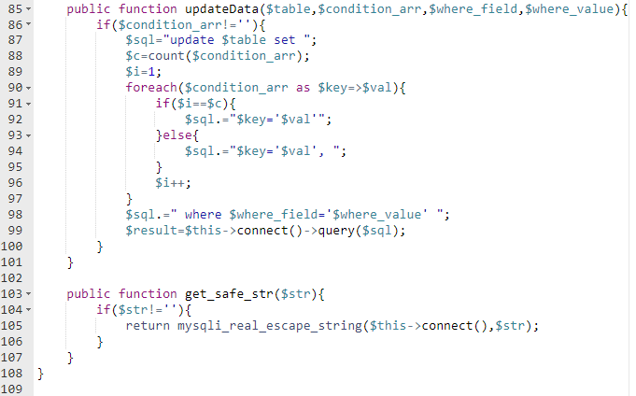**

**Users.php**

**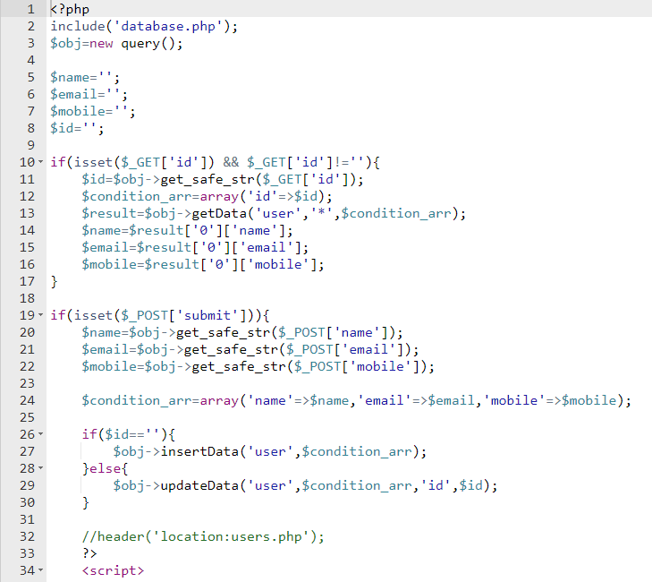**

**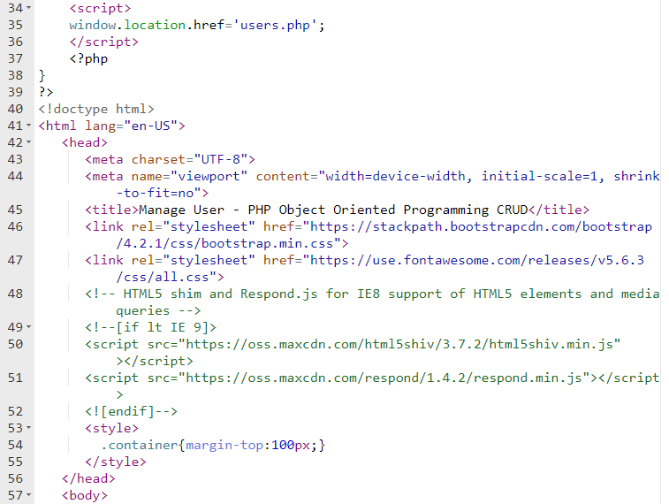**

**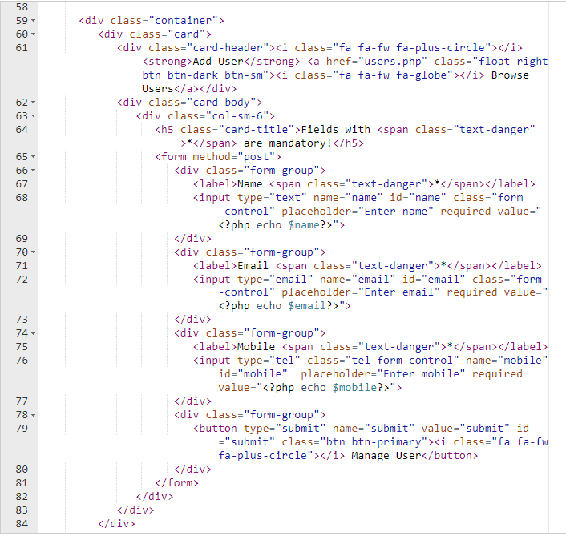**

**Index.php**

**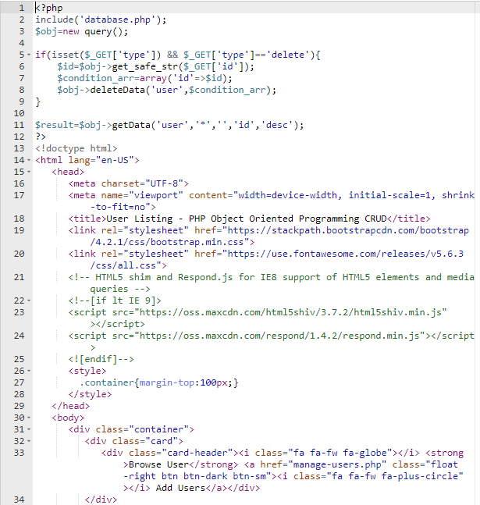**

**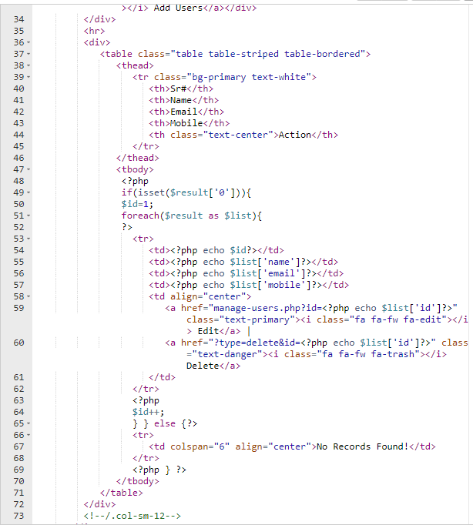**

**Yahoo baba CRUD OOPs**

**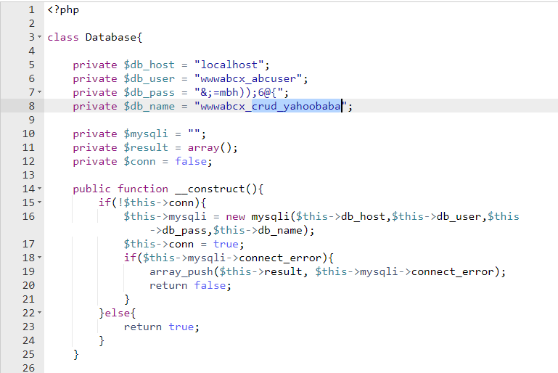**

**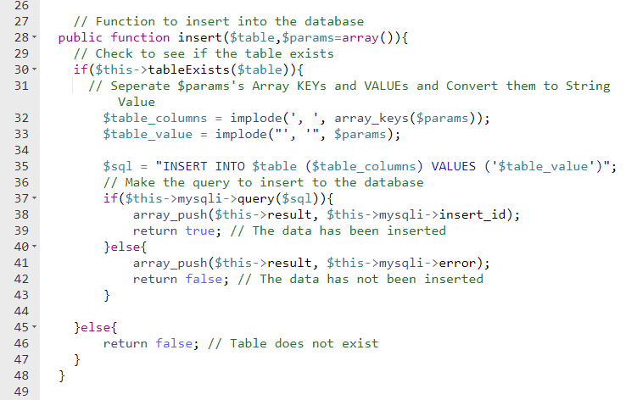**

**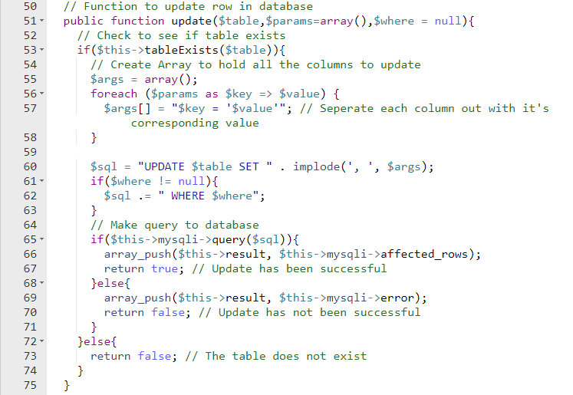**

**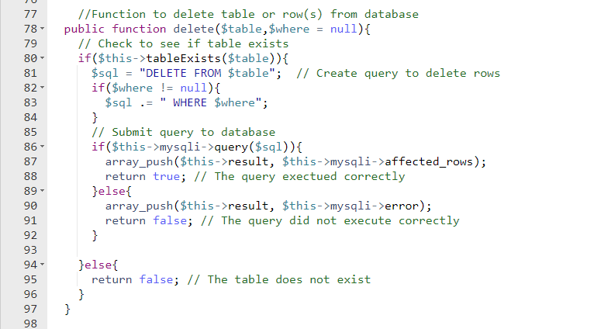**

**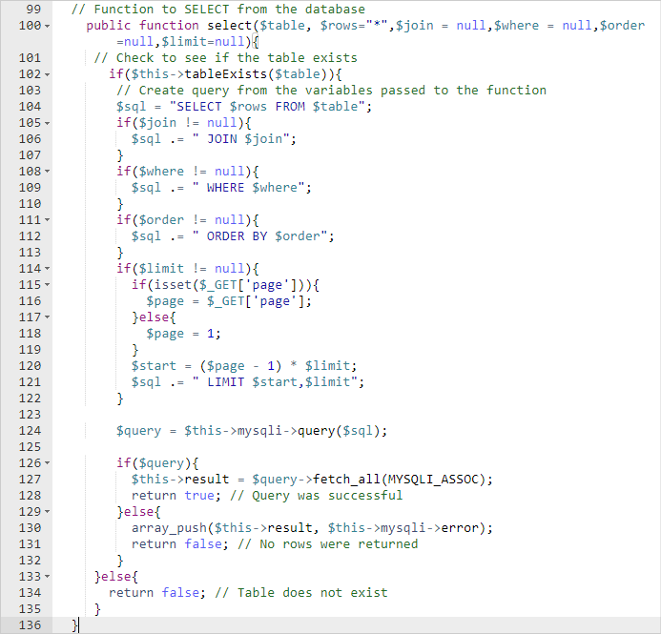**

**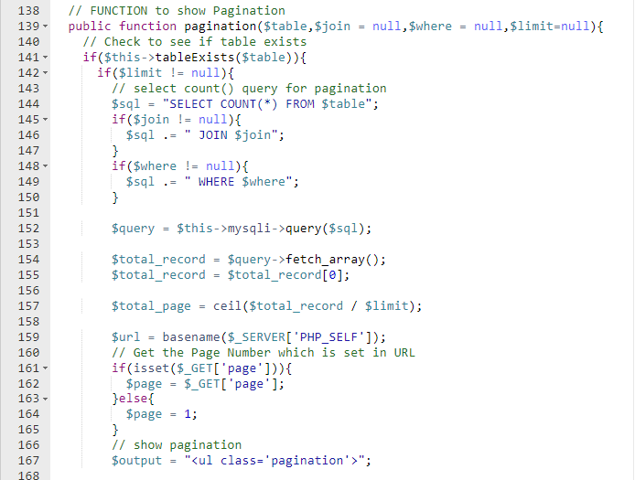**

**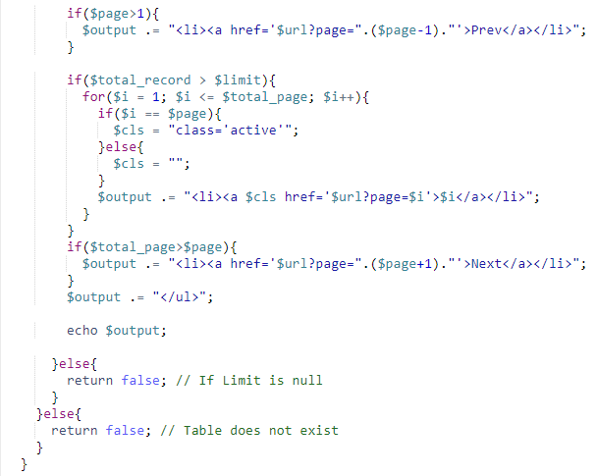**

**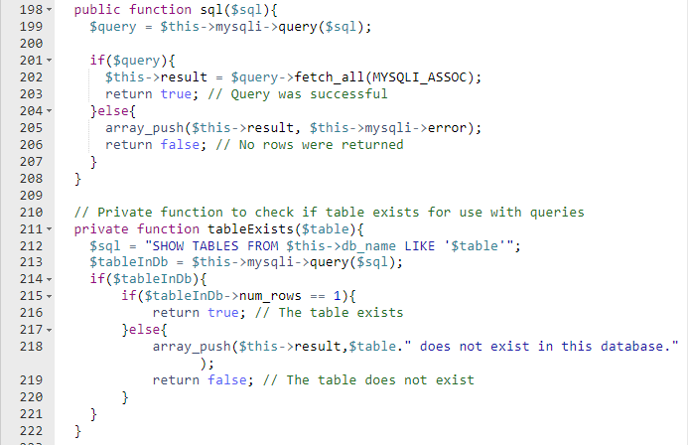**

**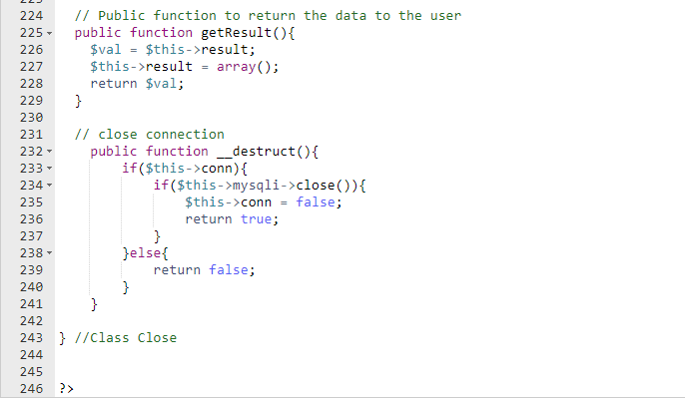**

**CRUD Using Oops (Chat GPT)**

**<?php**

**// Database configuration**

**$servername = "localhost";**

**$username = "your\_username";**

**$password = "your\_password";**

**$dbname = "your\_database";**

**// Create database connection**

**$conn = new mysqli($servername, $username, $password, $dbname);**

**// Check connection**

**if ($conn->connect\_error) {**

**die("Connection failed: " . $conn->connect\_error);**

**}**

**// Book class**

**class Book {**

**private $id;**

**private $title;**

**private $author;**

**public function \_\_construct($title, $author) {**

**$this->title = $title;**

**$this->author = $author;**

**}**

**public function getId() {**

**return $this->id;**

**}**

**public function getTitle() {**

**return $this->title;**

**}**

**public function getAuthor() {**

**return $this->author;**

**}**

**public function save() {**

**global $conn;**

**$stmt = $conn->prepare("INSERT INTO books (title, author) VALUES (?, ?)");**

**$stmt->bind\_param("ss", $this->title, $this->author);**

**$stmt->execute();**

**$this->id = $stmt->insert\_id;**

**$stmt->close();**

**}**

**public function update() {**

**global $conn;**

**$stmt = $conn->prepare("UPDATE books SET title = ?, author = ? WHERE id = ?");**

**$stmt->bind\_param("ssi", $this->title, $this->author, $this->id);**

**$stmt->execute();**

**$stmt->close();**

**}**

**public function delete() {**

**global $conn;**

**$stmt = $conn->prepare("DELETE FROM books WHERE id = ?");**

**$stmt->bind\_param("i", $this->id);**

**$stmt->execute();**

**$stmt->close();**

**}**

**}**

**// Example usage:**

**// Create a new book**

**$newBook = new Book("Sample Book", "John Doe");**

**$newBook->save();**

**echo "New book created with ID: " . $newBook->getId() . "<br>";**

**// Update the book**

**$newBook->setTitle("Updated Book");**

**$newBook->setAuthor("Jane Smith");**

**$newBook->update();**

**echo "Book updated<br>";**

**// Delete the book**

**$newBook->delete();**

**echo "Book deleted<br>";**

**// Close database connection**

**$conn->close();**

**?>**

**CRED Operation Wordpress**

Step 1: Create a new MySQL table (you can do this via phpMyAdmin or any MySQL client):

Step 2: Create a new folder for your plugin. For this example, we'll name it "crud-plugin."

Step 3: Create the main plugin file (crud-plugin.php) inside the "crud-plugin" folder:

**<?php**

**/\***

**Plugin Name: CRUD Plugin**

**Description: A simple plugin for CRUD operations.**

**Version: 1.0**

**Author: Your Name**

**\*/**

**// Create the database table on plugin activation**

**function crud\_plugin\_create\_table() {**

**global $wpdb;**

**$table\_name = $wpdb->prefix . 'custom\_table';**

**$sql = "CREATE TABLE $table\_name (**

**id INT NOT NULL AUTO\_INCREMENT,**

**name VARCHAR(255) NOT NULL,**

**email VARCHAR(255) NOT NULL,**

**phone VARCHAR(20),**

**PRIMARY KEY (id) )";**

**require\_once(ABSPATH . 'wp-admin/includes/upgrade.php');**

**dbDelta($sql);**

**}**

**register\_activation\_hook(\_\_FILE\_\_, 'crud\_plugin\_create\_table');**

**Step 4: Create a file to handle the CRUD operations (crud-operations.php) inside the "crud-plugin" folder:**

**<?php**

**// Add new record**

**function crud\_plugin\_add\_record($name, $email, $phone) {**

**global $wpdb;**

**$table\_name = $wpdb->prefix . 'custom\_table';**

**$data = array(**

**'name' => $name,**

**'email' => $email,**

**'phone' => $phone,**

**);**

**$wpdb->insert($table\_name, $data);**

**}**

**// Update record by ID**

**function crud\_plugin\_update\_record($id, $name, $email, $phone) {**

**global $wpdb;**

**$table\_name = $wpdb->prefix . 'custom\_table';**

**$data = array(**

**'name' => $name,**

**'email' => $email,**

**'phone' => $phone,**

**);**

**$where = array('id' => $id);**

**$wpdb->update($table\_name, $data, $where);**

**}**

**// Delete record by ID**

**function crud\_plugin\_delete\_record($id) {**

**global $wpdb;**

**$table\_name = $wpdb->prefix . 'custom\_table';**

**$where = array('id' => $id);**

**$wpdb->delete($table\_name, $where);**

**}**

**Step 5: Create a form in your main plugin file (crud-plugin.php) to handle user input:**

**<?php**

**// Include the file with CRUD operations functions**

**require\_once(plugin\_dir\_path(\_\_FILE\_\_) . 'crud-operations.php');**

**// Handle form submission**

**if (isset($\_POST['submit'])) {**

**$name = sanitize\_text\_field($\_POST['name']);**

**$email = sanitize\_email($\_POST['email']);**

**$phone = sanitize\_text\_field($\_POST['phone']);**

**// Add new record**

**crud\_plugin\_add\_record($name, $email, $phone);**

**}**

**?>**

**<!-- Display the form -->**

**<form method="post">**

**<label for="name">Name:</label> <input type="text" name="name" required>**

**<label for="email">Email:</label> <input type="email" name="email" required>**

**<label for="phone">Phone:</label> <input type="text" name="phone">**

**<input type="submit" name="submit" value="Submit">**

**</form>**

**CRUD application wordpress plugin refrence chatGPT**

**<?php**

**/\*\***

**\* Plugin Name: Book Manager**

**\* Description: A simple CRUD application for managing books.**

**\* Version: 1.0.0**

**\* Author: Your Name**

**\*/**

**// Activation hook**

**register\_activation\_hook(\_\_FILE\_\_, 'book\_manager\_activate');**

**function book\_manager\_activate() {**

**// Create the database table for books**

**global $wpdb;**

**$table\_name = $wpdb->prefix . 'books';**

**$charset\_collate = $wpdb->get\_charset\_collate();**

**$sql = "CREATE TABLE $table\_name (**

**id mediumint(9) NOT NULL AUTO\_INCREMENT,**

**title varchar(255) NOT NULL,**

**author varchar(255) NOT NULL,**

**publication\_date date NOT NULL,**

**PRIMARY KEY (id)**

**) $charset\_collate;";**

**require\_once(ABSPATH . 'wp-admin/includes/upgrade.php');**

**dbDelta($sql);**

**}**

**// Deactivation hook**

**register\_deactivation\_hook(\_\_FILE\_\_, 'book\_manager\_deactivate');**

**function book\_manager\_deactivate() {**

**// Remove the database table for books**

**global $wpdb;**

**$table\_name = $wpdb->prefix . 'books';**

**$wpdb->query("DROP TABLE IF EXISTS $table\_name");**

**}**

**// Admin menu hook**

**add\_action('admin\_menu', 'book\_manager\_menu');**

**function book\_manager\_menu() {**

**add\_menu\_page(**

**'Book Manager',**

**'Book Manager',**

**'manage\_options',**

**'book-manager',**

**'book\_manager\_list\_books',**

**'dashicons-book-alt',**

**30**

**);**

**}**

**function book\_manager\_list\_books() {**

**// Display the list of books**

**global $wpdb;**

**$table\_name = $wpdb->prefix . 'books';**

**$books = $wpdb->get\_results("SELECT \* FROM $table\_name");**

**echo '<div class="wrap">';**

**echo '<h1>Book Manager</h1>';**

**echo '<a href="?page=book-manager&action=add" class="page-title-action">Add New Book</a>';**

**echo '<table class="wp-list-table widefat fixed striped">';**

**echo '<thead><tr><th>Title</th><th>Author</th><th>Publication Date</th><th>Actions</th></tr></thead>';**

**echo '<tbody>';**

**foreach ($books as $book) {**

**echo '<tr>';**

**echo '<td>' . $book->title . '</td>';**

**echo '<td>' . $book->author . '</td>';**

**echo '<td>' . $book->publication\_date . '</td>';**

**echo '<td>';**

**echo '<a href="?page=book-manager&action=edit&id=' . $book->id . '">Edit</a> | ';**

**echo '<a href="?page=book-manager&action=delete&id=' . $book->id . '">Delete</a>';**

**echo '</td>';**

**echo '</tr>';**

**}**

**echo '</tbody>';**

**echo '</table>';**

**echo '</div>';**

**}**

**// Process actions**

**add\_action('admin\_init', 'book\_manager\_process\_actions');**

**function book\_manager\_process\_actions() {**

**if (isset($\_GET['page']) && $\_GET['page'] === 'book-manager') {**

**if (isset($\_GET['action'])) {**

**$action = $\_GET['action'];**

**switch ($action) {**

**case 'add':**

**book\_manager\_add\_book();**

**break;**

**case 'edit':**

**if (isset($\_GET['id'])) {**

**book\_manager\_edit\_book($\_GET['id']);**

**}**

**break;**

**case 'delete':**

**if (isset($\_GET['id'])) {**

**book\_manager\_delete\_book($\_GET['id']);**

**}**

**break;**

**}**

**}**

**}**

**}**

**function book\_manager\_add\_book() {**

**// Add a new book**

**if ($\_SERVER['REQUEST\_METHOD'] === 'POST') {**

**global $wpdb;**

**$table\_name = $wpdb->prefix . 'books';**

**$title = sanitize\_text\_field($\_POST['title']);**

**$author = sanitize\_text\_field($\_POST['author']);**

**$publication\_date = sanitize\_text\_field($\_POST['publication\_date']);**

**$wpdb->insert(**

**$table\_name,**

**array(**

**'title' => $title,**

**'author' => $author,**

**'publication\_date' => $publication\_date,**

**)**

**);**

**wp\_redirect(admin\_url('admin.php?page=book-manager'));**

**exit;**

**} else {**

**// Display add book form**

**echo '<div class="wrap">';**

**echo '<h1>Add New Book</h1>';**

**echo '<form method="post" action="">';**

**echo '<label>Title:</label>';**

**echo '<input type="text" name="title" required><br>';**

**echo '<label>Author:</label>';**

**echo '<input type="text" name="author" required><br>';**

**echo '<label>Publication Date:</label>';**

**echo '<input type="date" name="publication\_date" required><br>';**

**echo '<input type="submit" class="button button-primary" value="Add Book">';**

**echo '</form>';**

**echo '</div>';**

**}**

**}**

**function book\_manager\_edit\_book($id) {**

**// Edit an existing book**

**if ($\_SERVER['REQUEST\_METHOD'] === 'POST') {**

**global $wpdb;**

**$table\_name = $wpdb->prefix . 'books';**

**$title = sanitize\_text\_field($\_POST['title']);**

**$author = sanitize\_text\_field($\_POST['author']);**

**$publication\_date = sanitize\_text\_field($\_POST['publication\_date']);**

**$wpdb->update(**

**$table\_name,**

**array(**

**'title' => $title,**

**'author' => $author,**

**'publication\_date' => $publication\_date,**

**),**

**array('id' => $id)**

**);**

**wp\_redirect(admin\_url('admin.php?page=book-manager'));**

**exit;**

**} else {**

**// Display edit book form**

**global $wpdb;**

**$table\_name = $wpdb->prefix . 'books';**

**$book = $wpdb->get\_row("SELECT \* FROM $table\_name WHERE id = $id");**

**if ($book) {**

**echo '<div class="wrap">';**

**echo '<h1>Edit Book</h1>';**

**echo '<form method="post" action="">';**

**echo '<label>Title:</label>';**

**echo '<input type="text" name="title" value="' . $book->title . '" required><br>';**

**echo '<label>Author:</label>';**

**echo '<input type="text" name="author" value="' . $book->author . '" required><br>';**

**echo '<label>Publication Date:</label>';**

**echo '<input type="date" name="publication\_date" value="' . $book->publication\_date . '" required><br>';**

**echo '<input type="submit" class="button button-primary" value="Update Book">';**

**echo '</form>';**

**echo '</div>';**

**} else {**

**wp\_redirect(admin\_url('admin.php?page=book-manager'));**

**exit;**

**}**

**}**

**}**

**function book\_manager\_delete\_book($id) {**

**// Delete a book**

**global $wpdb;**

**$table\_name = $wpdb->prefix . 'books';**

**$wpdb->delete($table\_name, array('id' => $id));**

**wp\_redirect(admin\_url('admin.php?page=book-manager'));**

**exit;**

**}**

**// Enqueue styles and scripts**

**add\_action('admin\_enqueue\_scripts', 'book\_manager\_enqueue\_scripts');**

**function book\_manager\_enqueue\_scripts($hook) {**

**if ($hook === 'toplevel\_page\_book-manager') {**

**wp\_enqueue\_style('book-manager-styles', plugins\_url('css/styles.css', \_\_FILE\_\_));**

**}**

**}**

**Plugin Name: CRUD Book Plugin**

**<?php**

**/\***

**Plugin Name: CRUD Book Plugin**

**Description: Simple CRUD operations for managing books.**

**Version: 1.0**

**Author: Your Name**

**\*/**

**// Create custom table on plugin activation**

**function crud\_book\_plugin\_activation() {**

**global $wpdb;**

**$table\_name = $wpdb->prefix . 'books';**

**$charset\_collate = $wpdb->get\_charset\_collate();**

**$sql = "CREATE TABLE $table\_name (**

**id INT NOT NULL AUTO\_INCREMENT,**

**title VARCHAR(255) NOT NULL,**

**author VARCHAR(255) NOT NULL,**

**PRIMARY KEY (id)**

**) $charset\_collate;";**

**require\_once( ABSPATH . 'wp-admin/includes/upgrade.php' );**

**dbDelta( $sql );**

**}**

**register\_activation\_hook( \_\_FILE\_\_, 'crud\_book\_plugin\_activation' );**

**// Insert book data into the custom table**

**function crud\_book\_plugin\_insert\_book($title, $author) {**

**global $wpdb;**

**$table\_name = $wpdb->prefix . 'books';**

**$wpdb->insert(**

**$table\_name,**

**array(**

**'title' => $title,**

**'author' => $author,**

**)**

**);**

**}**

**// Update book data in the custom table**

**function crud\_book\_plugin\_update\_book($id, $title, $author) {**

**global $wpdb;**

**$table\_name = $wpdb->prefix . 'books';**

**$wpdb->update(**

**$table\_name,**

**array(**

**'title' => $title,**

**'author' => $author,**

**),**

**array('id' => $id)**

**);**

**}**

**// Delete book data from the custom table**

**function crud\_book\_plugin\_delete\_book($id) {**

**global $wpdb;**

**$table\_name = $wpdb->prefix . 'books';**

**$wpdb->delete(**

**$table\_name,**

**array('id' => $id)**

**);**

**}**

**// Retrieve all books from the custom table**

**function crud\_book\_plugin\_get\_books() {**

**global $wpdb;**

**$table\_name = $wpdb->prefix . 'books';**

**return $wpdb->get\_results("SELECT \* FROM $table\_name", ARRAY\_A);**

**}**

**Step 4: Now, let's create a simple front-end form to interact with our plugin and manage books. Add the following shortcode to the 'crud\_book\_plugin.php' file:**

**// Shortcode to display the book management form**

**function crud\_book\_plugin\_shortcode() {**

**ob\_start();**

**?>**

**<div class="crud-book-form">**

**<h3>Add a New Book</h3>**

**<form method="post">**

**<input type="text" name="title" placeholder="Title" required>**

**<input type="text" name="author" placeholder="Author" required>**

**<button type="submit">Add Book</button>**

**</form>**

**<h3>Existing Books</h3>**

**<ul>**

**<?php**

**$books = crud\_book\_plugin\_get\_books();**

**foreach ($books as $book) {**

**echo '<li>' . $book['title'] . ' - ' . $book['author'] . ' [<a href="?action=edit&id=' . $book['id'] . '">Edit</a> | <a href="?action=delete&id=' . $book['id'] . '">Delete</a>]</li>';**

**}**

**?>**

**</ul>**

**</div>**

**<?php**

**return ob\_get\_clean();**

**}**

**add\_shortcode('crud\_book\_plugin', 'crud\_book\_plugin\_shortcode');**

**// Handle form submissions**

**function crud\_book\_plugin\_handle\_form() {**

**if (isset($\_POST['title']) && isset($\_POST['author'])) {**

**$title = sanitize\_text\_field($\_POST['title']);**

**$author = sanitize\_text\_field($\_POST['author']);**

**crud\_book\_plugin\_insert\_book($title, $author);**

**}**

**}**

**add\_action('init', 'crud\_book\_plugin\_handle\_form');**

**// Handle delete and edit actions**

**function crud\_book\_plugin\_handle\_actions() {**

**if (isset($\_GET['action']) && isset($\_GET['id'])) {**

**$id = intval($\_GET['id']);**

**if ($\_GET['action'] === 'delete') {**

**crud\_book\_plugin\_delete\_book($id);**

**} elseif ($\_GET['action'] === 'edit') {**

**// For editing, you can implement a separate form and handle the update operation.**

**}**

**}**

**}**

**add\_action('init', 'crud\_book\_plugin\_handle\_actions');**

**Plugin Name: CRUD Operations**

**<?php**

**/\***

**Plugin Name: CRUD Operations**

**Plugin URI: https://www.davidangulo.xyz/portfolio/**

**Description: A simple plugin that allows you to perform Create (INSERT), Read (SELECT), Update and Delete operations.**

**Version: 1.0.0**

**Author: David Angulo**

**Author URI: https://www.davidangulo.xyz/**

**License: GPL2**

**\*/**

**register\_activation\_hook(\_\_FILE\_\_, 'crudOperationsTable');**

**function crudOperationsTable() {**

**global $wpdb;**

**$charset\_collate = $wpdb->get\_charset\_collate();**

**$table\_name = $wpdb->prefix . 'userstable';**

**$sql = "CREATE TABLE `$table\_name` (**

**`user\_id` int(11) NOT NULL AUTO\_INCREMENT,**

**`name` varchar(220) DEFAULT NULL,**

**`email` varchar(220) DEFAULT NULL,**

**PRIMARY KEY(user\_id)**

**) ENGINE=MyISAM DEFAULT CHARSET=latin1;**

**";**

**if ($wpdb->get\_var("SHOW TABLES LIKE '$table\_name'") != $table\_name) {**

**require\_once(ABSPATH . 'wp-admin/includes/upgrade.php');**

**dbDelta($sql);**

**}**

**}**

**add\_action('admin\_menu', 'addAdminPageContent');**

**function addAdminPageContent() {**

**add\_menu\_page('CRUD', 'CRUD', 'manage\_options' ,\_\_FILE\_\_, 'crudAdminPage', 'dashicons-wordpress');**

**}**

**function crudAdminPage() {**

**global $wpdb;**

**$table\_name = $wpdb->prefix . 'userstable';**

**if (isset($\_POST['newsubmit'])) {**

**$name = $\_POST['newname'];**

**$email = $\_POST['newemail'];**

**$wpdb->query("INSERT INTO $table\_name(name,email) VALUES('$name','$email')");**

**echo "<script>location.replace('admin.php?page=crud.php');</script>";**

**}**

**if (isset($\_POST['uptsubmit'])) {**

**$id = $\_POST['uptid'];**

**$name = $\_POST['uptname'];**

**$email = $\_POST['uptemail'];**

**$wpdb->query("UPDATE $table\_name SET name='$name',email='$email' WHERE user\_id='$id'");**

**echo "<script>location.replace('admin.php?page=crud.php');</script>";**

**}**

**if (isset($\_GET['del'])) {**

**$del\_id = $\_GET['del'];**

**$wpdb->query("DELETE FROM $table\_name WHERE user\_id='$del\_id'");**

**echo "<script>location.replace('admin.php?page=crud.php');</script>";**

**}**

**?>**

**<div class="wrap">**

**<h2>CRUD Operations</h2>**

**<table class="wp-list-table widefat striped">**

**<thead>**

**<tr>**

**<th width="25%">User ID</th>**

**<th width="25%">Name</th>**

**<th width="25%">Email Address</th>**

**<th width="25%">Actions</th>**

**</tr>**

**</thead>**

**<tbody>**

**<form action="" method="post">**

**<tr>**

**<td><input type="text" value="AUTO\_GENERATED" disabled></td>**

**<td><input type="text" id="newname" name="newname"></td>**

**<td><input type="text" id="newemail" name="newemail"></td>**

**<td><button id="newsubmit" name="newsubmit" type="submit">INSERT</button></td>**

**</tr>**

**</form>**

**<?php**

**$result = $wpdb->get\_results("SELECT \* FROM $table\_name");**

**foreach ($result as $print) {**

**echo "**

**<tr>**

**<td width='25%'>$print->user\_id</td>**

**<td width='25%'>$print->name</td>**

**<td width='25%'>$print->email</td>**

**<td width='25%'><a href='admin.php?page=crud.php&upt=$print->user\_id'><button type='button'>UPDATE</button></a> <a href='admin.php?page=crud.php&del=$print->user\_id'><button type='button'>DELETE</button></a></td>**

**</tr>**

**";**

**}**

**?>**

**</tbody>**

**</table>**

**<br>**

**<br>**

**<?php**

**if (isset($\_GET['upt'])) {**

**$upt\_id = $\_GET['upt'];**

**$result = $wpdb->get\_results("SELECT \* FROM $table\_name WHERE user\_id='$upt\_id'");**

**foreach($result as $print) {**

**$name = $print->name;**

**$email = $print->email;**

**}**

**echo "**

**<table class='wp-list-table widefat striped'>**

**<thead>**

**<tr>**

**<th width='25%'>User ID</th>**

**<th width='25%'>Name</th>**

**<th width='25%'>Email Address</th>**

**<th width='25%'>Actions</th>**

**</tr>**

**</thead>**

**<tbody>**

**<form action='' method='post'>**

**<tr>**

**<td width='25%'>$print->user\_id <input type='hidden' id='uptid' name='uptid' value='$print->user\_id'></td>**

**<td width='25%'><input type='text' id='uptname' name='uptname' value='$print->name'></td>**

**<td width='25%'><input type='text' id='uptemail' name='uptemail' value='$print->email'></td>**

**<td width='25%'><button id='uptsubmit' name='uptsubmit' type='submit'>UPDATE</button> <a href='admin.php?page=crud.php'><button type='button'>CANCEL</button></a></td>**

**</tr>**

**</form>**

**</tbody>**

**</table>";**

**}**

**?></div>**

**<?php}**

**Plugin Name: Custom EMS**

**<?php**

**/\***

**\* Plugin Name: Custom EMS**

**\* Description: My plugin to explain the crud functionality.**

**\* Version: 1.0**

**\* Author: Diwakar Academy**

**\* Plugin URI: https://diwakaracademy.com/how-to-create-crud-operations-plugin-in-wordpress/**

**\* Author URI: https://diwakaracademy.com/**

**\*/**

**register\_activation\_hook(\_\_FILE\_\_, 'table\_creator');**

**function table\_creator()**

**{**

**global $wpdb;**

**$charset\_collate = $wpdb->get\_charset\_collate();**

**$table\_name = $wpdb->prefix . 'ems';**

**$sql = "DROP TABLE IF EXISTS $table\_name;**

**CREATE TABLE $table\_name(**

**id mediumint(11) NOT NULL AUTO\_INCREMENT,**

**emp\_id varchar(50) NOT NULL,**

**emp\_name varchar (250) NOT NULL,**

**emp\_email varchar (250) NOT NULL,**

**emp\_dept varchar (250) NOT NULL,**

**PRIMARY KEY id(id)**

**)$charset\_collate;";**

**require\_once(ABSPATH . 'wp-admin/includes/upgrade.php');**

**dbDelta($sql);**

**}**

**add\_action('admin\_menu', 'da\_display\_esm\_menu');**

**function da\_display\_esm\_menu()**

**{**

**add\_menu\_page('EMS', 'EMS', 'manage\_options', 'emp-list', 'da\_ems\_list\_callback');**

**add\_submenu\_page('emp-list', 'Employee List', 'Employee List', 'manage\_options', 'emp-list', 'da\_ems\_list\_callback');**

**add\_submenu\_page('emp-list', 'Add Employee', 'Add Employee', 'manage\_options', 'add-emp', 'da\_ems\_add\_callback');**

**add\_submenu\_page(null, 'Update Employee', 'Update Employee', 'manage\_options', 'update-emp', 'da\_emp\_update\_call');**

**add\_submenu\_page(null, 'Delete Employee', 'Delete Employee', 'manage\_options', 'delete-emp', 'da\_emp\_delete\_call');**

**add\_submenu\_page('emp-list', 'Employee List Shortcode', 'Employee List Shortcode', 'edit\_others\_posts', 'emp-shotcode', 'da\_emp\_shortcode\_call');**

**}**

**function da\_ems\_add\_callback()**

**{**

**global $wpdb;**

**$table\_name = $wpdb->prefix . 'ems';**

**$msg = '';**

**if (isset($\_REQUEST['submit'])) {**

**$wpdb->insert("$table\_name", [**

**"emp\_id" => $\_REQUEST['emp\_id'],**

**'emp\_name' => $\_REQUEST['emp\_name'],**

**'emp\_email' => $\_REQUEST['emp\_email'],**

**'emp\_dept' => $\_REQUEST['emp\_dept']**

**]);**

**if ($wpdb->insert\_id > 0) {**

**$msg = "Saved Successfully";**

**} else {**

**$msg = "Failed to save data";**

**}**

**}**

**?>**

**<h4 id="msg"><?php echo $msg; ?></h4>**

**<form method="post">**

**<p><label>EMP ID</label> <input type="text" name="emp\_id" placeholder="Enter ID" required> </p>**

**<p><label>Name</label> <input type="text" name="emp\_name" placeholder="Enter Name" required>  </p>**

**<p><label>Email</label><input type="email" name="emp\_email" placeholder="Enter Email" required> </p>**

**<p>**

**<label>Department</label> <input type="text" name="emp\_dept" placeholder="Enter Department" required>  </p>**

**<p><button type="submit" name="submit">Submit</button></p>**

**</form>**

**<?php }**

**function da\_emp\_shortcode\_call()**

**{ ?>**

**<p> <label>Shortcode</label> <input type="text" value="[employee\_list]"></p>**

**<?php }**

**//[employee\_list]**

**add\_shortcode('employee\_list', 'da\_ems\_list\_callback');**

**function da\_ems\_list\_callback()**

**{**

**global $wpdb;**

**$table\_name = $wpdb->prefix . 'ems';**

**$employee\_list = $wpdb->get\_results($wpdb->prepare("select \* FROM $table\_name", ""), ARRAY\_A);**

**if (count($employee\_list) > 0): ?>**

**<div style="margin-top: 40px;">**

**<table border="1" cellpadding="10">**

**<tr>**

**<th>S.No.</th>**

**<th>EMP ID</th>**

**<th>Name</th>**

**<th>Email</th>**

**<th>Department</th>**

**<?php if (is\_admin()): ?>**

**<th>Action</th>**

**<?php endif; ?>**

**</tr>**

**<?php $i = 1;**

**foreach ($employee\_list as $index => $employee): ?>**

**<tr>**

**<td><?php echo $i++; ?></td>**

**<td><?php echo $employee['emp\_id']; ?></td>**

**<td><?php echo $employee['emp\_name']; ?></td>**

**<td><?php echo $employee['emp\_email']; ?></td>**

**<td><?php echo $employee['emp\_dept']; ?></td>**

**<?php if (is\_admin()): ?>**

**<td>**

**<a href="admin.php?page=update-emp&id=<?php echo $employee['id']; ?>">Edit</a>**

**<a href="admin.php?page=delete-emp&id=<?php echo $employee['id']; ?>">Delete</a>**

**</td>**

**<?php endif; ?>**

**</tr>**

**<?php endforeach; ?>**

**</table>**

**</div>**

**<?php else:echo "<h2>Employee Record Not Found</h2>";endif;**

**}**

**function da\_emp\_update\_call()**

**{**

**global $wpdb;**

**$table\_name = $wpdb->prefix . 'ems';**

**$msg = '';**

**$id = isset($\_REQUEST['id']) ? intval($\_REQUEST['id']) : "";**

**if (isset($\_REQUEST['update'])) {**

**if (!empty($id)) {**

**$wpdb->update("$table\_name", ["emp\_id" => $\_REQUEST['emp\_id'], 'emp\_name' => $\_REQUEST['emp\_name'], 'emp\_email' => $\_REQUEST['emp\_email'], 'emp\_dept' => $\_REQUEST['emp\_dept']], ["id" => $id]);**

**$msg = 'Data updated';**

**}**

**}**

**$employee\_details = $wpdb->get\_row($wpdb->prepare("SELECT \* FROM $table\_name where id = %d", $id), ARRAY\_A); ?>**

**<h4><?php echo $msg; ?></h4>**

**<form method="post">**

**<p>**

**<label>EMP ID</label>**

**<input type="text" name="emp\_id" placeholder="Enter ID" value="<?php echo $employee\_details['emp\_id']; ?>"**

**required>**

**</p>**

**<p>**

**<label>Name</label>**

**<input type="text" name="emp\_name" placeholder="Enter Name"**

**value="<?php echo $employee\_details['emp\_name']; ?>" required>**

**</p>**

**<p>**

**<label>Email</label>**

**<input type="email" name="emp\_email" placeholder="Enter Email"**

**value="<?php echo $employee\_details['emp\_email']; ?>" required>**

**</p>**

**<p>**

**<label>Department</label>**

**<input type="text" name="emp\_dept" placeholder="Enter Department"**

**value="<?php echo $employee\_details['emp\_dept']; ?>" required>**

**</p>**

**<p>**

**<button type="submit" name="update">Update</button>**

**</p>**

**</form>**

**<?php }**

**function da\_emp\_delete\_call()**

**{**

**global $wpdb;**

**$table\_name = $wpdb->prefix . 'ems';**

**$id = isset($\_REQUEST['id']) ? intval($\_REQUEST['id']) : "";**

**if (isset($\_REQUEST['delete'])) {**

**if ($\_REQUEST['conf'] == 'yes') {**

**$row\_exits = $wpdb->get\_row($wpdb->prepare("SELECT \* FROM $table\_name WHERE id = %d", $id), ARRAY\_A);**

**if (count($row\_exits) > 0) {**

**$wpdb->delete("$table\_name", array('id' => $id,));**

**}**

**} ?>**

**<script>**

**location.href = "<?php echo site\_url(); ?>/wp-admin/admin.php?page=emp-list";**

**</script>**

**<?php } ?>**

**<form method="post">**

**<p>**

**<label>Are you sure want delete?</label><br>**

**<input type="radio" name="conf" value="yes">Yes**

**<input type="radio" name="conf" value="no" checked>No**

**</p>**

**<p>**

**<button type="submit" name="delete">Delete</button>**

**<input type="hidden" name="id" value="<?php echo $id; ?>">**

**</p>**

**</form>**

**<?php }**

**Plugin Name: Custom EMS**

**<?php**

**/\***

**\* Plugin Name: Custom EMS**

**\* Description: My plugin to explain the frontend crud functionality.**

**\* Version: 1.0**

**\* Author: Diwakar Academy**

**\* Plugin URI: hhttps://diwakaracademy.com/how-to-create-crud-operations-from-front-end-in-wordpress/**

**\* Author URI: https://diwakaracademy.com/**

**\*/**

**register\_activation\_hook(\_\_FILE\_\_, 'table\_creator');**

**function table\_creator()**

**{**

**global $wpdb;**

**$charset\_collate = $wpdb->get\_charset\_collate();**

**$table\_name = $wpdb->prefix . 'ems';**

**$sql = "DROP TABLE IF EXISTS $table\_name;**

**CREATE TABLE $table\_name(**

**id mediumint(11) NOT NULL AUTO\_INCREMENT,**

**emp\_id varchar(50) NOT NULL,**

**emp\_name varchar (250) NOT NULL,**

**emp\_email varchar (250) NOT NULL,**

**emp\_dept varchar (250) NOT NULL,**

**PRIMARY KEY id(id)**

**)$charset\_collate;";**

**require\_once(ABSPATH . 'wp-admin/includes/upgrade.php');**

**dbDelta($sql);**

**}**

**//[frontend\_crud]**

**add\_shortcode('frontend\_crud','da\_ems\_frontend\_crud\_callback');**

**function da\_ems\_frontend\_crud\_callback(){**

**global $wpdb;**

**$table\_name = $wpdb->prefix.'ems';**

**$msg = '';**

**if(@$\_REQUEST['action'] == 'submit'){**

**$wpdb->insert("$table\_name", [**

**'emp\_id' => sanitize\_text\_field($\_REQUEST['emp\_id']),**

**'emp\_name'=> sanitize\_text\_field($\_REQUEST['emp\_name']),**

**'emp\_email'=> sanitize\_email($\_REQUEST['emp\_email']),**

**'emp\_dept'=> sanitize\_text\_field($\_REQUEST['emp\_dept']),**

**]);**

**if($wpdb->insert\_id > 0){**

**$msg = "Saved Successfully";**

**}else{**

**$msg = "Failed to save data";**

**}**

**}**

**if(@$\_REQUEST['action'] == 'update-emp' && @$\_REQUEST['id']){**

**$id = @$\_REQUEST['id'];**

**if(@$\_REQUEST['emp\_id'] && @$\_REQUEST['emp\_name'] && @$\_REQUEST['emp\_email'] && @$\_REQUEST['emp\_dept']){**

**$update = $wpdb->update("$table\_name",[**

**'emp\_id' =>sanitize\_text\_field($\_REQUEST['emp\_id']),**

**'emp\_name' =>sanitize\_text\_field($\_REQUEST['emp\_name']),**

**'emp\_email' =>sanitize\_email($\_REQUEST['emp\_email']),**

**'emp\_dept' =>sanitize\_text\_field($\_REQUEST['emp\_dept'])],**

**['id' => $id]);**

**if($update){**

**$msg = "Data Updated <a href='".get\_page\_link(get\_the\_ID())."'>Add Employee</a>";**

**}**

**}**

**$employee = $wpdb->get\_row($wpdb->prepare("select \* from $table\_name where id = %d", $id), ARRAY\_A);**

**$emp\_id = $employee['emp\_id'];**

**$emp\_name = $employee['emp\_name'];**

**$emp\_email = $employee['emp\_email'];**

**$emp\_dept = $employee['emp\_dept'];**

**}**

**if(@$\_REQUEST['action'] == 'delete-emp' && @$\_REQUEST['id']){**

**$id = @$\_REQUEST['id'];**

**if($id){**

**$row\_exits = $wpdb->get\_row($wpdb->prepare("select \* from $table\_name where id = %d",$id),ARRAY\_A);**

**if(count($row\_exits)> 0){**

**$wpdb->delete("$table\_name", array('id'=>$id));**

**}**

**}**

**?>**

**<script>**

**location.href="<?php echo get\_the\_permalink(); ?>";**

**</script>**

**<?php**

**}**

**?>**

**<div class="form\_container">**

**<h4><?php echo @$msg; ?></h4>**

**<form method="post">**

**<p>**

**<label>EMP ID</label>**

**<input type="text" name="emp\_id" value="<?php echo @$emp\_id; ?>" placeholder="Enter ID" required>**

**</p>**

**<p>**

**<label>Name</label>**

**<input type="text" name="emp\_name"  value="<?php echo @$emp\_name; ?>" placeholder="Enter Name" required>**

**</p>**

**<p>**

**<label>Email</label>**

**<input type="email" name="emp\_email" value="<?php echo @$emp\_email; ?>" placeholder="Enter Email" required>**

**</p>**

**<p>**

**<label>Department</label>**

**<input type="text" name="emp\_dept" value="<?php echo @$emp\_dept; ?>" placeholder="Enter Department" required>**

**</p>**

**<p>**

**<button type="submit" name="action" value="<?php echo (@$\_REQUEST['action'] == 'update-emp')?'update-emp':'submit'; ?>"><?php echo (@$\_REQUEST['action'] == 'update-emp')?'Update':'Submit'; ?></button>**

**</p>**

**</form>**

**</div>**

**<?php**

**$employee\_list = $wpdb->get\_results("SELECT \* FROM $table\_name", ARRAY\_A);**

**$i = 1;**

**if($employee\_list > 0 ){ ?>**

**<div style="margin-top: 40px">**

**<table border="1" cellpadding="10" style="font-size:14px;">**

**<tr>**

**<th>S. No.</th>**

**<th>EMP ID</th>**

**<th>Name</th>**

**<th>Email</th>**

**<th>Dept.</th>**

**<th>Action</th>**

**</tr>**

**<?php foreach ($employee\_list as $index =>  $employee):**

**?>**

**<tr>**

**<td><?php echo $i++; ?></td>**

**<td><?php echo $employee['emp\_id'];  ?></td>**

**<td><?php echo $employee['emp\_name']; ?></td>**

**<td><?php echo $employee['emp\_email'];; ?></td>**

**<td><?php echo $employee['emp\_dept'];; ?></td>**

**<td>**

**<a href="?action=update-emp&id=<?php echo $employee['id']; ?>">Update</a>**

**<a href="?action=delete-emp&id=<?php echo $employee['id']; ?>" onclick="return confirm('Are you sure to remove this record?')">Delete</a>**

**</td>**

**</tr>**

**<?php endforeach; ?>**

**</table>**

**</div>**

**<?php }**

**}**

**CRUD for Wordpress theme**

1.In your WordPress theme directory, create a new folder for your CRUD application. Let's call it "book-manager".

2.Create the main file, book-manager.php, inside the "book-manager" folder, and add the following code:

<?php

// Template Name: Book Manager

get\_header();

// Check if the user is logged in and has the necessary capability

if (is\_user\_logged\_in() && current\_user\_can('manage\_options')) {

    // Handle form submissions

    if ($\_SERVER['REQUEST\_METHOD'] === 'POST') {

        // Process CRUD operations

        if (isset($\_POST['action'])) {

            $action = $\_POST['action'];

            switch ($action) {

                case 'add':

                    // Handle the add operation

                    book\_manager\_add\_book();

                    break;

                case 'edit':

                    // Handle the edit operation

                    if (isset($\_POST['book\_id'])) {

                        $book\_id = intval($\_POST['book\_id']);

                        book\_manager\_edit\_book($book\_id);

                    }

                    break;

                case 'delete':

                    // Handle the delete operation

                    if (isset($\_POST['book\_id'])) {

                        $book\_id = intval($\_POST['book\_id']);

                        book\_manager\_delete\_book($book\_id);

                    }

                    break;

            }

        }

    }

    // Display the book manager form

    book\_manager\_display\_form();

} else {

    echo '<p>You do not have sufficient permissions to access this page.</p>';

}

get\_footer();

// CRUD operations

function book\_manager\_add\_book() {

    // Perform the add operation

    // Retrieve and sanitize form data

    $title = sanitize\_text\_field($\_POST['title']);

    $author = sanitize\_text\_field($\_POST['author']);

    $publication\_date = sanitize\_text\_field($\_POST['publication\_date']);

    // Add your code to handle the add operation

    // Example:

    // $new\_book\_id = wp\_insert\_post(array(

    //     'post\_title' => $title,

    //     'post\_content' => $author,

    //     'post\_date' => $publication\_date,

    //     'post\_type' => 'book',

    // ));

    // Redirect to the book manager page after the operation

    wp\_redirect(get\_permalink());

    exit;

}

function book\_manager\_edit\_book($book\_id) {

    // Perform the edit operation

    // Retrieve and sanitize form data

    $title = sanitize\_text\_field($\_POST['title']);

    $author = sanitize\_text\_field($\_POST['author']);

    $publication\_date = sanitize\_text\_field($\_POST['publication\_date']);

    // Add your code to handle the edit operation

    // Example:

    // $updated = wp\_update\_post(array(

    //     'ID' => $book\_id,

    //     'post\_title' => $title,

    //     'post\_content' => $author,

    //     'post\_date' => $publication\_date,

    // ));

    // Redirect to the book manager page after the operation

    wp\_redirect(get\_permalink());

    exit;

}

function book\_manager\_delete\_book($book\_id) {

    // Perform the delete operation

    // Add your code to handle the delete operation

    // Example:

    // $deleted = wp\_delete\_post($book\_id, true);

    // Redirect to the book manager page after the operation

    wp\_redirect(get\_permalink());

    exit;

}

// Display form

function book\_manager\_display\_form() {

    // Display the book manager form

    ?>

    <div class="book-manager-form">

        <h2>Book Manager</h2>

        <form method="post" action="">

            <input type="hidden" name="action" value="add">

            <label for="title">Title:</label>

            <input type="text" name="title" required>

            <label for="author">Author:</label>

            <input type="text" name="author" required>

            <label for="publication\_date">Publication Date:</label>

            <input type="date" name="publication\_date" required>

            <input type="submit" value="Add Book">

        </form>

        <?php

        // Retrieve books from the database and display them in a table

        $books = get\_posts(array(

            'post\_type' => 'book',

            'posts\_per\_page' => -1,

        ));

        if ($books) {

            echo '<table>';

            echo '<tr><th>Title</th><th>Author</th><th>Publication Date</th><th>Actions</th></tr>';

            foreach ($books as $book) {

                $book\_id = $book->ID;

                $title = $book->post\_title;

                $author = $book->post\_content;

                $publication\_date = $book->post\_date;

                echo '<tr>';

                echo '<td>' . $title . '</td>';

                echo '<td>' . $author . '</td>';

                echo '<td>' . $publication\_date . '</td>';

                echo '<td>';

                echo '<form method="post" action="">';

                echo '<input type="hidden" name="action" value="edit">';

                echo '<input type="hidden" name="book\_id" value="' . $book\_id . '">';

                echo '<input type="submit" value="Edit">';

                echo '</form>';

                echo '<form method="post" action="">';

                echo '<input type="hidden" name="action" value="delete">';

                echo '<input type="hidden" name="book\_id" value="' . $book\_id . '">';

                echo '<input type="submit" value="Delete">';

                echo '</form>';

                echo '</td>';

                echo '</tr>';

            }

            echo '</table>';

        } else {

            echo '<p>No books found.</p>';

        }

        ?>

    </div>

    <?php

}

Create a new page template file, template-book-manager.php, in your theme directory, and add the following code:

<?php

/\*

 \* Template Name: Book Manager

 \*/

get\_header();

if (have\_posts()) {

    while (have\_posts()) {

        the\_post();

        the\_content();

    }

}

get\_footer();

### Custom end point

### Refrences Video

### <https://www.youtube.com/watch?v=ckpd90TyBwY&t=32s>

### 

### 

### 

### 

### 

### WordPress HTTP API

### Official documentation

### <https://developer.wordpress.org/plugins/http-api/>

### 

### 

### Output:

### 

### 

### 

### 

### 

**$args = array(**

**'headers' => array(**

**'Authorization' => 'Basic ' . base64\_encode( YOUR\_USERNAME . ':' . YOUR\_PASSWORD )**

**)**

**);**

**wp\_remote\_get( $url, $args );**

### 

### 

### 

### 

### 

### 

### 

### 

$args     = array(

    'method' => 'DELETE',

);

$response = wp\_remote\_request( 'http://some-api.com/object/to/delete', $args );

### 

### 

### 

### 

### 

### 

### 

### 

### 

### 

### 

### 

### 

### 

### 

**$url = 'https://api.twitter.com/1.1/statuses/user\_timeline.json?screen\_name=danielpataki&count=3';**

**$args = array(**

**'headers' => array(**

**'Authorization' => 'Bearer ' . $access\_token,**

**),**

**);**

**$response = wp\_remote\_get( $url, $args );**

**$tweets = json\_decode( wp\_remote\_retrieve\_body($response), true )**

**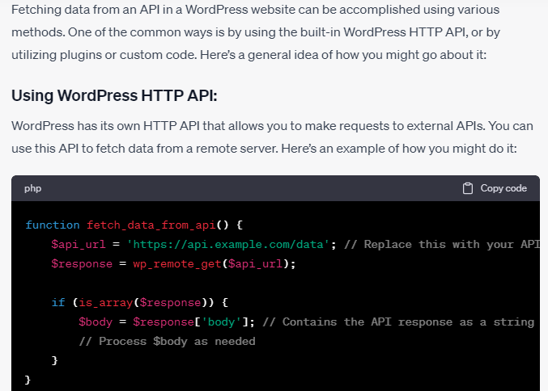**

### for adding data to an API server in WordPress using Basic Authentication or JWT token, you'll need to include the authentication details in your HTTP request headers. Here’s an example using Basic Authentication and JWT token with the WordPress HTTP API:

### 

### By JWT

### 

### 

### 

### 

### 

Fetch API in to interact with a RESTful API and want to add new data (perform a POST request),

**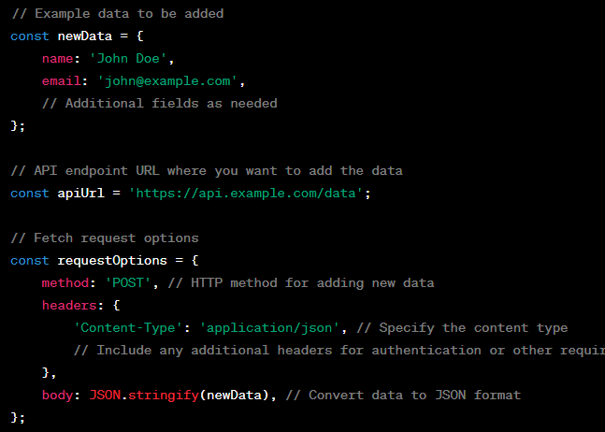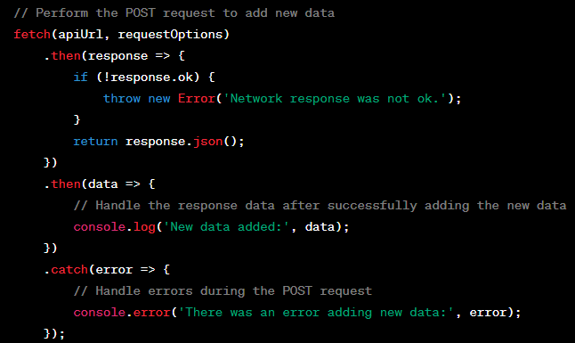**

**Wordpress Calling REST API**

[**https://www.youtube.com/watch?v=c8kBOWPKpyU**](https://www.youtube.com/watch?v=c8kBOWPKpyU)

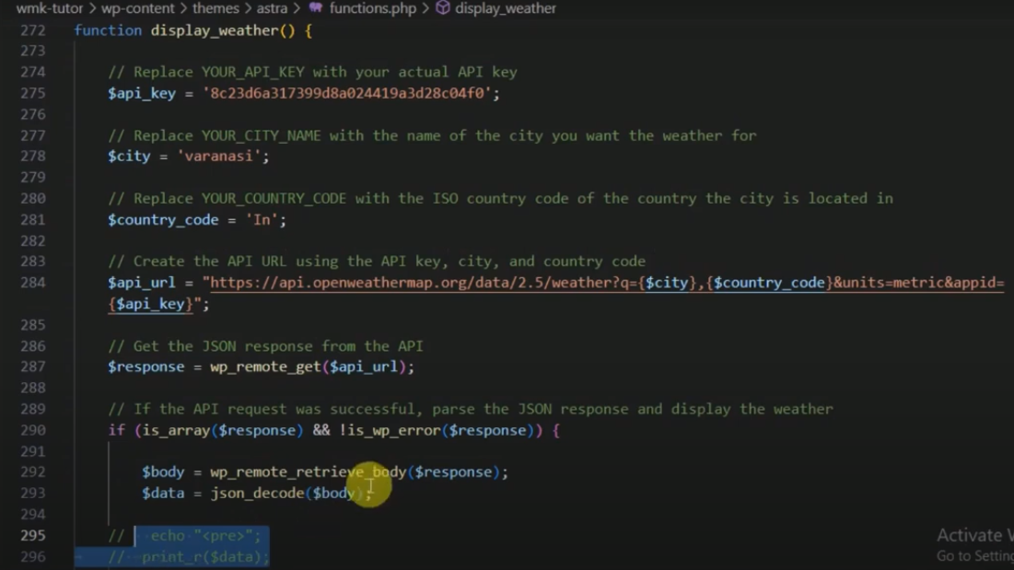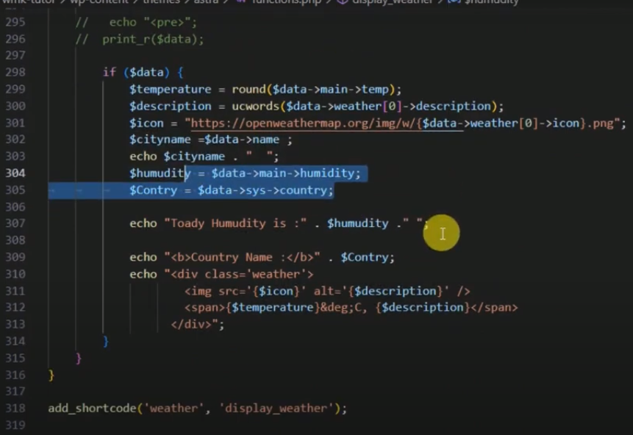

**JWT Autherntication.**

**First install JWT Autherntication plugin for REST API.**

**Second Configure plugin**

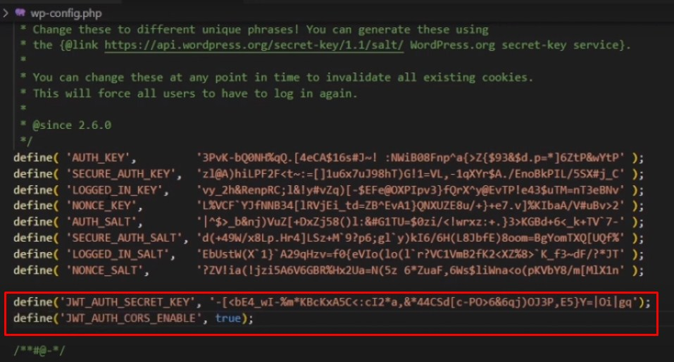

**Token Generation through Postman API Tool**

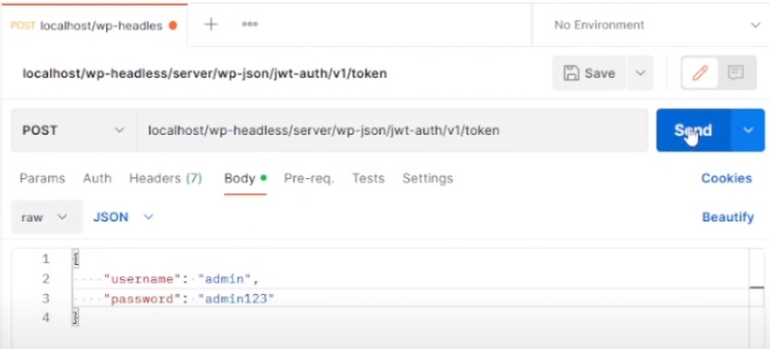

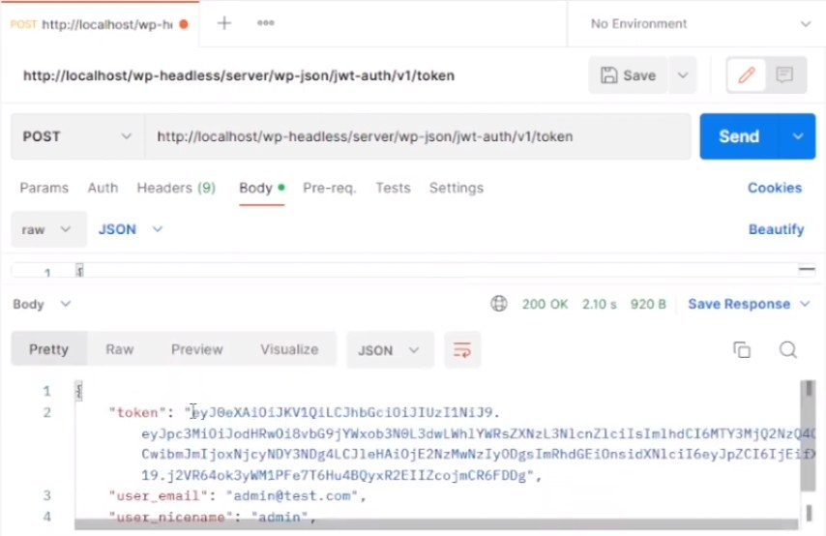

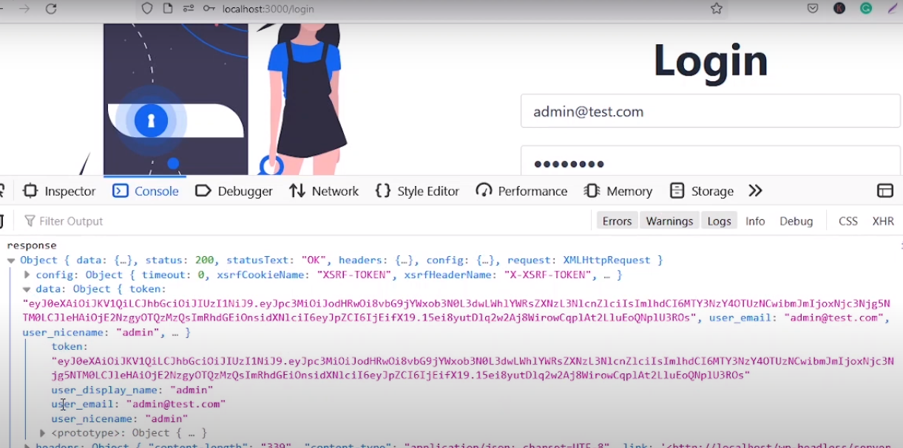

# [How to Add Custom Endpoints to WordPress API](https://artisansweb.net/how-to-add-custom-endpoints-to-wordpress-api/)

[**https://artisansweb.net/category/wordpress/**](https://artisansweb.net/category/wordpress/)

[**https://artisansweb.net/how-to-add-custom-endpoints-to-wordpress-api/**](https://artisansweb.net/how-to-add-custom-endpoints-to-wordpress-api/)

**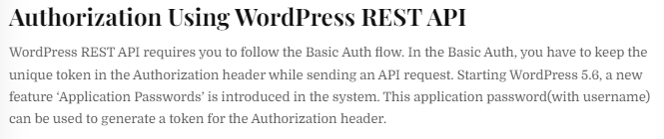**

**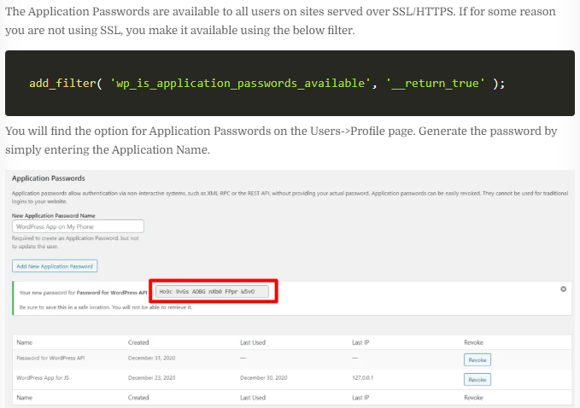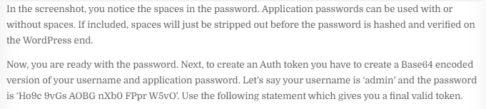**

**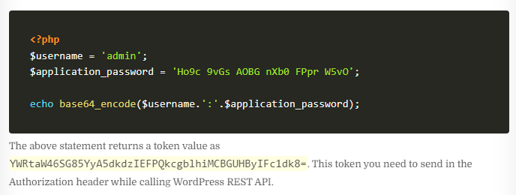**

**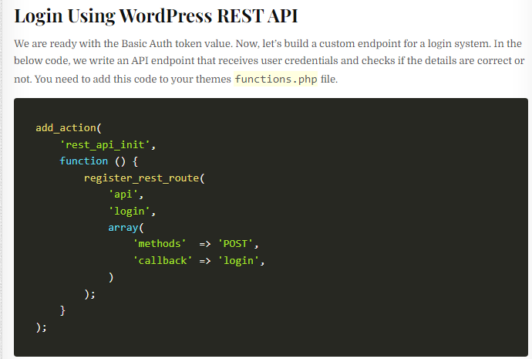**

****

**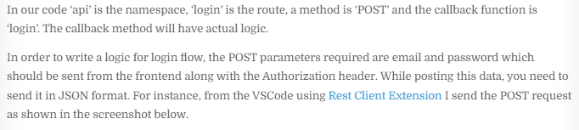**

**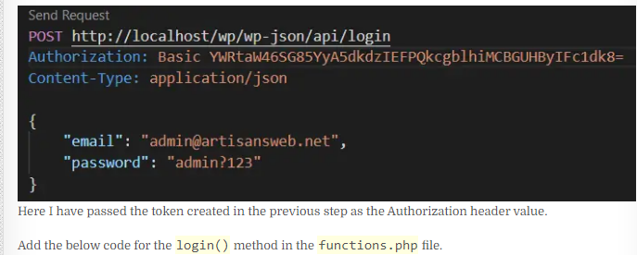**

**<?php**

**function login( WP\_REST\_Request $request ) {**

**$arr\_request = json\_decode( $request->get\_body() );**

**if ( ! empty( $arr\_request->email ) && ! empty( $arr\_request->password ) ) {**

**// this returns the user ID and other info from the user name.**

**$user = get\_user\_by( 'email', $arr\_request->email );**

**if ( ! $user ) {**

**// if the user name doesn't exist.**

**return [**

**'status' => 'error',**

**'message' => 'Wrong email address.',**

**];**

**}**

**// check the user's login with their password.**

**if ( ! wp\_check\_password( $arr\_request->password, $user->user\_pass, $user->ID ) ) {**

**// if the password is incorrect for the specified user.**

**return [**

**'status' => 'error',**

**'message' => 'Wrong password.',**

**];**

**}**

**return [**

**'status' => 'success',**

**'message' => 'User credentials are correct.',**

**];**

**} else {**

**return [**

**'status' => 'error',**

**'message' => 'Email and password are required.',**

**];**

**}**

**}**

**?>**

**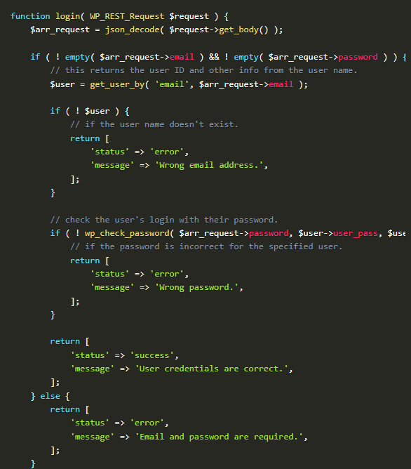**

**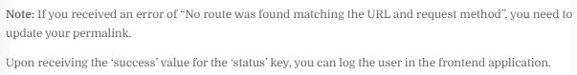**

**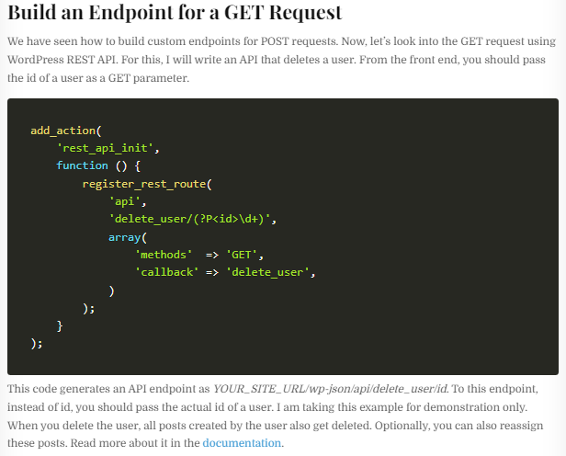**

**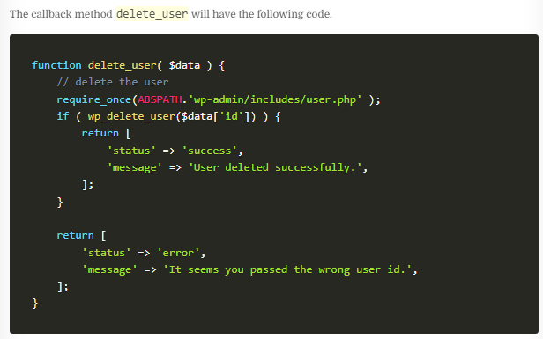**

**Custom Endpoint Tanuj para**

[**https://www.youtube.com/watch?v=-30MKlNDHrA&t=27s**](https://www.youtube.com/watch?v=-30MKlNDHrA&t=27s)

**<?php**

**/\***

**\* Plugin Name:       IWS Custom Code**

**\* Description:       Add custom code**

**\* Author:            Tanuj G. Patra**

**\* Version:           1.0.0**

**\* Requires at least: 5.2**

**\* Requires PHP:      5.6**

**\*/**

**remove\_filter('the\_excerpt', 'wpautop');**

**remove\_filter('the\_content', 'wpautop');**

**function iwsGetFeaturedImgSrc($obj, $fieldName, $request)**

**{**

**if ($obj['featured\_media']) {**

**$img = wp\_get\_attachment\_image\_src($obj['featured\_media'], 'full');**

**return $img[0];**

**}**

**return false;**

**}**

**function iwsCreatePostWithFeaturedImg($request) {**

**$params = $request->get\_params();**

**$title = sanitize\_text\_field($params['title']);**

**$content = wp\_kses\_post($params['content']);**

**$post = [**

**'post\_title' => $title,**

**'post\_content' => $content,**

**'post\_status' => 'publish',**

**'post\_type' => 'post'**

**];**

**$postId = wp\_insert\_post($post);**

**// Image upload**

**if (isset($\_FILES['featured\_img']) && !empty($\_FILES)) {**

**$img = $\_FILES['featured\_img'];**

**$img\_name = str\_replace(' ', '-', $title.'.'.explode('.', $img['name'])[1]);**

**$file = wp\_upload\_bits($img\_name, null, file\_get\_contents($img['tmp\_name']));**

**$fileType = wp\_check\_filetype($file['file'], null);**

**$attachmentData = [**

**'post\_mime\_type' => $fileType['type'],**

**'post\_title' => $img\_name,**

**'post\_content' => '',**

**'post\_status' => 'inherit'**

**];**

**$attachmentId = wp\_insert\_attachment($attachmentData, $file['file'], $postId);**

**set\_post\_thumbnail($postId, $attachmentId);**

**}**

**return [**

**'status' => 'success',**

**'post' => $postId**

**];**

**}**

**function iwsRegisterUser($request) {**

**$params = $request->get\_params();**

**$username = sanitize\_text\_field($params['username']);**

**$email = wp\_kses\_post($params['email']);**

**$password = wp\_kses\_post($params['password']);**

**$user = wp\_create\_user($username, $password, $email);**

**if (is\_wp\_error($user)) {**

**return ['status' => 'REGISTER\_FAILED', 'error', $user->get\_error\_message()];**

**}**

**return [**

**'user' => $user,**

**'starus' => 201,**

**];**

**}**

**add\_action('rest\_api\_init', function () {**

**register\_rest\_field('post', 'featured\_src', [**

**'get\_callback' => 'iwsGetFeaturedImgSrc',**

**]);**

**register\_rest\_route('wp/v2', 'create-post', [**

**'methods' => "POST",**

**'callback' => 'iwsCreatePostWithFeaturedImg'**

**]);**

**register\_rest\_route('wp/v2', 'register', [**

**'methods' => "POST",**

**'callback' => 'iwsRegisterUser'**

**]);**

**});**

**Wordpress official Custom Endpoint Method**

<https://developer.wordpress.org/rest-api/requests/>

**// Register our individual books endpoint.**

**function prefix\_register\_book\_route() {**

**register\_rest\_route( 'my-namespace/v1', '/books/(?P<id>\d+)', array(**

**// Supported methods for this endpoint. WP\_REST\_Server::READABLE translates to GET.**

**'methods' => WP\_REST\_Server::READABLE,**

**// Register the callback for the endpoint.**

**'callback' => 'prefix\_get\_book',**

**) );**

**}**

**add\_action( 'rest\_api\_init', 'prefix\_register\_book\_route' );**

**/\*\***

**\* Our registered endpoint callback. Notice how we are passing in $request as an argument.**

**\* By default, the WP\_REST\_Server will pass in the matched request object to our callback.**

**\***

**\* @param WP\_REST\_Request $request The current matched request object.**

**\*/**

**function prefix\_get\_book( $request ) {**

**// Here we are accessing the path variable 'id' from the $request.**

**$book = prefix\_get\_the\_book( $request['id'] );**

**return rest\_ensure\_response( $book );**

**}**

**// A simple function that grabs a book title from our books by ID.**

**function prefix\_get\_the\_book( $id ) {**

**$books = array(**

**'Design Patterns',**

**'Clean Code',**

**'Refactoring',**

**'Structure and Interpretation of Computer Programs',**

**);**

**$book = '';**

**if ( isset( $books[ $id ] ) ) {**

**// Grab the matching book.**

**$book = $books[ $id ];**

**} else {**

**// Error handling.**

**return new WP\_Error( 'rest\_not\_found', esc\_html\_\_( 'The book does not exist', 'my-text-domain' ), array( 'status' => 404 ) );**

**}**

**return $book;**

**}**

Query parameters exist in the query string portion of a URI. The query string portion of a URI in https://ourawesomesite.com/wp-json/my-namespace/v1/books?per\_page=2&genre=fiction` is?per\_page=2&genre=fiction. The query string is started by the '?' character, the different values within the query string are separated by the '&' character. We specified two parameters in our query string;per\_pageandgenre. In our endpoint we would want to grab only two books from the fiction genre. We could access those values in a callback like this:$request[‘per\_page’], and$request[‘genre’]` ( assuming $request is the name of the argument we are using ). If you are familiar with PHP you have probably used query parameters in your web applications.

**// Register our individual books endpoint.**

**function prefix\_register\_book\_route() {**

**register\_rest\_route( 'my-namespace/v1', '/books/(?P<id>\d+)', array(**

**// Supported methods for this endpoint. WP\_REST\_Server::READABLE translates to GET.**

**'methods' => WP\_REST\_Server::READABLE,**

**// Register the callback for the endpoint.**

**'callback' => 'prefix\_get\_book',**

**) );**

**}**

**add\_action( 'rest\_api\_init', 'prefix\_register\_book\_route' );**

**/\*\***

**\* Our registered endpoint callback. Notice how we are passing in $request as an argument.**

**\* By default, the WP\_REST\_Server will pass in the matched request object to our callback.**

**\***

**\* @param WP\_REST\_Request $request The current matched request object.**

**\*/**

**function prefix\_get\_book( $request ) {**

**// Here we are accessing the path variable 'id' from the $request.**

**$book = prefix\_get\_the\_book( $request['id'] );**

**return rest\_ensure\_response( $book );**

**}**

**// A simple function that grabs a book title from our books by ID.**

**function prefix\_get\_the\_book( $id ) {**

**$books = array(**

**'Design Patterns',**

**'Clean Code',**

**'Refactoring',**

**'Structure and Interpretation of Computer Programs',**

**);**

**$book = '';**

**if ( isset( $books[ $id ] ) ) {**

**// Grab the matching book.**

**$book = $books[ $id ];**

**} else {**

**// Error handling.**

**return new WP\_Error( 'rest\_not\_found', esc\_html\_\_( 'The book does not exist', 'my-text-domain' ), array( 'status' => 404 ) );**

**}**

**return $book;**

**}**

**Custom end point**

<https://developer.wordpress.org/rest-api/extending-the-rest-api/adding-custom-endpoints/>

**<?php**

**add\_action( 'rest\_api\_init', function () {**

**register\_rest\_route( 'myplugin/v1', '/author/(?P<id>\d+)', array(**

**'methods' => 'GET',**

**'callback' => 'my\_awesome\_func',**

**) );**

**} );**

## [Creating Endpoints](https://developer.wordpress.org/rest-api/extending-the-rest-api/routes-and-endpoints/#creating-endpoints)

<https://developer.wordpress.org/rest-api/extending-the-rest-api/routes-and-endpoints/>

<https://developer.wordpress.org/rest-api/reference/categories/>

<https://developer.wordpress.org/rest-api/reference/pages/>

<https://developer.wordpress.org/rest-api/reference/posts/>

<https://developer.wordpress.org/rest-api/reference/application-passwords/>

If we wanted to create an endpoint that would return the phrase “Hello World, this is the WordPress REST API” when it receives a GET request, we would first need to register the route for that endpoint. To register routes you should use the register\_rest\_route() function. It needs to be called on the rest\_api\_init action hook. register\_rest\_route() handles all of the mapping for routes to endpoints. Let’s try to create a “Hello World, this is the WordPress REST API” route.

**/\*\***

**\* This is our callback function that embeds our phrase in a WP\_REST\_Response**

**\*/**

**function prefix\_get\_endpoint\_phrase() {**

**// rest\_ensure\_response() wraps the data we want to return into a WP\_REST\_Response, and ensures it will be properly returned.**

**return rest\_ensure\_response( 'Hello World, this is the WordPress REST API' );**

**}**

**/\*\***

**\* This function is where we register our routes for our example endpoint.**

**\*/**

**function prefix\_register\_example\_routes() {**

**// register\_rest\_route() handles more arguments but we are going to stick to the basics for now.**

**register\_rest\_route( 'hello-world/v1', '/phrase', array(**

**// By using this constant we ensure that when the WP\_REST\_Server changes our readable endpoints will work as intended.**

**'methods'  => WP\_REST\_Server::READABLE,**

**// Here we register our callback. The callback is fired when this endpoint is matched by the WP\_REST\_Server class.**

**'callback' => 'prefix\_get\_endpoint\_phrase',**

**) );**

**}**

**add\_action( 'rest\_api\_init', 'prefix\_register\_example\_routes' );**

### [HTTP Methods](https://developer.wordpress.org/rest-api/extending-the-rest-api/routes-and-endpoints/#http-methods)

HTTP methods are sometimes referred to as HTTP verbs. They are simply just different ways to communicate via HTTP. The main ones used by the WordPress REST API are:

* **GET should be used for retrieving data from the API.**
* **POST should be used for creating new resources (i.e users, posts, taxonomies).**
* **PUT should be used for updating resources.**
* **DELETE should be used for deleting resources.**
* **OPTIONS should be used to provide context about our resources.**

### Vishal API Creation

### C:\Users\Rajiv\Desktop\Screenshot_1.jpg

### C:\Users\Rajiv\Desktop\Screenshot_2.jpg

### C:\Users\Rajiv\Desktop\Screenshot_4.jpg

### C:\Users\Rajiv\Desktop\Screenshot_5.jpg

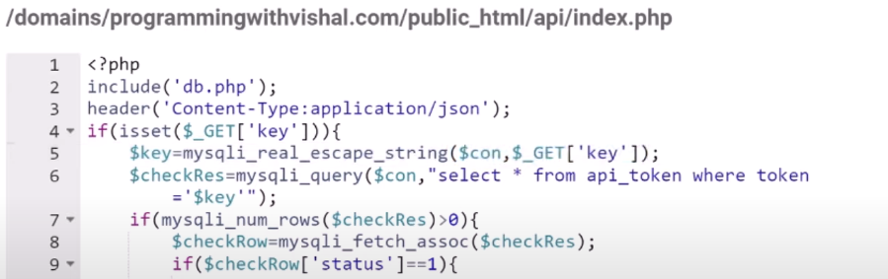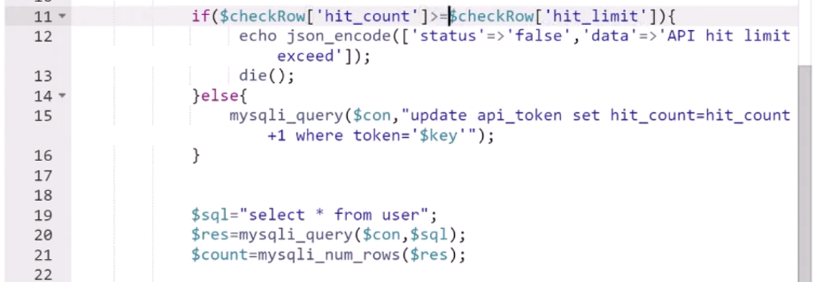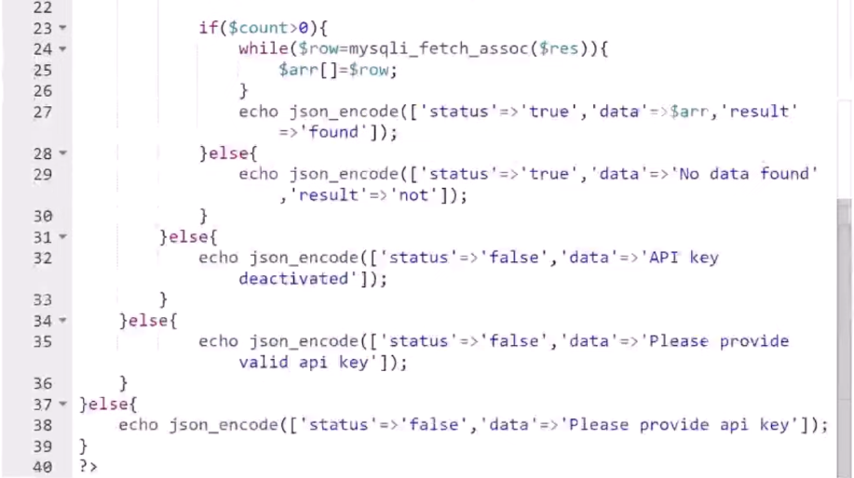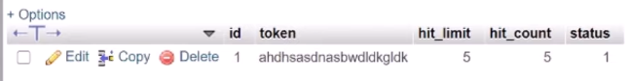

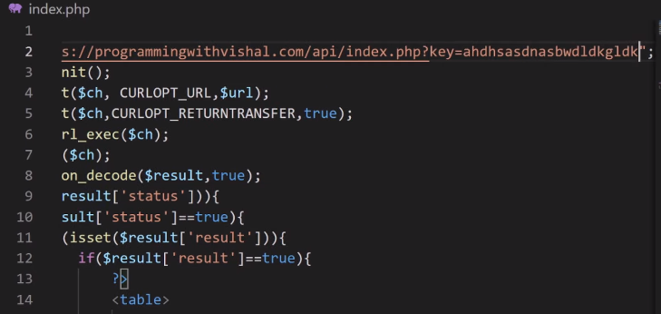

### Vishal Complete API CRED with Token Auth

### 

### 

**API token.php** 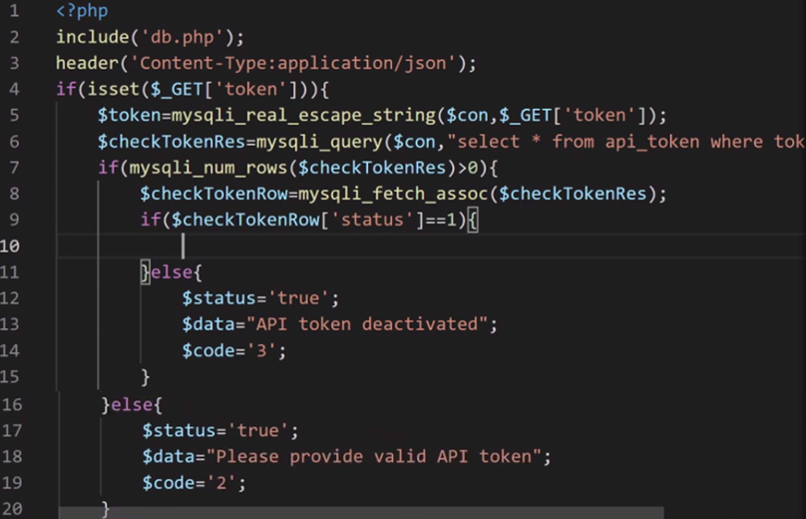

**API insert.php** 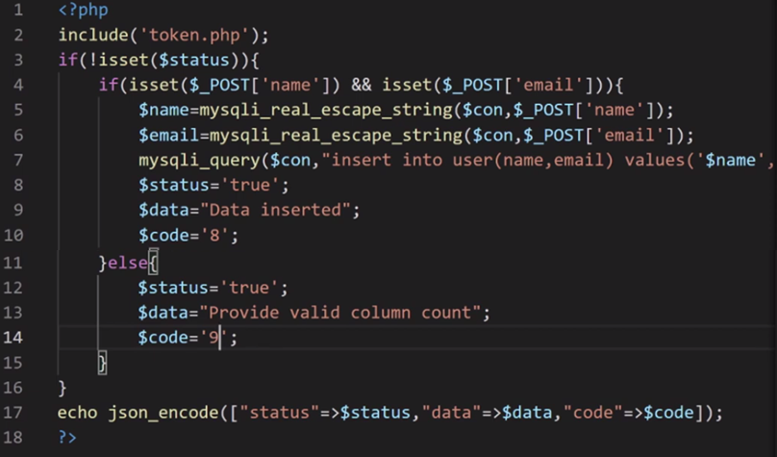

**API delete.php**

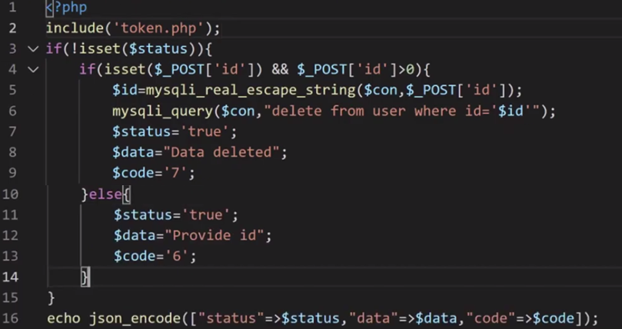

**Consumer delete.php**

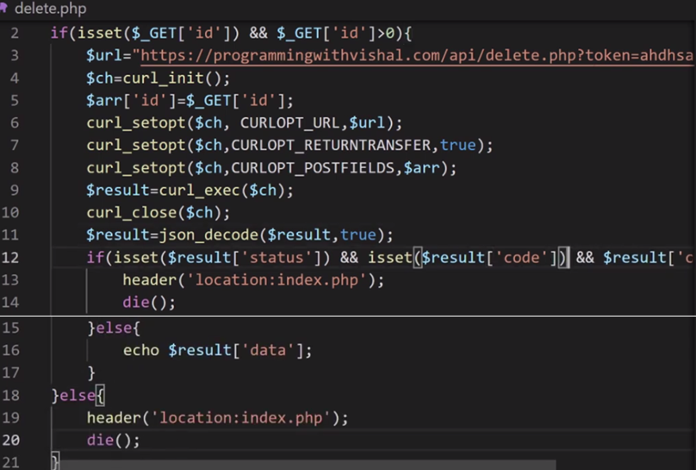

**API db.php**

**<?php**

**$con=mysqli\_connect('localhost','username','password','db');**

**?>**

**API token.php**

**<?php**

**include('db.php');**

**header('Content-Type:application/json');**

**if(isset($\_GET['token'])){**

**$token=mysqli\_real\_escape\_string($con,$\_GET['token']);**

**$checkTokenRes=mysqli\_query($con,"select \* from api\_token where token='$token'");**

**if(mysqli\_num\_rows($checkTokenRes)>0){**

**$checkTokenRow=mysqli\_fetch\_assoc($checkTokenRes);**

**if($checkTokenRow['status']==1){**

**}else{**

**$status='true';**

**$data="API token deactivated";**

**$code='3';**

**}**

**}else{**

**$status='true';**

**$data="Please provide valid API token";**

**$code='2';**

**}**

**}else{**

**$status='true';**

**$data="Please provide API token";**

**$code='1';**

**}**

**?>**

**API index.php**

**<?php**

**include('token.php');**

**if(!isset($status)){**

**$sql="select \* from user ";**

**if(isset($\_GET['id']) && $\_GET['id']>0){**

**$id=mysqli\_real\_escape\_string($con,$\_GET['id']);**

**$sql.=" where id='$id'";**

**}**

**$sqlRes=mysqli\_query($con,$sql);**

**if(mysqli\_num\_rows($sqlRes)>0){**

**$data=[];**

**while($row=mysqli\_fetch\_assoc($sqlRes)){**

**$data[]=$row;**

**}**

**$status='true';**

**$code='5';**

**}else{**

**$status='true';**

**$data="Data not found";**

**$code='4';**

**}**

**}**

**echo json\_encode(["status"=>$status,"data"=>$data,"code"=>$code]);**

**?>**

**API delete.php**

**<?php**

**include('token.php');**

**if(!isset($status)){**

**if(isset($\_POST['id']) && $\_POST['id']>0){**

**$id=mysqli\_real\_escape\_string($con,$\_POST['id']);**

**mysqli\_query($con,"delete from user where id='$id'");**

**$status='true';**

**$data="Data deleted";**

**$code='7';**

**}else{**

**$status='true';**

**$data="Provide id";**

**$code='6';**

**}**

**}**

**echo json\_encode(["status"=>$status,"data"=>$data,"code"=>$code]);**

**?>**

**API manage\_form.php**

**<?php**

**include('token.php');**

**if(!isset($status)){**

**if(isset($\_POST['name']) && isset($\_POST['email'])){**

**$name=mysqli\_real\_escape\_string($con,$\_POST['name']);**

**$email=mysqli\_real\_escape\_string($con,$\_POST['email']);**

**if(isset($\_GET['id']) && $\_GET['id']>0){**

**$id=mysqli\_real\_escape\_string($con,$\_GET['id']);**

**mysqli\_query($con,"update user set name='$name', email='$email' where id='$id'");**

**$data="Data updated";**

**$code='10';**

**}else{**

**mysqli\_query($con,"insert into user(name,email) values('$name','$email')");**

**$data="Data inserted";**

**$code='8';**

**}**

**$status='true';**

**}else{**

**$status='true';**

**$data="Provide valid column count";**

**$code='9';**

**}**

**}**

**echo json\_encode(["status"=>$status,"data"=>$data,"code"=>$code]);**

**?>**

**API Respone Code**

**1=>Please provide API token**

**2=>Please provide valid API token**

**3=>API token deactivated**

**4=>Data not found**

**5=>Data Return**

**6=>Provide id**

**7=>Data deleted**

**8=>Data Inserted**

**9=>Provide valid column count**

**10=>Data updated**

**Consumer form.php**

**<?php**

**$msg="";**

**$name="";**

**$email="";**

**if(isset($\_POST['submit'])){**

**$arr['name']=$\_POST['name'];**

**$arr['email']=$\_POST['email'];**

**$id="";**

**if(isset($\_GET['id']) && $\_GET['id']>0){**

**$id=$\_GET['id'];**

**}**

**$url="api\_url/manage\_form.php?token=ahdhsasdnasbwdldkgldk&id=".$id;**

**$ch=curl\_init();**

**curl\_setopt($ch, CURLOPT\_URL,$url);**

**curl\_setopt($ch,CURLOPT\_RETURNTRANSFER,true);**

**curl\_setopt($ch,CURLOPT\_POSTFIELDS,$arr);**

**$result=curl\_exec($ch);**

**curl\_close($ch);**

**$result=json\_decode($result,true);**

**$msg=$result['data'];**

**}**

**if(isset($\_GET['id']) && $\_GET['id']>0){**

**$url="https://programmingwithvishal.com/api/index.php?token=ahdhsasdnasbwdldkgldk&id=".$\_GET['id'];**

**$ch=curl\_init();**

**curl\_setopt($ch, CURLOPT\_URL,$url);**

**curl\_setopt($ch,CURLOPT\_RETURNTRANSFER,true);**

**$result=curl\_exec($ch);**

**curl\_close($ch);**

**$result=json\_decode($result,true);**

**if(isset($result['status']) && isset($result['code']) && $result['code']==5){**

**$name=$result['data']['0']['name'];**

**$email=$result['data']['0']['email'];**

**}else{**

**header('location:index.php');**

**die();**

**}**

**}**

**?>**

**<!DOCTYPE html>**

**<html lang="en">**

**<head>**

**<meta charset="utf-8">**

**<title>API Crud Operation</title>**

**<meta name="viewport" content="width=device-width, initial-scale=1">**

**<link rel="stylesheet" href="https://maxcdn.bootstrapcdn.com/bootstrap/3.4.1/css/bootstrap.min.css">**

**<script src="https://ajax.googleapis.com/ajax/libs/jquery/3.5.1/jquery.min.js"></script>**

**<script src="https://maxcdn.bootstrapcdn.com/bootstrap/3.4.1/js/bootstrap.min.js"></script>**

**<link rel="stylesheet" href="https://fonts.googleapis.com/icon?family=Material+Icons">**

**<link rel="stylesheet" href="https://maxcdn.bootstrapcdn.com/font-awesome/4.7.0/css/font-awesome.min.css">**

**<link rel="stylesheet" href="css/style.css">**

**</head>**

**<body>**

**<div class="container-xl">**

**<div class="table-responsive">**

**<div class="table-wrapper">**

**<div class="table-title">**

**<div class="row">**

**<div class="col-sm-5">**

**<h2>Manage User</h2>**

**</div>**

**<div class="col-sm-7">**

**<a href="index.php" class="btn btn-secondary"><i class="material-icons arrow\_back">&#xe5c4;</i> <span>Back</span></a>**

**</div>**

**</div>**

**</div>**

**</div>**

**</div>**

**<div class="row" id="form\_bg">**

**<?php echo $msg?>**

**<form method="post">**

**<div class="col-sm-4">**

**<div class="form-group">**

**<input type="name" class="form-control" id="name" name="name" placeholder="Enter name" required value="<?php echo $name?>">**

**</div>**

**</div>**

**<div class="col-sm-4">**

**<div class="form-group">**

**<input type="email" class="form-control" id="nombre" name="email" placeholder="Enter email" required value="<?php echo $email?>">**

**</div>**

**</div>**

**<div class="col-sm-1">**

**<div class="form-group">**

**<input type="submit" value="Submit" class="btn btn-info btn-block" name="submit">**

**</div>**

**</div>**

**</form>**

**</div>**

**</div>**

**</body>**

**</html>**

**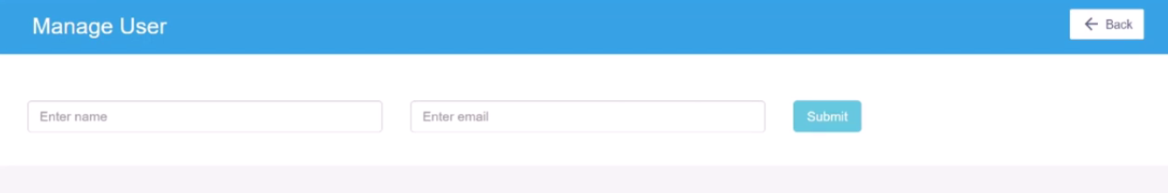**

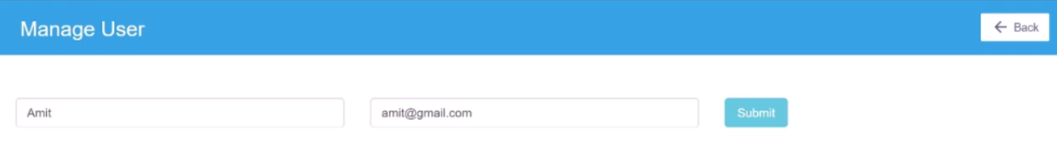

**Consumer index.php**

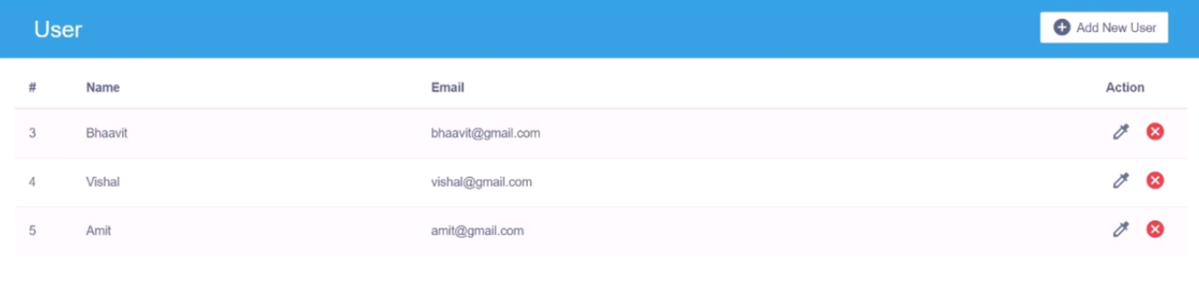

**<?php**

**$url="api\_url/index.php?token=ahdhsasdnasbwdldkgldk";**

**$ch=curl\_init();**

**curl\_setopt($ch, CURLOPT\_URL,$url);**

**curl\_setopt($ch,CURLOPT\_RETURNTRANSFER,true);**

**$result=curl\_exec($ch);**

**curl\_close($ch);**

**$result=json\_decode($result,true);**

**?>**

**<!DOCTYPE html>**

**<html lang="en">**

**<head>**

**<meta charset="utf-8">**

**<title>API Crud Operation</title>**

**<meta name="viewport" content="width=device-width, initial-scale=1">**

**<link rel="stylesheet" href="https://maxcdn.bootstrapcdn.com/bootstrap/3.4.1/css/bootstrap.min.css">**

**<script src="https://ajax.googleapis.com/ajax/libs/jquery/3.5.1/jquery.min.js"></script>**

**<script src="https://maxcdn.bootstrapcdn.com/bootstrap/3.4.1/js/bootstrap.min.js"></script>**

**<link rel="stylesheet" href="https://fonts.googleapis.com/icon?family=Material+Icons">**

**<link rel="stylesheet" href="https://maxcdn.bootstrapcdn.com/font-awesome/4.7.0/css/font-awesome.min.css">**

**<link rel="stylesheet" href="css/style.css">**

**<script>**

**$(document).ready(function(){**

**$('[data-toggle="tooltip"]').tooltip();**

**});**

**</script>**

**</head>**

**<body>**

**<div class="container-xl">**

**<div class="table-responsive">**

**<div class="table-wrapper">**

**<div class="table-title">**

**<div class="row">**

**<div class="col-sm-5">**

**<h2>User</h2>**

**</div>**

**<div class="col-sm-7">**

**<a href="form.php" class="btn btn-secondary"><i class="material-icons">&#xE147;</i> <span>Add New User</span></a>**

**</div>**

**</div>**

**</div>**

**<?php**

**if(isset($result['status']) && isset($result['code']) && $result['code']==5){**

**?>**

**<table class="table table-striped table-hover">**

**<thead>**

**<tr>**

**<th>#</th>**

**<th>Name</th>**

**<th>Email</th>**

**<th>Action</th>**

**</tr>**

**</thead>**

**<tbody>**

**<?php**

**foreach($result['data'] as $list){**

**?>**

**<tr>**

**<td><?php echo $list['id']?></td>**

**<td><?php echo $list['name']?></a></td>**

**<td><?php echo $list['email']?></td>**

**<td>**

**<a href="form.php?id=<?php echo $list['id']?>" class="edit" title="Edit"><i class="material-icons colorize">&#xe3b8;</i></a>**

**<a href="delete.php?id=<?php echo $list['id']?>" class="delete" title="Delete" ><i class="material-icons">&#xE5C9;</i></a>**

**</td>**

**</tr>**

**<?php**

**}**

**?>**

**</tbody>**

**</table>**

**<?php**

**}else{**

**echo $result['data'];**

**}**

**?>**

**</div>**

**</div>**

**</div>**

**</body>**

**</html>**

**Consumer delete.php**

**<?php**

**if(isset($\_GET['id']) && $\_GET['id']>0){**

**$url="api\_url/delete.php?token=ahdhsasdnasbwdldkgldk";**

**$ch=curl\_init();**

**$arr['id']=$\_GET['id'];**

**curl\_setopt($ch, CURLOPT\_URL,$url);**

**curl\_setopt($ch,CURLOPT\_RETURNTRANSFER,true);**

**curl\_setopt($ch,CURLOPT\_POSTFIELDS,$arr);**

**$result=curl\_exec($ch);**

**curl\_close($ch);**

**$result=json\_decode($result,true);**

**if(isset($result['status']) && isset($result['code']) && $result['code']==7){**

**header('location:index.php');**

**die();**

**}else{**

**echo $result['data'];**

**}**

**}else{**

**header('location:index.php');**

**die();**

**}**

**?>**

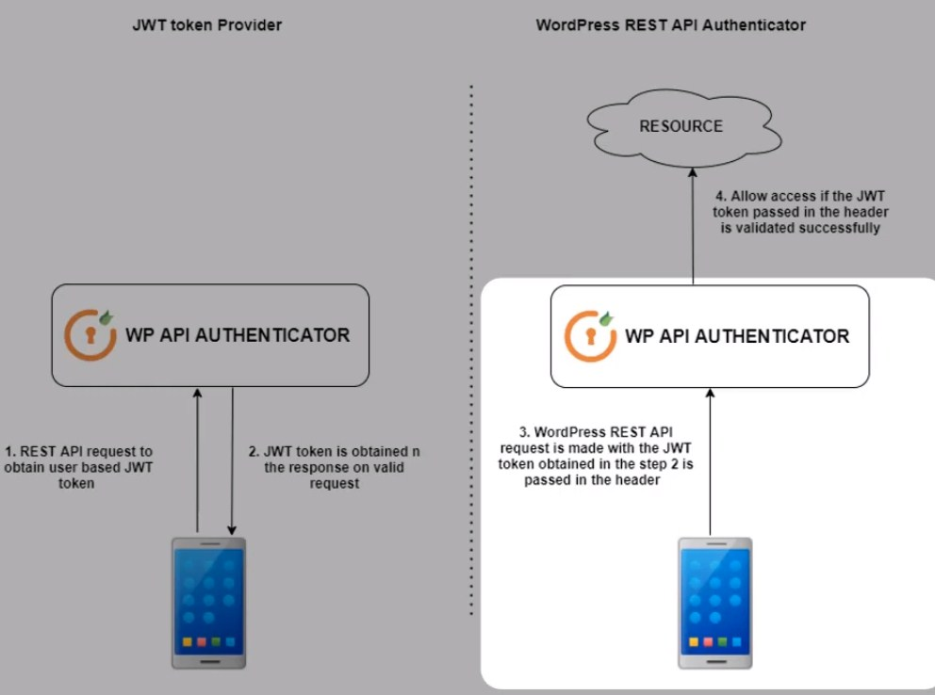

Rest API basic authentication in WordPress

In WordPress, you can use the HTTP API to make requests to a REST API that requires basic authentication. You can use the wp\_remote\_request() function with the appropriate authentication headers. For instance:

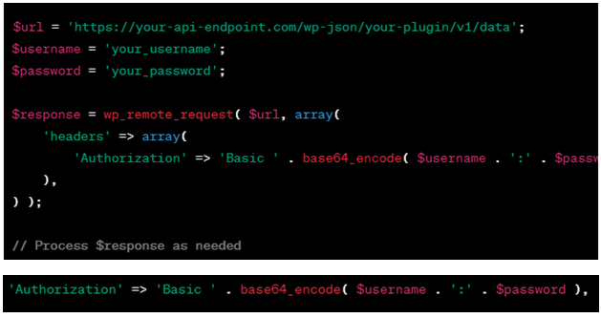

Jwt token authentication in rest API in WordPress

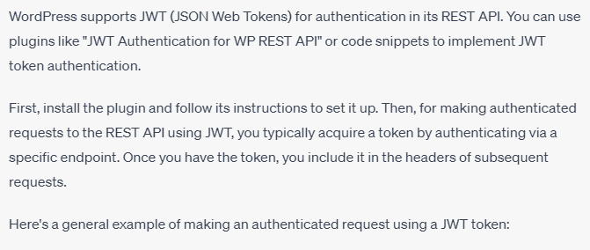

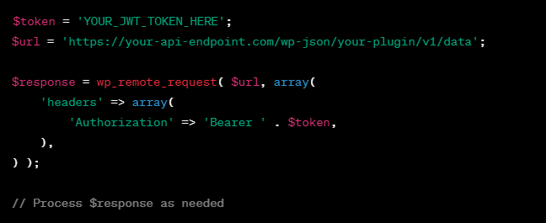

Basic authentication in PHP involves sending an HTTP request with the appropriate headers that include a username and password. Here's an example using PHP's cURL, a popular way to make HTTP requests:

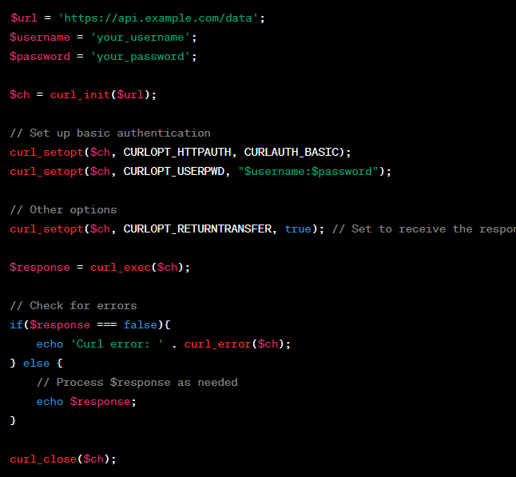

To fetch all posts from a WordPress site using the REST API, you can make a GET request to the wp/v2/posts endpoint. Here's an example using PHP's cURL:

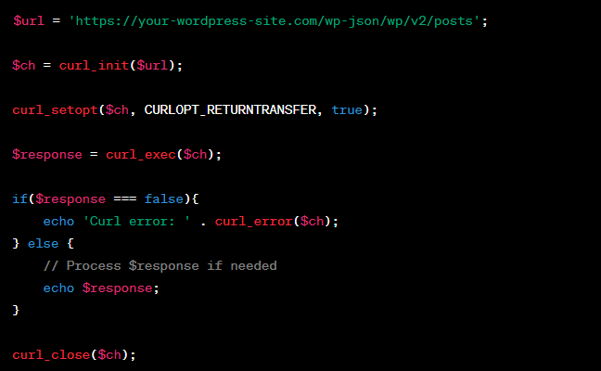

By wordpress

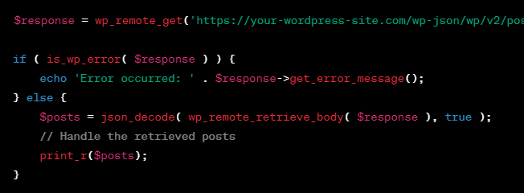

By Jquery method, To fetch all posts from a WordPress site using the REST API,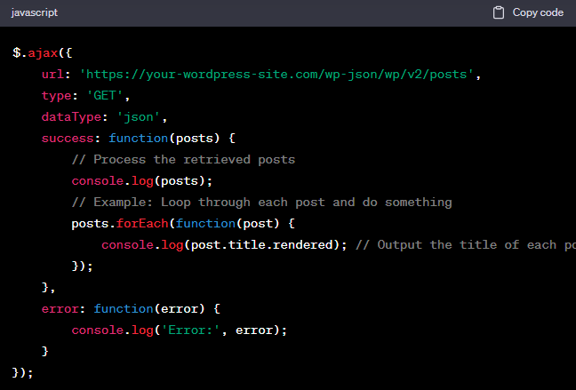

How to add new post in wordpress by rest api

Adding a new post in WordPress using the REST API involves sending a POST request to the wp/v2/posts endpoint with the necessary post data. You'll need to include specific headers, authentication, and the post content in your request.

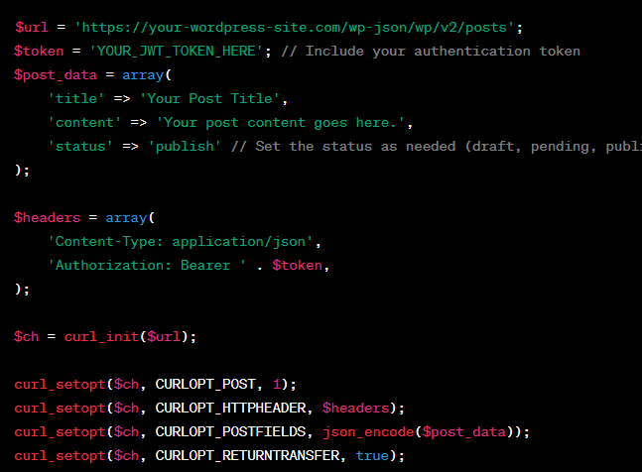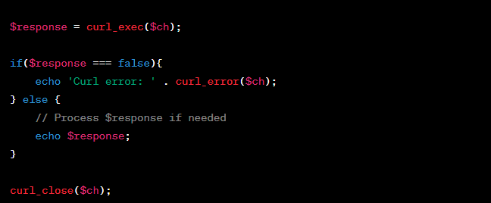

How to add new post in wordpress by rest api by jquery ajax

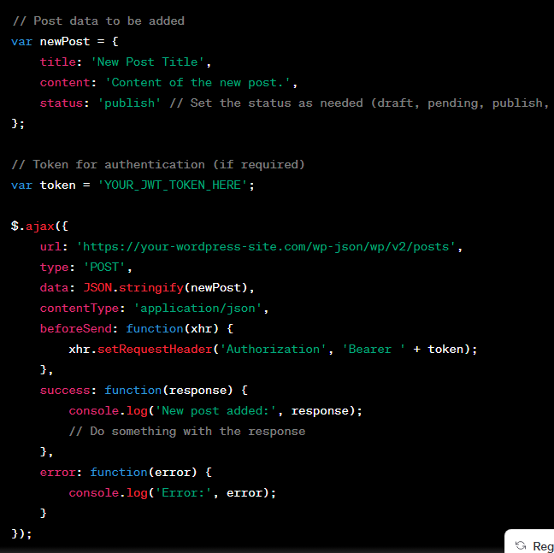

By wordpress

Another way

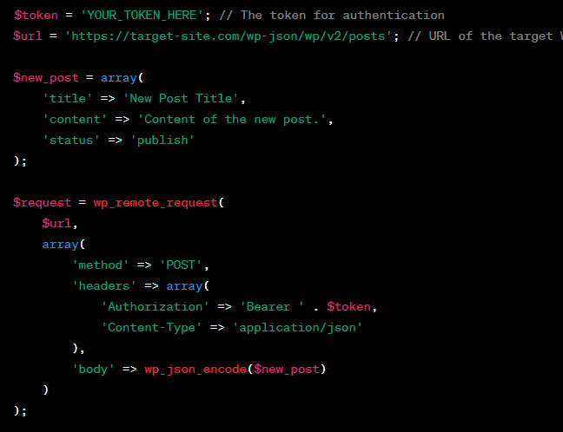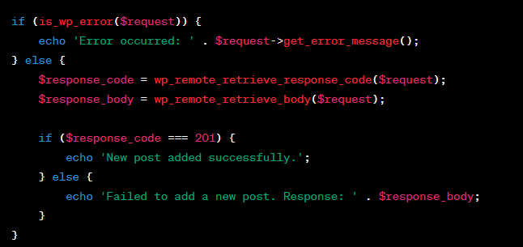

Another way

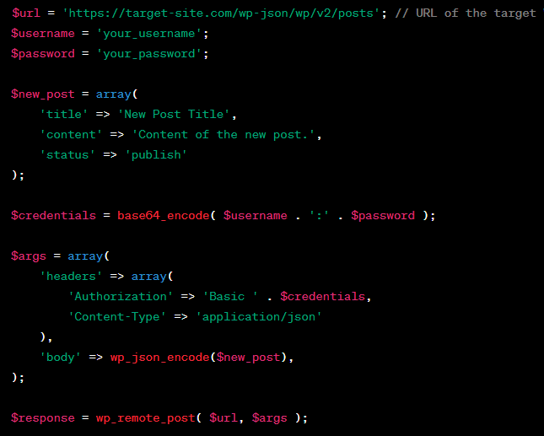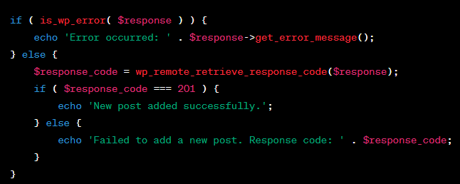

To delete a specific post in WordPress using the REST API

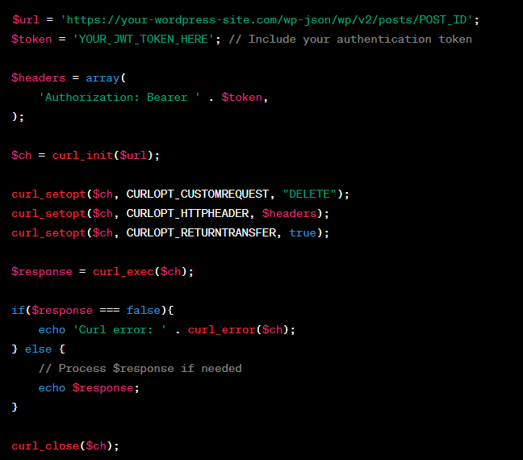

To delete specific post in wp by rest api by jquery ajax

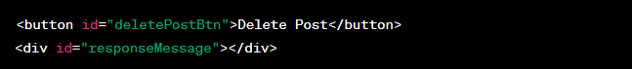

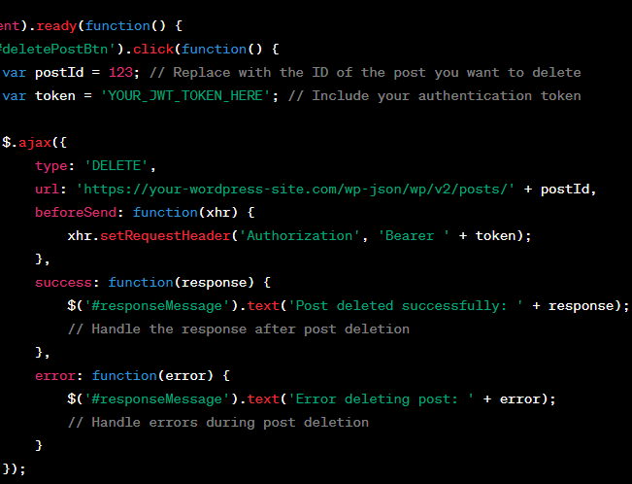

To update specific post in wp by rest api

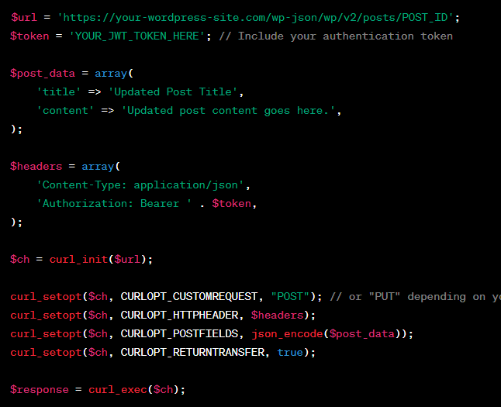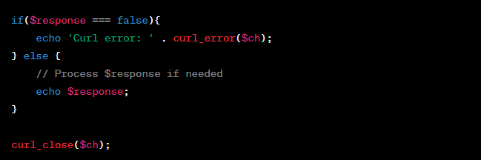

To update specific post in wp by rest api by jquery



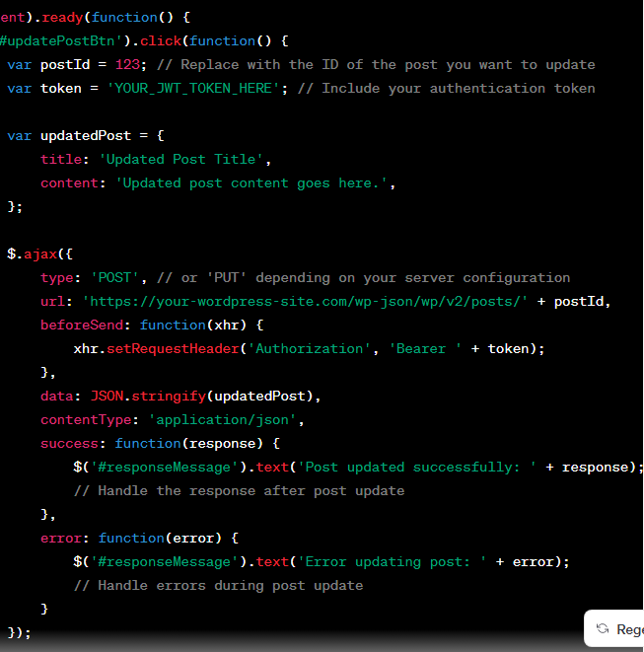

How to fetch all user of wordpress in through rest api by js

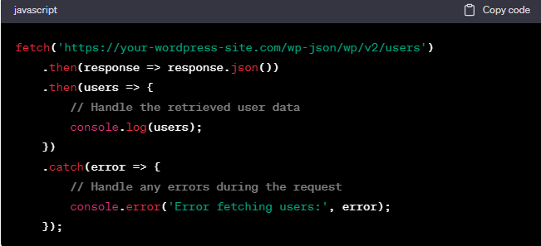

By Jquery

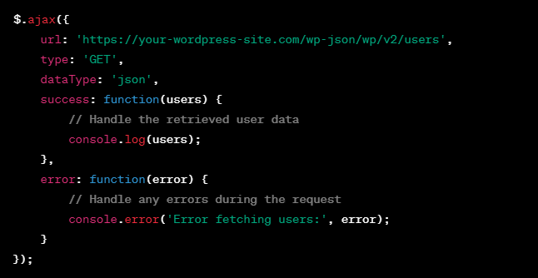

By php curl

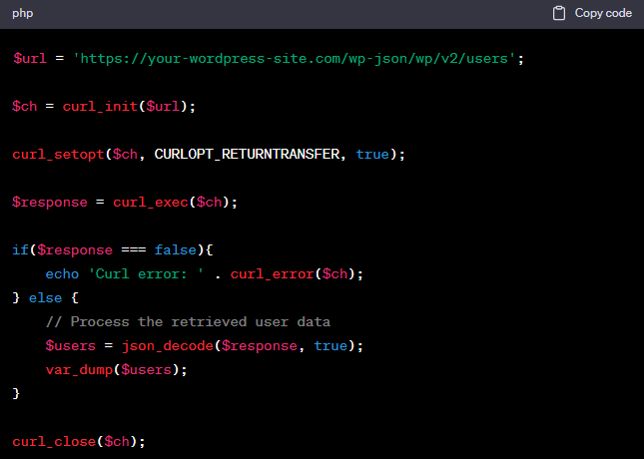

How to create user in wp through rest api by php curl

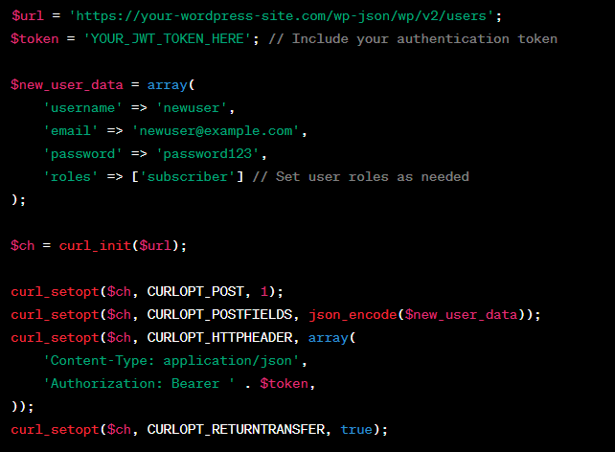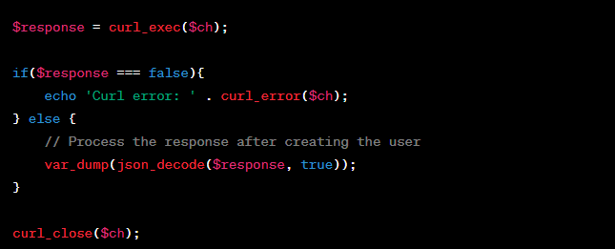

By Jquery



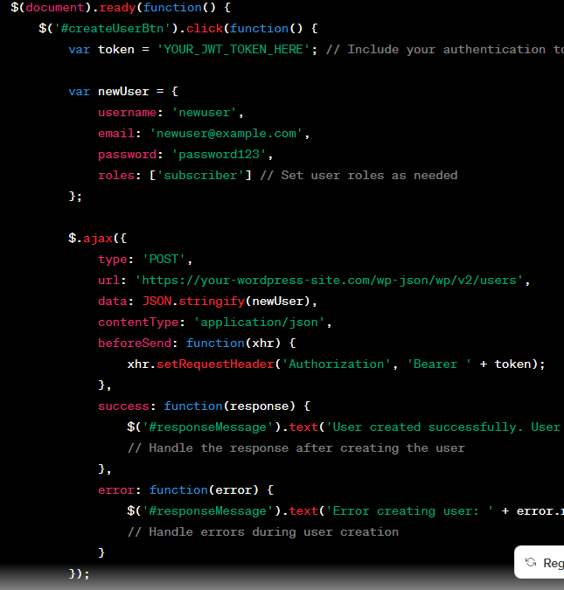



### Complete Rest API

### <https://tutorialsclass.com/php-rest-api-file_get_contents/>

### <https://dummy.restapiexample.com/>

### 

### 

### 

### 

### 

### 

### 

### 

### 

### 

### 

### 

**Disable WordPress REST API**

add\_filter( 'json\_enabled', '\_\_return\_false' ); add\_filter( 'json\_jsonp\_enabled', '\_\_return\_false' );

**Here's how to get and use REST API endpoints in WordPress**

In WordPress, you can access the REST API endpoints by default without any additional configuration. The REST API is enabled by default in recent WordPress versions, and it provides access to various data and functionalities within your WordPress site

**Explore Available Endpoints**: You can explore the available REST API endpoints by visiting the following URL in your browser

[**http://yourwordpresssite.com/wp-json/**](http://yourwordpresssite.com/wp-json/)

This will give you a list of available routes and endpoints. You can navigate through this structure to find the specific endpoint you want to use

**Retrieve Data from an Endpoint**

To retrieve data from a specific endpoint, you can use the wp\_remote\_get() function in WordPress. Here's an example of how to use it to retrieve data from the REST API

**// Define the API endpoint URL**

**$api\_url = 'http://yourwordpresssite.com/wp-json/wp/v2/posts';**

**// Make the API request**

**$response = wp\_remote\_get($api\_url);**

**// Check if the request was successful**

**if (is\_array($response) && !is\_wp\_error($response)) {**

**// Parse the JSON response**

**$data = json\_decode(wp\_remote\_retrieve\_body($response));**

**// Process and use the data as needed**

**foreach ($data as $post) {**

**echo 'Title: ' . $post->title->rendered . '<br>';**

**echo 'Content: ' . $post->content->rendered . '<br>';**

**}**

**}**

In the code above, we are making a GET request to the /wp-json/wp/v2/posts endpoint to retrieve a list of posts. You can replace this endpoint with the one you need.

**Authentication and Permissions:** Some REST API endpoints may require authentication or have different permission levels. You may need to provide authentication credentials or set up custom endpoints with specific permissions if necessary.

**Customizing and Extending Endpoints:** WordPress allows you to customize and extend REST API endpoints to suit your specific needs. You can create custom endpoints using the register\_rest\_route() function in your theme's functions.php file or a custom plugin. This allows you to define your own routes and callback functions for handling API requests.

Here's an example of registering a custom REST API endpoint:

**function custom\_api\_route() {**

**register\_rest\_route('custom/v1', 'my-endpoint', array(**

**'methods' => 'GET',**

**'callback' => 'my\_custom\_callback',**

**));**

**}**

**function my\_custom\_callback($data) {**

**// Your custom logic here**

**return array('message' => 'Custom API endpoint response');**

**}**

**add\_action('rest\_api\_init', 'custom\_api\_route');**

In this example, we've registered a custom endpoint at /wp-json/custom/v1/my-endpoint. When you make a GET request to this endpoint, it will trigger the my\_custom\_callback function and return a custom response.

**To call a REST API in WordPress,**

you can use the built-in functions and classes provided by WordPress. Here's a step-by-step guide on how to call a REST API in WordPress:

**1.Determine the API Endpoint:**

Identify the REST API endpoint you want to call. WordPress provides several REST API endpoints for different resources, such as posts, pages, users, and custom endpoints created by plugins or themes.

**2.Use the WP HTTP API:**

WordPress provides the WP HTTP API, which is a set of functions and classes for making HTTP requests. The WP HTTP API supports various HTTP methods like GET, POST, PUT, and DELETE.

Here's an example of how to make a GET request to a REST API endpoint using the WP HTTP API:

**// Make a GET request to the REST API endpoint**

**$response = wp\_remote\_get('https://example.com/wp-json/wp/v2/posts');**

**// Check if the request was successful**

**if (is\_wp\_error($response)) {**

**$error\_message = $response->get\_error\_message();**

**echo "Error: $error\_message";**

**} else {**

**$body = wp\_remote\_retrieve\_body($response);**

**$data = json\_decode($body, true);**

**// Process the response data**

**}**

**Process the response data**

**}**

**What is localize script in ajax of wordpress**

In WordPress, **wp\_localize\_script** is a function used to make data from the server-side (PHP) available for use in client-side (JavaScript) scripts. It's a powerful tool for passing dynamic data, such as configuration settings or localized strings, from your WordPress server to your JavaScript code, including those used in Ajax requests.

Here's how **wp\_localize\_script** works in the context of Ajax in WordPress:

**Enqueue Your JavaScript File:**

First, you enqueue your JavaScript file using the **wp\_enqueue\_script** function. This ensures that your JavaScript file is loaded on the page where you want to use it.

**wp\_enqueue\_script('your-script-handle', 'path-to-your-script.js', array('jquery'), '1.0', true);**

**Use wp\_localize\_script:**

Next, you use the **wp\_localize\_script** function to pass data from the server to your JavaScript file. This function takes the following parameters:

* + Script handle: The handle of the JavaScript file you want to localize.
  + Object name: The name of the JavaScript object that will hold the localized data.
  + Data array: An array of key-value pairs containing the data you want to pass.

**wp\_localize\_script('your-script-handle', 'yourLocalizedData', array(**

**'ajax\_url' => admin\_url('admin-ajax.php'),**

**'nonce' => wp\_create\_nonce('your-nonce'),**

**// Other data...**

**));**

**Access Data in JavaScript:**

In your JavaScript file, you can access the localized data through the **yourLocalizedData** object. For example:

**// Access the Ajax URL**

**var ajaxUrl = yourLocalizedData.ajax\_url;**

**// Access the nonce**

**var nonce = yourLocalizedData.nonce;**

**Use the Data in Ajax Requests:**

When making Ajax requests in your JavaScript code, you can use the **ajaxUrl** and **nonce** variables to specify the Ajax URL and add security checks to your requests. For example:

**jQuery.ajax({**

**type: 'POST',**

**url: ajaxUrl,**

**data: {**

**action: 'your\_ajax\_action',**

**nonce: nonce,**

**// Other data...**

**},**

**success: function(response) {**

**// Handle the response**

**}**

**});**

In this code, 'your\_ajax\_action' should be replaced with the name of the server-side action that handles your Ajax request.

By localizing scripts using wp\_localize\_script, you can keep your JavaScript code modular and organized while still having access to dynamic server-side data. This is particularly useful when working with Ajax in WordPress, as it allows you to pass essential data, such as security tokens or URLs, seamlessly from the server to the client.

**// Define a custom shortcode to display the current date**

**function custom\_current\_date\_shortcode() {**

**$current\_date = date('Y-m-d');**

**return "Today's date is: $current\_date";**

**}**

**add\_shortcode('current\_date', 'custom\_current\_date\_shortcode');**

**Load more post by AJAX Call**

**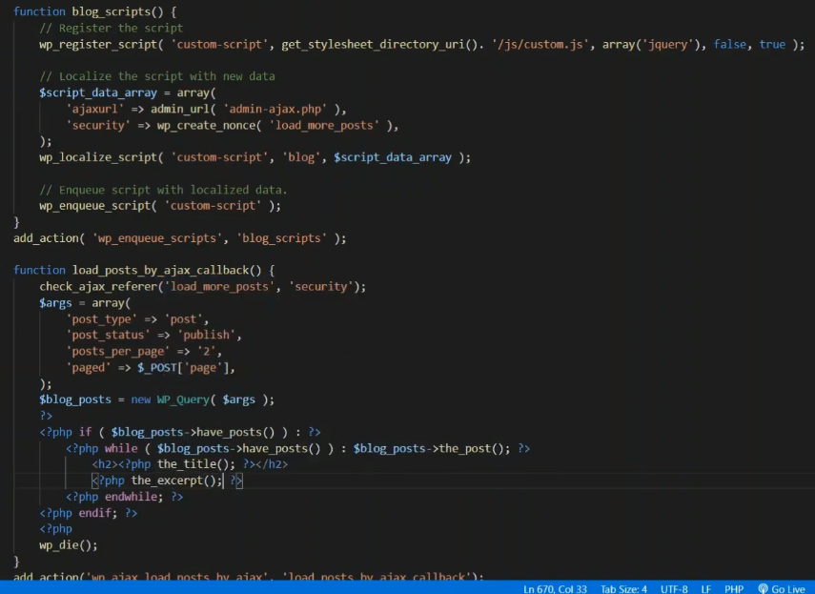**

**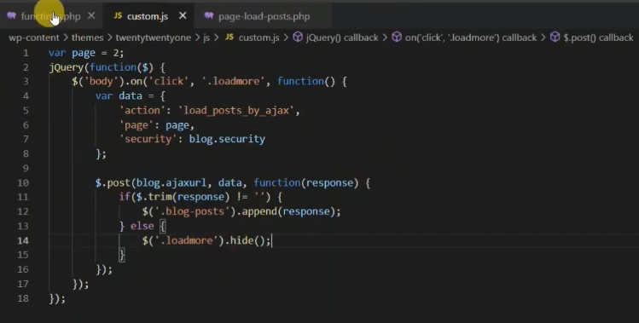**

**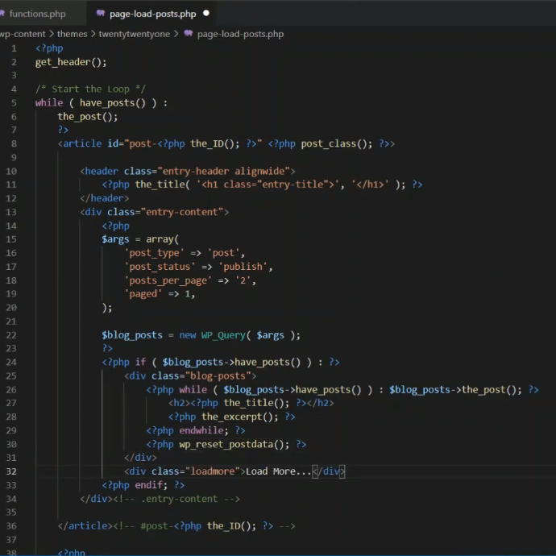**

**Reffrence link** [**https://www.youtube.com/watch?v=2k-hPpHzL1Q&t=28**](https://www.youtube.com/watch?v=2k-hPpHzL1Q&t=28)

[**https://artisansweb.net/load-wordpress-post-ajax/**](https://artisansweb.net/load-wordpress-post-ajax/)

[**https://www.youtube.com/watch?v=bBsIHE-lkGo&list=PLaoZUFJYLaOYRd\_WSV22NPv7q-ZV4gKWs&index=78**](https://www.youtube.com/watch?v=bBsIHE-lkGo&list=PLaoZUFJYLaOYRd_WSV22NPv7q-ZV4gKWs&index=78)

**Block development link**

**AJAX call in WordPress, you can follow these steps:**

**Reference**

[**https://developer.wordpress.org/plugins/javascript/ajax/**](https://developer.wordpress.org/plugins/javascript/ajax/)

**1.Enqueue jQuery:**

**function enqueue\_scripts() {**

**wp\_enqueue\_script('jquery');**

**}**

**add\_action('wp\_enqueue\_scripts', 'enqueue\_scripts');**

**2.Create the JavaScript file:**

Create a new JavaScript file where you'll write the AJAX code. You can create a separate file or include it in an existing JavaScript file in your theme or plugin**.**

**For example, let's create a file called ajax-script.js:**

**jQuery(document).ready(function($) {**

**$.ajax({**

**url: ajax\_object.ajax\_url, // AJAX handler URL provided by WordPress**

**type: 'POST',**

**data: {**

**action: 'my\_ajax\_action',**

**// The PHP function to handle the AJAX request**

**// Add any additional data you want to send to the server**

**},**

**success: function(response) {**

**},**

**error: function(xhr, status, error) {**

**// Handle AJAX error**

**}**

**});**

**});**

**3.Register the AJAX handler in PHP:**

In your theme or plugin's functions.php file, register a PHP function to handle the AJAX request.

**function my\_ajax\_handler() {**

**// Handle the AJAX request**

**// Perform any necessary processing or database operations**

**// Generate the response data**

**// Send the response**

**wp\_send\_json($response);**

**}**

**add\_action('wp\_ajax\_my\_ajax\_action', 'my\_ajax\_handler');**

**add\_action('wp\_ajax\_nopriv\_my\_ajax\_action', 'my\_ajax\_handler'); // For non-logged-in users**

Make sure to replace 'my\_ajax\_action' with the name you provided in the AJAX call (step 2).

**4.Localize the JavaScript file:**

In your theme or plugin's functions.php file, use the wp\_localize\_script() function to pass the AJAX handler URL to the JavaScript file. Add the following code:

**function localize\_scripts()**

**{**

**wp\_enqueue\_script('ajax-script', get\_template\_directory\_uri() . '/path/to/ajax-script.js', array('jquery'), '1.0', true);**

**wp\_localize\_script('ajax-script', 'ajax\_object', array('ajax\_url' => admin\_url('admin-ajax.php')));**

**}**

**add\_action('wp\_enqueue\_scripts', 'localize\_scripts');**

**Make sure to replace '/path/to/ajax-script.js' with the correct path to your JavaScript file.**

That's it! You now have an AJAX call set up in WordPress. When the JavaScript code is executed, it will send an AJAX request to the server, which will be handled by the PHP function specified in the AJAX action. You can perform any necessary processing, database operations, and generate a response that will be sent back to the JavaScript code for further handling.

**Wordpress Ajax Call**

**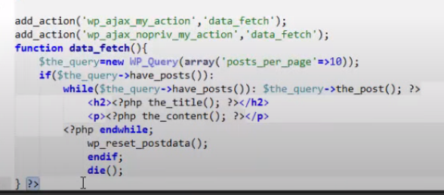**

**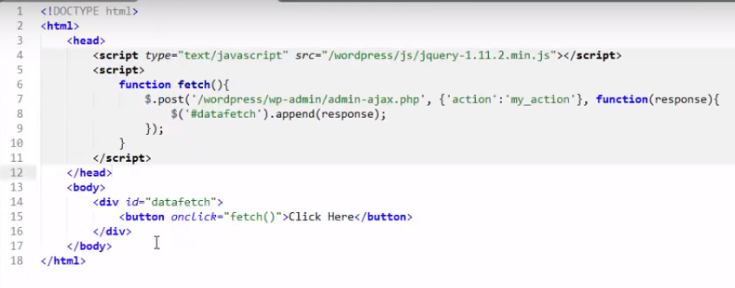**

**WP Ajax call Visshal programming**

**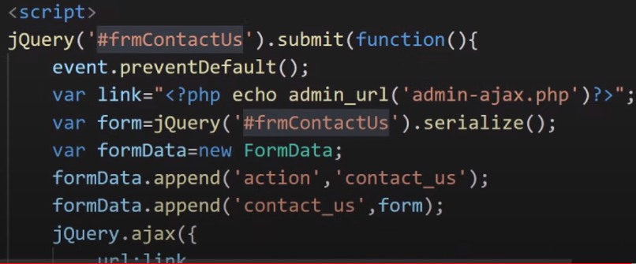**

**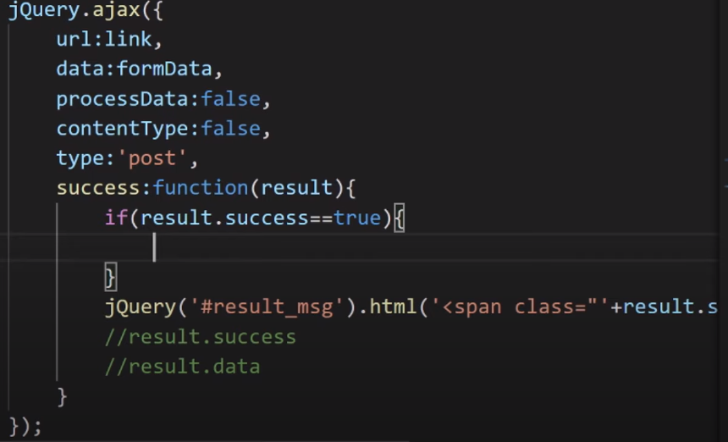**

**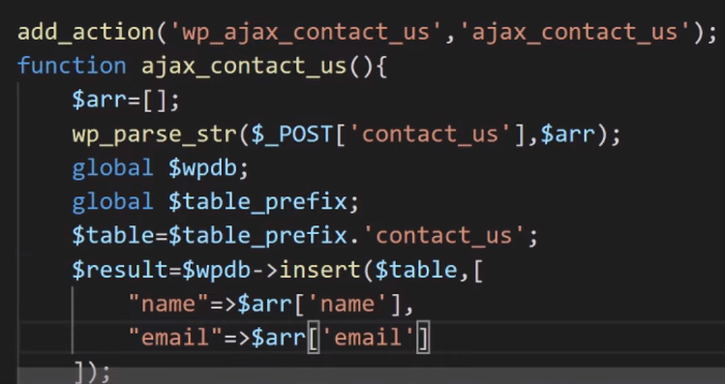**

**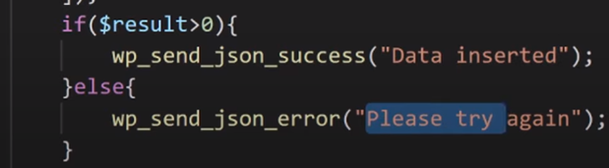**

**Load more post by AJAX Call**

****

****

****

**Reffrence link** [**https://www.youtube.com/watch?v=2k-hPpHzL1Q&t=28**](https://www.youtube.com/watch?v=2k-hPpHzL1Q&t=28)

[**https://artisansweb.net/load-wordpress-post-ajax/**](https://artisansweb.net/load-wordpress-post-ajax/)

[**https://www.youtube.com/watch?v=bBsIHE-lkGo&list=PLaoZUFJYLaOYRd\_WSV22NPv7q-ZV4gKWs&index=78**](https://www.youtube.com/watch?v=bBsIHE-lkGo&list=PLaoZUFJYLaOYRd_WSV22NPv7q-ZV4gKWs&index=78)

**Ajax call**

[**https://developer.wordpress.org/plugins/javascript/ajax/**](https://developer.wordpress.org/plugins/javascript/ajax/)

#### [Client Side Summary](https://developer.wordpress.org/plugins/javascript/ajax/#client-side-summary)

Now that we’ve added our callback as the final parameter for the $.post() function, we’ve completed our sample jQuery Ajax script. All the pieces put together look like this:

**jQuery(document).ready(function($) {         //wrapper**

**$(".pref").change(function() {          //event**

**var this2 = this;                  //use in callback**

**$.post(my\_ajax\_obj.ajax\_url, {      //POST request**

**\_ajax\_nonce: my\_ajax\_obj.nonce, //nonce**

**action: "my\_tag\_count",         //action**

**title: this.value               //data**

**}, function(data) {            //callback**

**this2.nextSibling.remove(); //remove current title**

**$(this2).after(data);       //insert server response**

**}**

**);**

**} );**

**} );**

**$title\_nonce = wp\_create\_nonce( 'title\_example' );**

**wp\_localize\_script(**

**'ajax-script',**

**'my\_ajax\_obj',**

**array(**

**'ajax\_url' => admin\_url( 'admin-ajax.php' ),**

**'nonce'    => $title\_nonce,**

**)**

**);**

**Sample code**

**add\_action( 'admin\_enqueue\_scripts', 'my\_enqueue' );**

**/\*\***

**\* Enqueue my scripts and assets.**

**\***

**\* @param $hook**

**\*/**

**function my\_enqueue( $hook ) {**

**if ( 'myplugin\_settings.php' !== $hook ) {**

**return;**

**}**

**wp\_enqueue\_script(**

**'ajax-script',**

**plugins\_url( '/js/myjquery.js', \_\_FILE\_\_ ),**

**array( 'jquery' ),**

**'1.0.0',**

**true**

**);**

**wp\_localize\_script(**

**'ajax-script',**

**'my\_ajax\_obj',**

**array(**

**'ajax\_url' => admin\_url( 'admin-ajax.php' ),**

**'nonce'    => wp\_create\_nonce( 'title\_example' ),**

**)**

**);**

**}**

#### [Register vs. Enqueue](https://developer.wordpress.org/plugins/javascript/enqueuing/#register-vs-enqueue)

You will see examples in other tutorials that religiously use [wp\_register\_script()](https://developer.wordpress.org/reference/functions/wp_register_script/). This is fine, but its use is optional. What is not optional is wp\_enqueue\_script(). This function must be called in order for your script file to be properly linked on the web page. So why register scripts? It creates a useful tag or handle with which you can easily reference the script in various parts of your code as needed. If you just need your script loaded and are not referencing it elsewhere in your code, there is no need to register it.

### [AJAX Handler Summary](https://developer.wordpress.org/plugins/javascript/enqueuing/#ajax-handler-summary)

### <https://developer.wordpress.org/plugins/javascript/enqueuing/>

**/\*\***

**\* AJAX handler using JSON**

**\*/**

**function my\_ajax\_handler\_\_json() {**

**check\_ajax\_referer( 'title\_example' );**

**$title = wp\_unslash( $\_POST['title'] );**

**update\_user\_meta( get\_current\_user\_id(), 'title\_preference', sanitize\_post\_title( $title ) );**

**$args      = array(**

**'tag' => $title,**

**);**

**$the\_query = new WP\_Query( $args );**

**wp\_send\_json( esc\_html( $title ) . ' (' . $the\_query->post\_count . ') ' );**

**}**

# Heartbeat API

## [How it works](https://developer.wordpress.org/plugins/javascript/heartbeat-api/#how-it-works)

When the page loads, the client-side heartbeat code sets up an interval (called the “tick”) to run every 15-120 seconds. When it runs, heartbeat gathers data to send via a jQuery event, then sends this to the server and waits for a response. On the server, an admin-ajax handler takes the passed data, prepares a response, filters the response, then returns the data in JSON format. The client receives this data and fires a final jQuery event to indicate the data has been received.

The basic process for custom Heartbeat events is:

1. Add additional fields to the data to be sent (JS heartbeat-send event)
2. Detect sent fields in PHP, and add additional response fields (heartbeat\_received filter)
3. Process returned data in JS (JS heartbeat-tick)

(You can choose to use only one or two of these events, depending on what functionality you need.)

## [Using the API](https://developer.wordpress.org/plugins/javascript/heartbeat-api/#using-the-api)

Using the heartbeat API requires two separate pieces of functionality: send and receive callbacks in JavaScript, and a server-side filter to process passed data in PHP.

### [Sending Data to the Server](https://developer.wordpress.org/plugins/javascript/heartbeat-api/#sending-data-to-the-server)

When Heartbeat sends data to the server, you can include custom data. This can be any data you want to send to the server, or a simple true value to indicate you are expecting data.

**jQuery( document ).on( 'heartbeat-send', function ( event, data ) {**

**// Add additional data to Heartbeat data.**

**data.myplugin\_customfield = 'some\_data';**

**});**

### [Receiving and Responding on the Server](https://developer.wordpress.org/plugins/javascript/heartbeat-api/#receiving-and-responding-on-the-server)

On the server side, you can then detect this data, and add additional data to the response.

/\*\*

 \* Receive Heartbeat data and respond.

 \*

 \* Processes data received via a Heartbeat request, and returns additional data to pass back to the front end.

 \*

 \* @param array $response Heartbeat response data to pass back to front end.

 \* @param array $data     Data received from the front end (unslashed).

 \*

 \* @return array

 \*/

function myplugin\_receive\_heartbeat( array $response, array $data ) {

    // If we didn't receive our data, don't send any back.

    if ( empty( $data['myplugin\_customfield'] ) ) {

        return $response;

    }

    // Calculate our data and pass it back. For this example, we'll hash it.

    $received\_data = $data['myplugin\_customfield'];

    $response['myplugin\_customfield\_hashed'] = sha1( $received\_data );

    return $response;

}

add\_filter( 'heartbeat\_received', 'myplugin\_receive\_heartbeat', 10, 2 );

### [Processing the Response](https://developer.wordpress.org/plugins/javascript/heartbeat-api/#processing-the-response)

Back on the frontend, you can then handle receiving this data back.

**jQuery( document ).on( 'heartbeat-tick', function ( event, data ) {**

**// Check for our data, and use it.**

**if ( ! data.myplugin\_customfield\_hashed ) {**

**return;**

**}**

**alert( 'The hash is ' + data.myplugin\_customfield\_hashed );**

**});**

**Ajax Calling Method**

**Method :1**

**<head>**

**<script src="https://ajax.googleapis.com/ajax/libs/jquery/3.6.4/jquery.min.js"></script>**

**<script>**

**$(document).ready(function(){**

**$("button").click(function(){**

**$("#div1").load("demo\_test.txt");**

**});**

**});**

**</script>**

**</head>**

**<body>**

**<div id="div1"><h2>Let jQuery AJAX Change This Text</h2></div>**

**<button>Get External Content</button>**

**</body>**

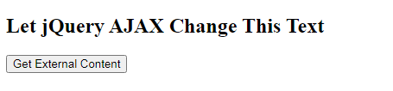

**After clicking result**

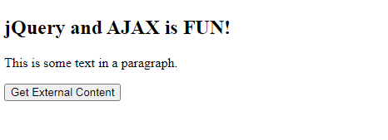

**Method :2**

**<head>**

**<script src="https://ajax.googleapis.com/ajax/libs/jquery/3.6.4/jquery.min.js"></script>**

**<script>**

**$(document).ready(function(){**

**$("button").click(function(){**

**$.ajax({url: "demo\_test.txt", success: function(result){**

**$("#div1").html(result);**

**}});**

**});**

**});**

**</script>**

**</head>**

**<body>**

**<div id="div1"><h2>Let jQuery AJAX Change This Text</h2></div>**

**<button>Get External Content</button>**

**</body>**

**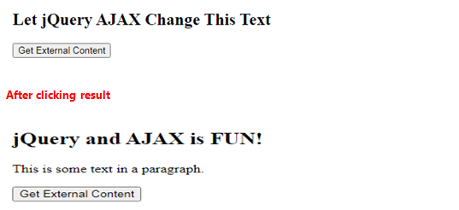**

**Method :3**

**<head>**

**<script src="https://ajax.googleapis.com/ajax/libs/jquery/3.6.4/jquery.min.js"></script>**

**<script>**

**$(document).ready(function(){**

**$("button").click(function(){**

**$.get("demo\_test.asp", function(data, status){**

**alert("Data: " + data + "\nStatus: " + status);**

**});**

**});**

**});**

**</script>**

**</head>**

**<body>**

**<button>Send an HTTP GET request to a page and get the result back</button>**

**</body>**

****

**Result**

**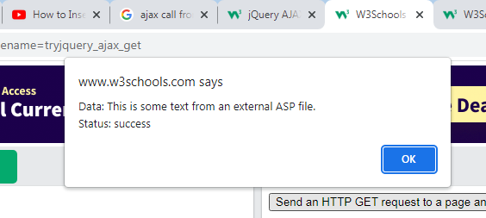**

**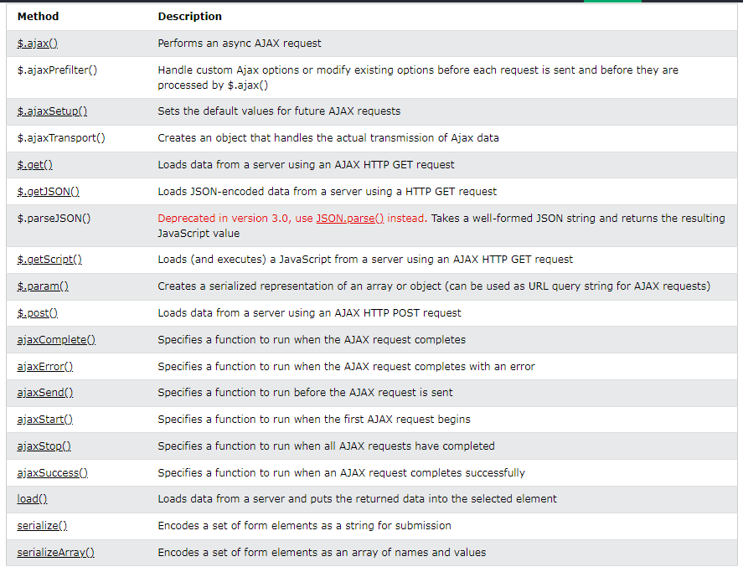**

**Ajax with PHP**

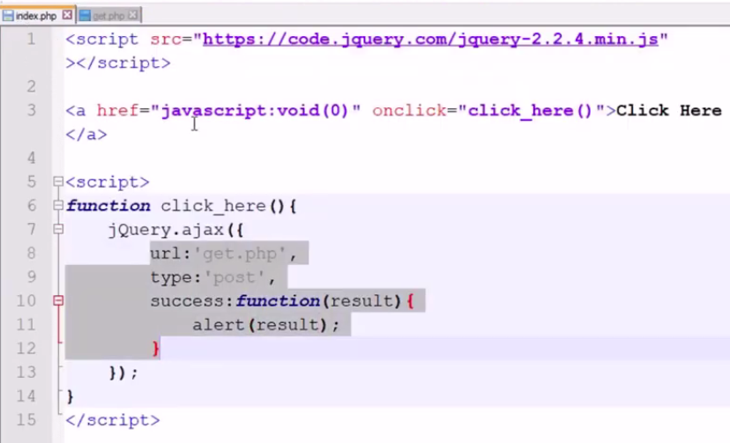

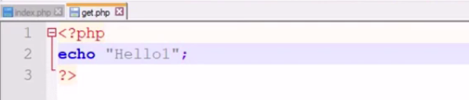

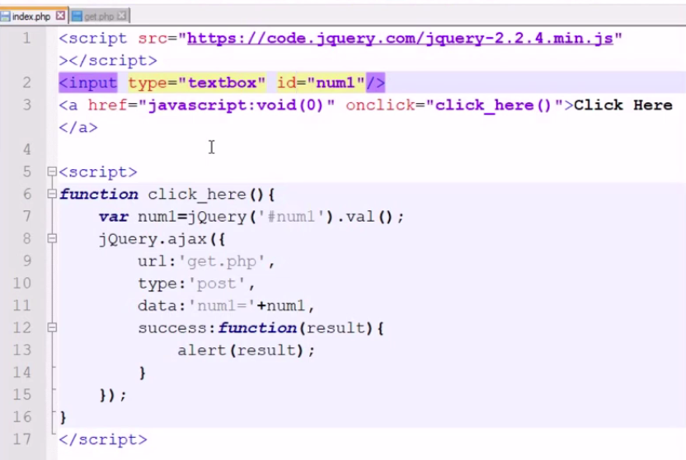

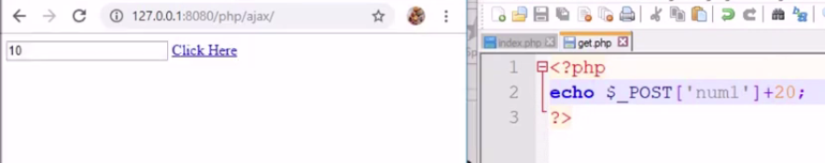

**Syncronus AJAX- Parallel, it is not waiting for other**

**Asyncronus AJAX it is depending on other, Its work one after one.**

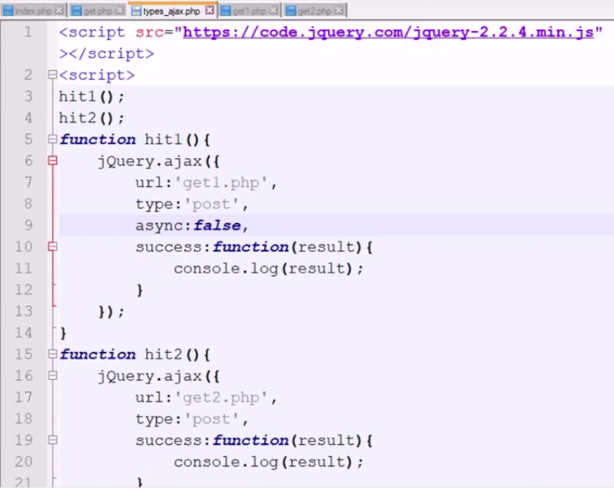

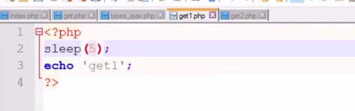

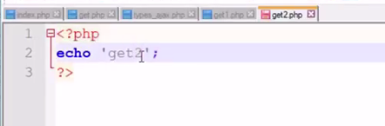

**AJAX With JSON Dataserve API call**

**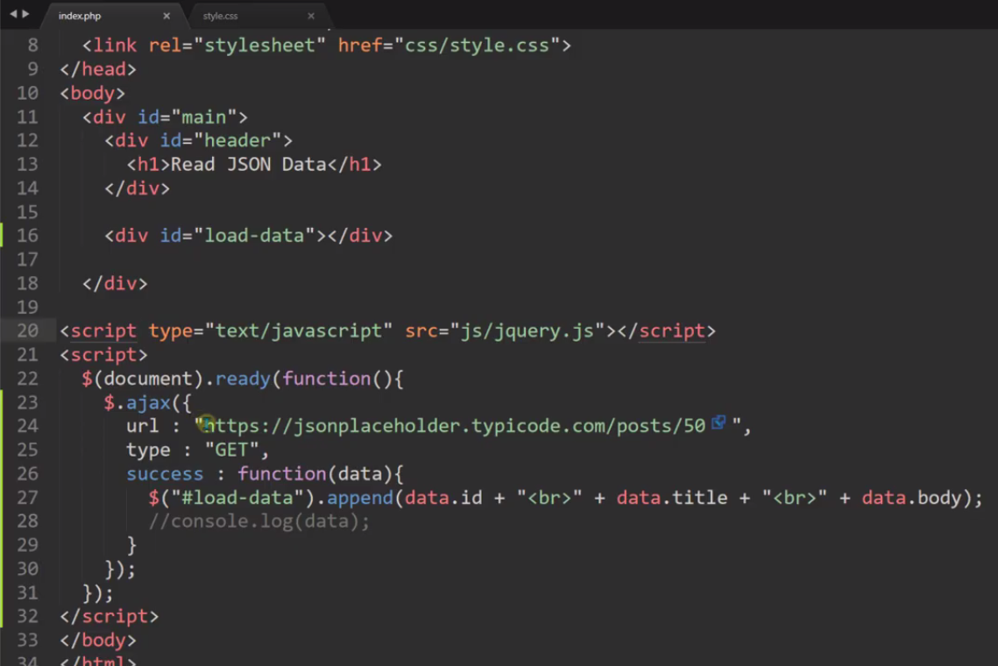**

**For looping data**

**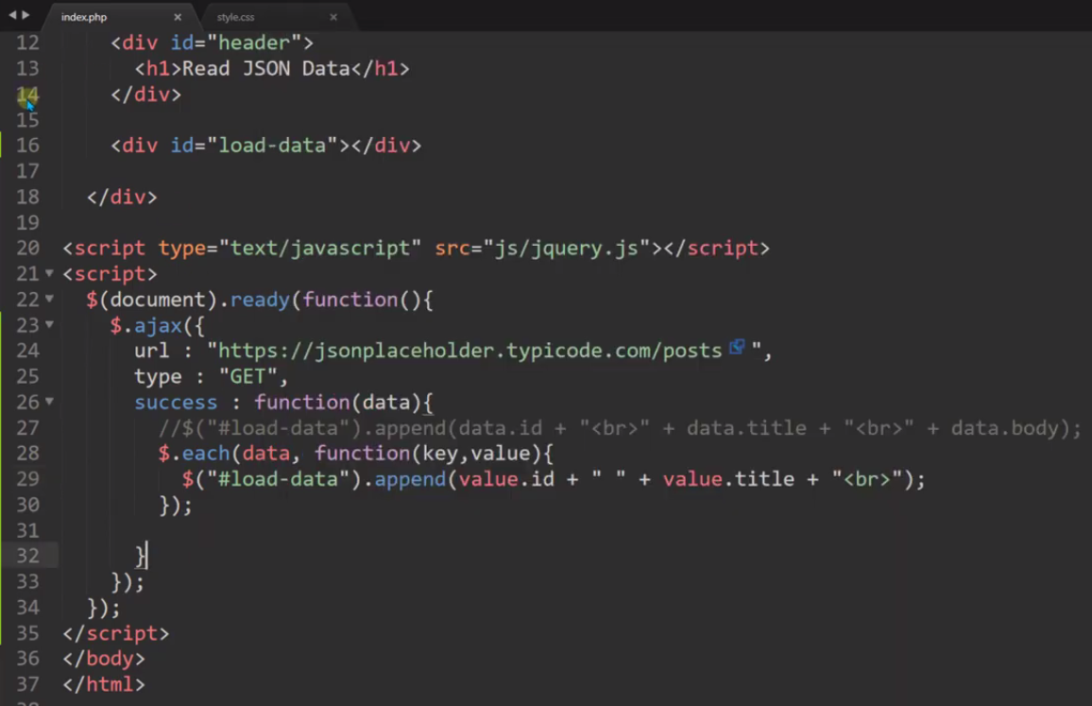**

**API call from Json file**

**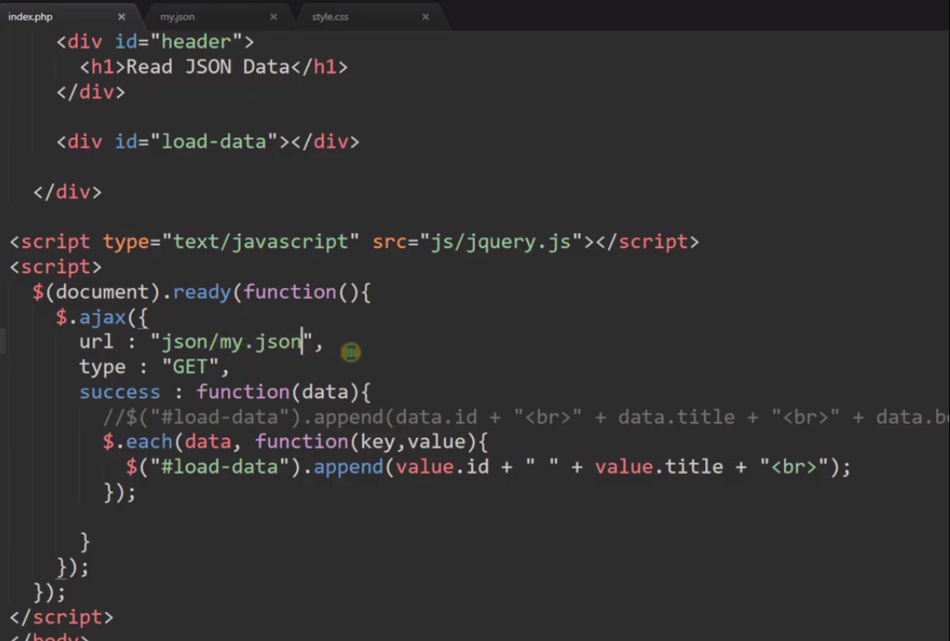**

**Sorcut method for AJAX call for Only JSON Data**

**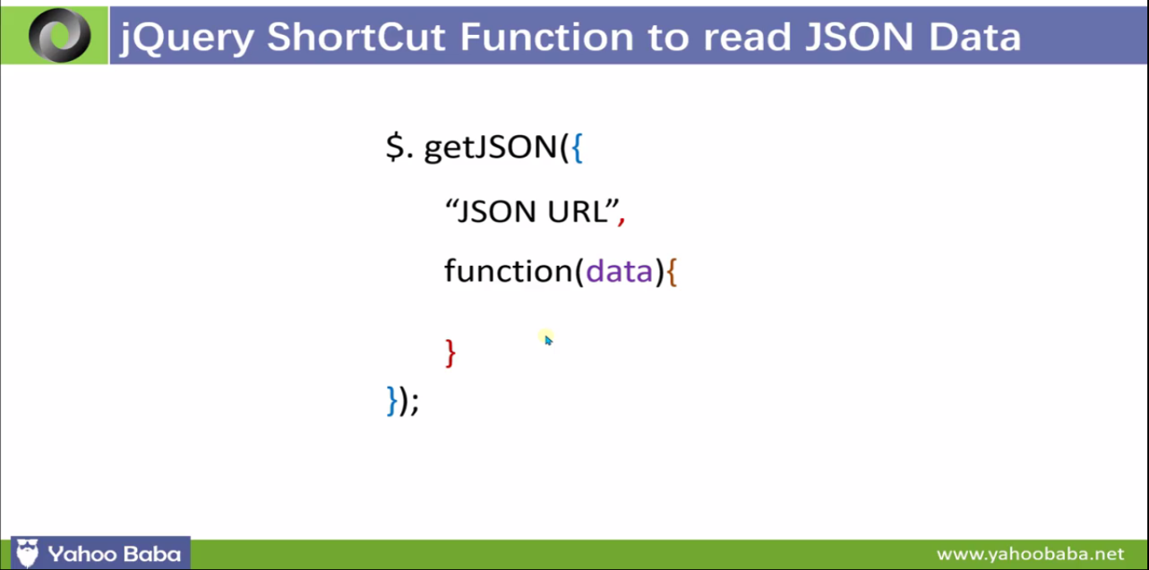**

**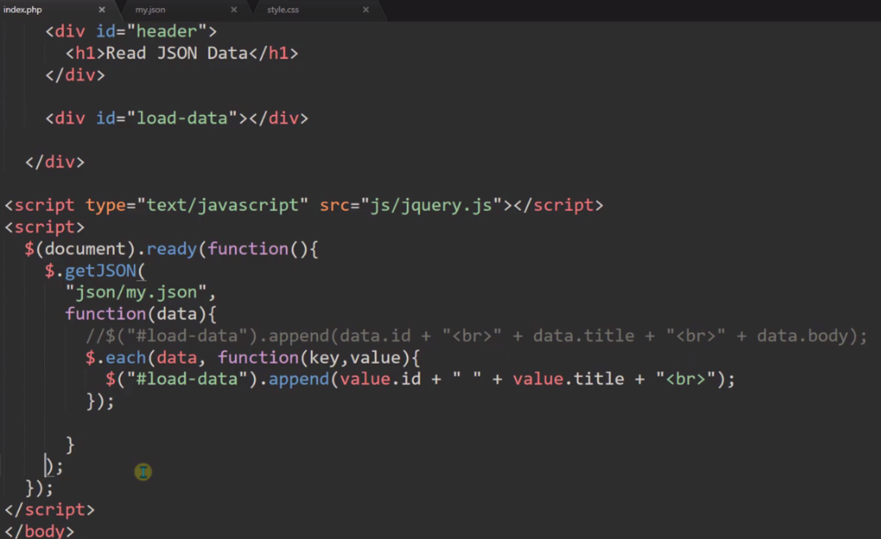**

**Ajax call**

**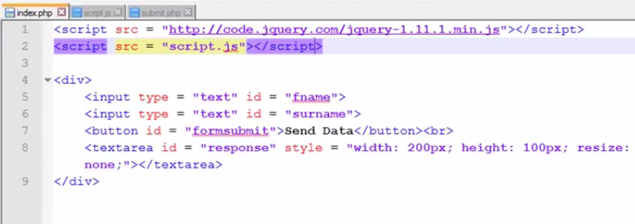**

**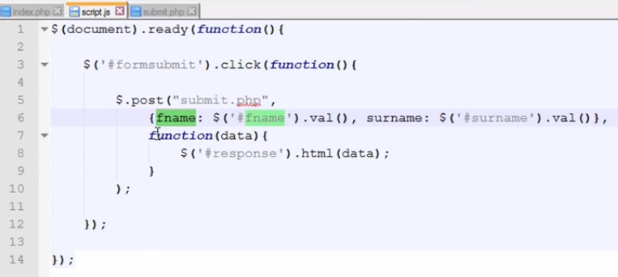**

**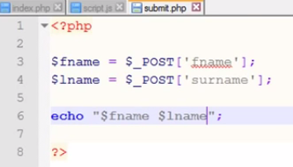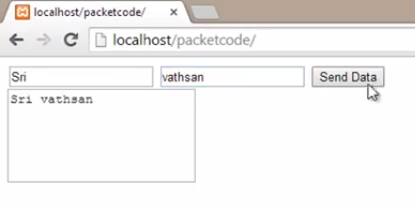**

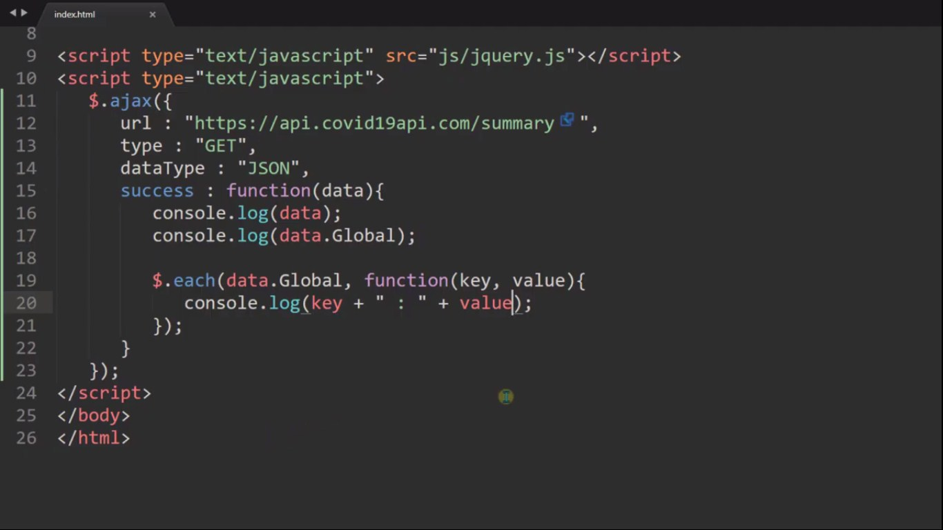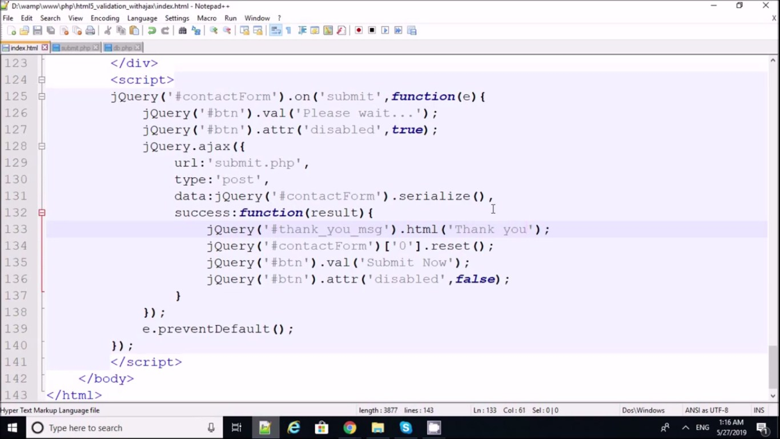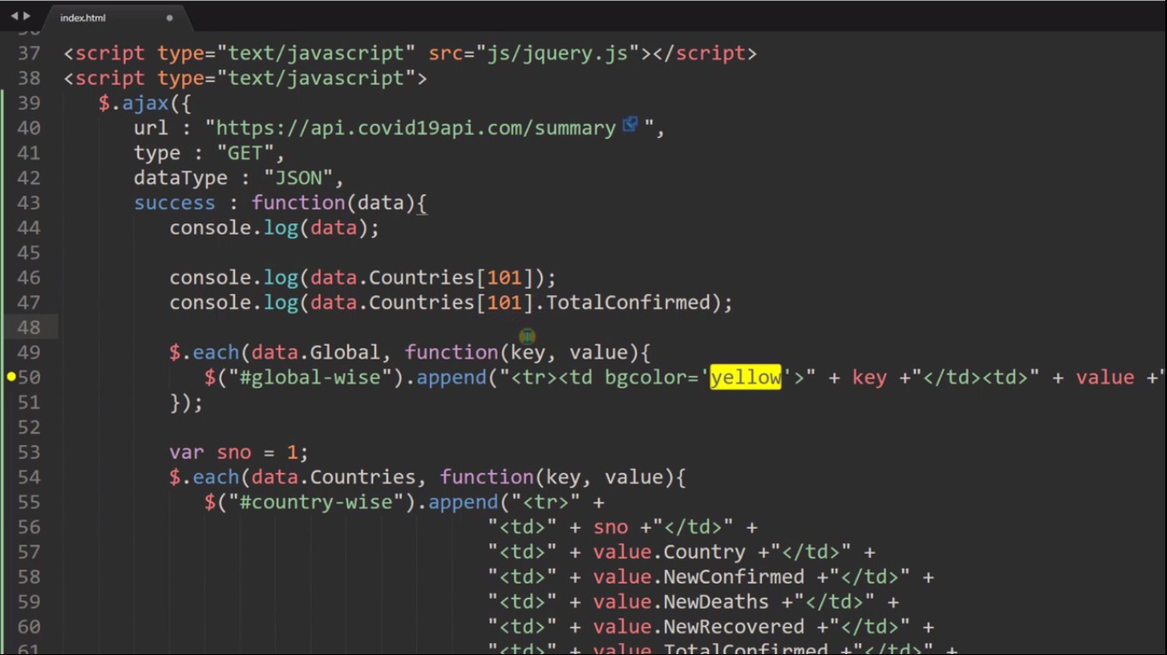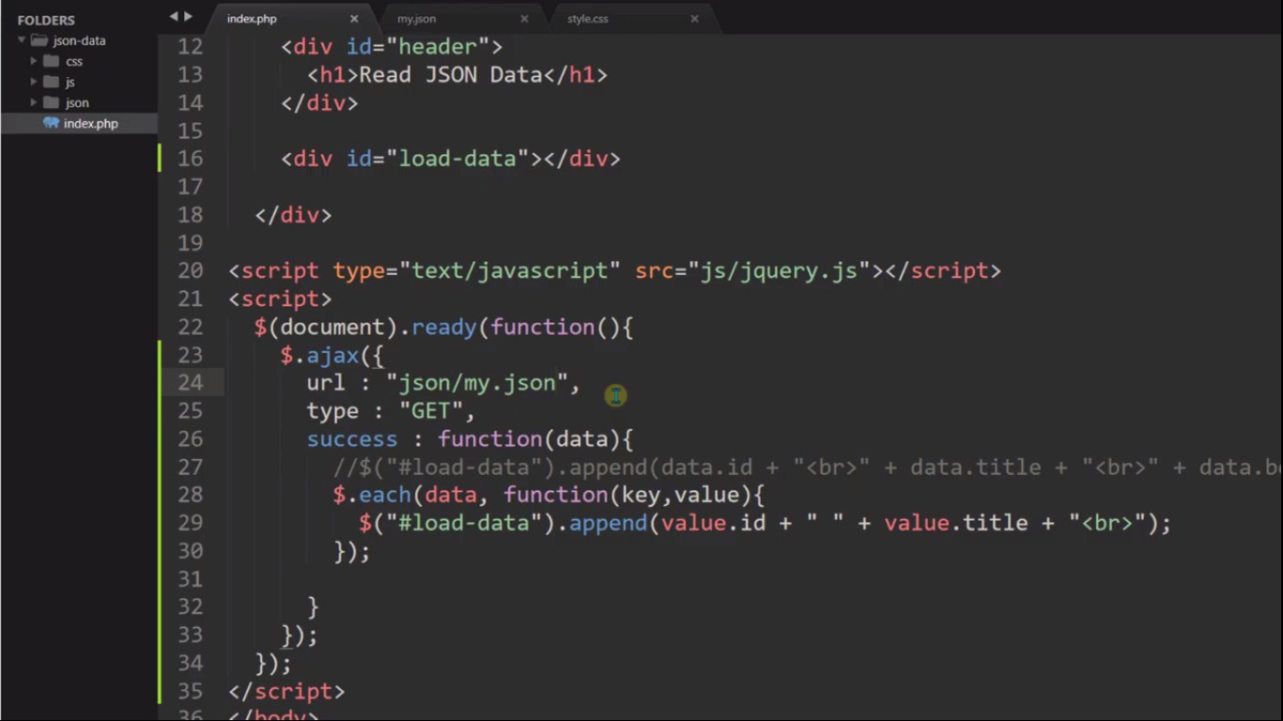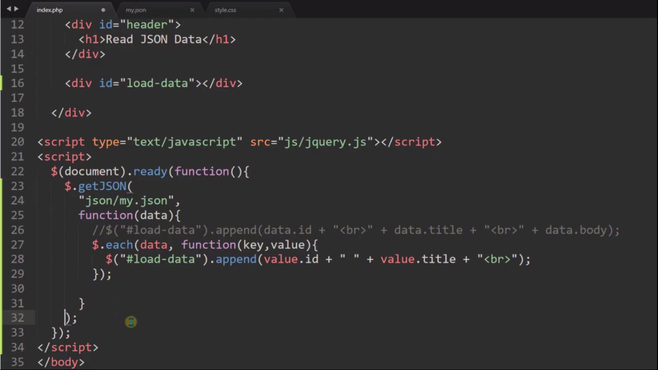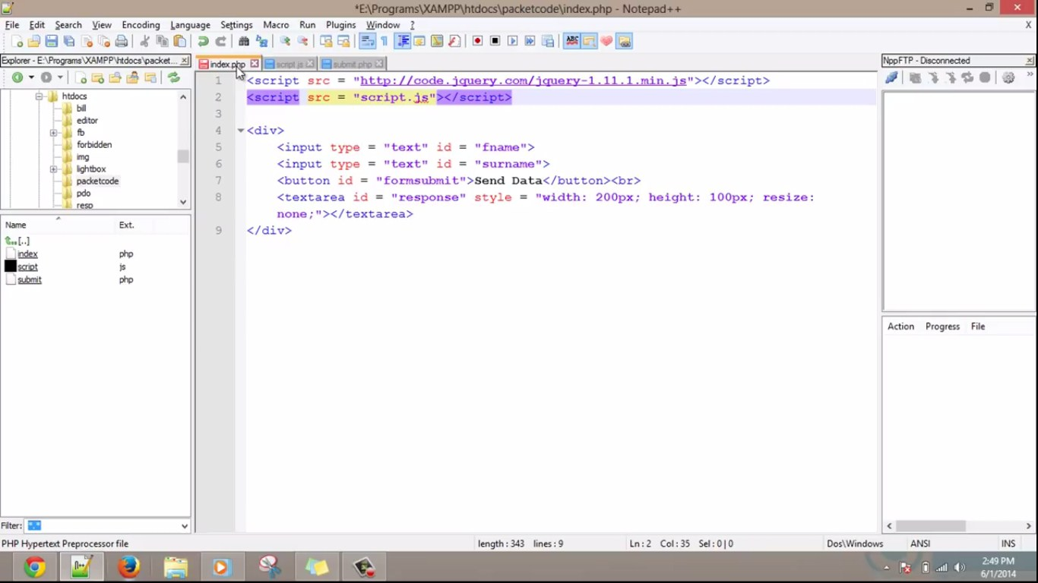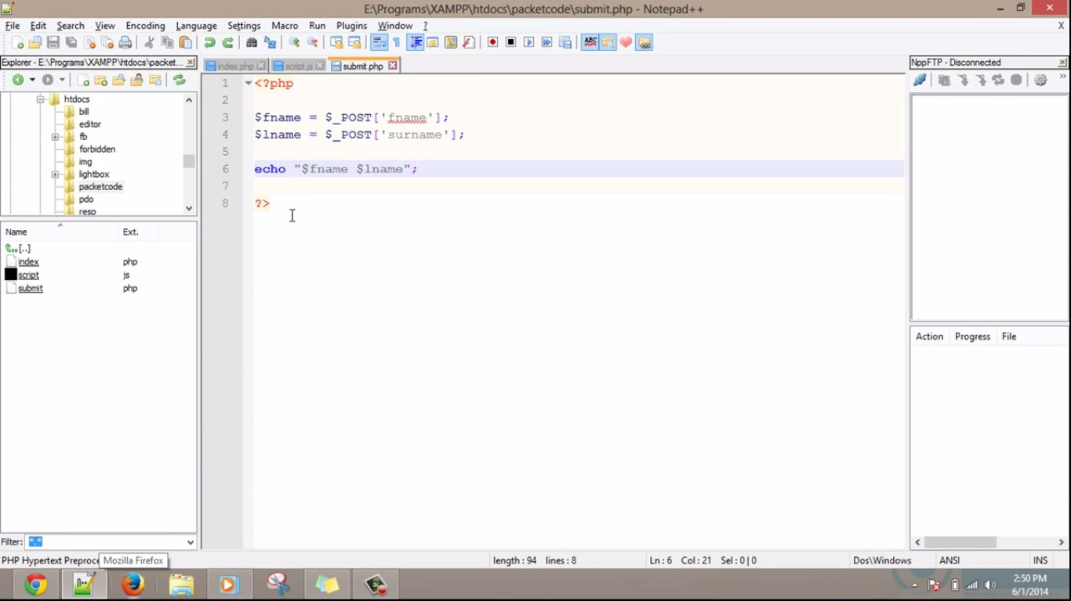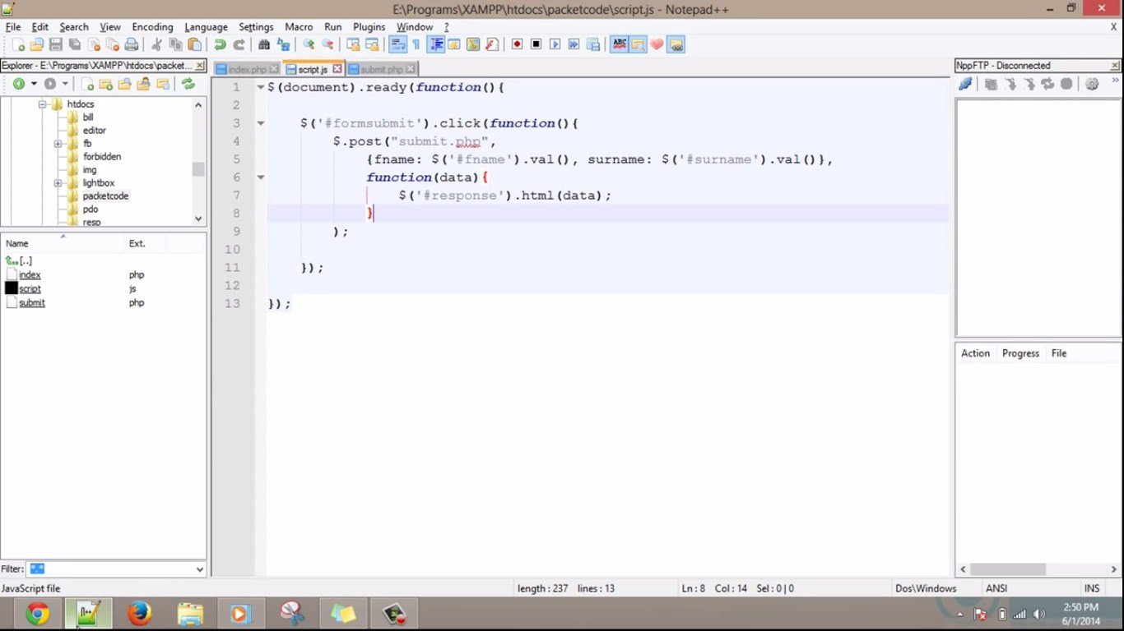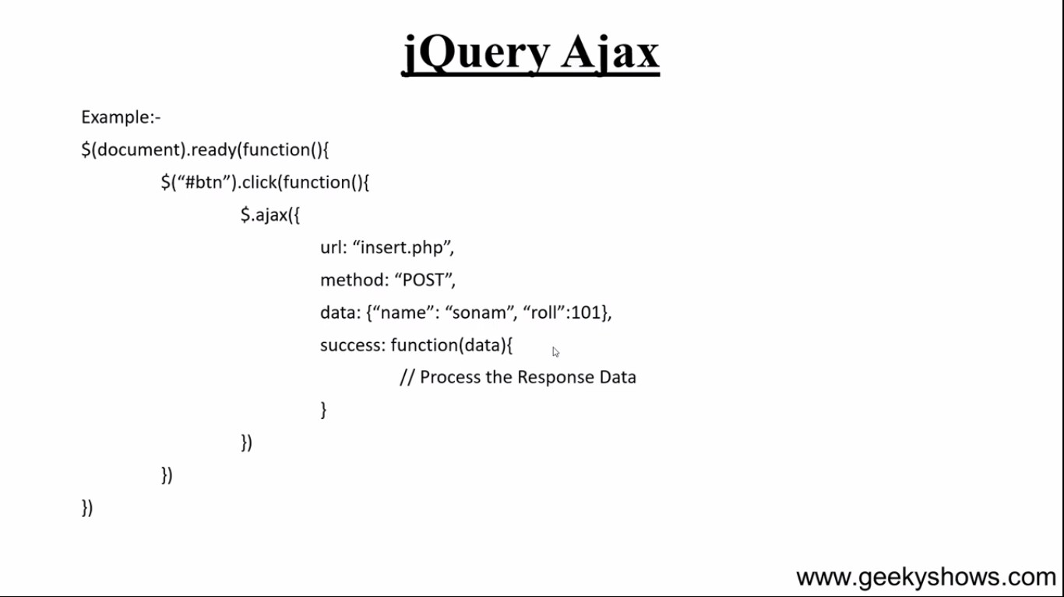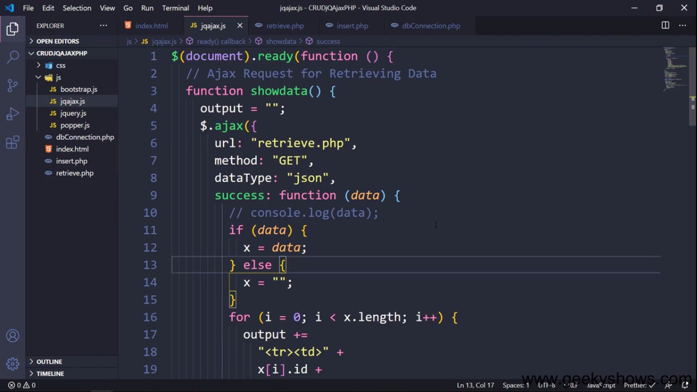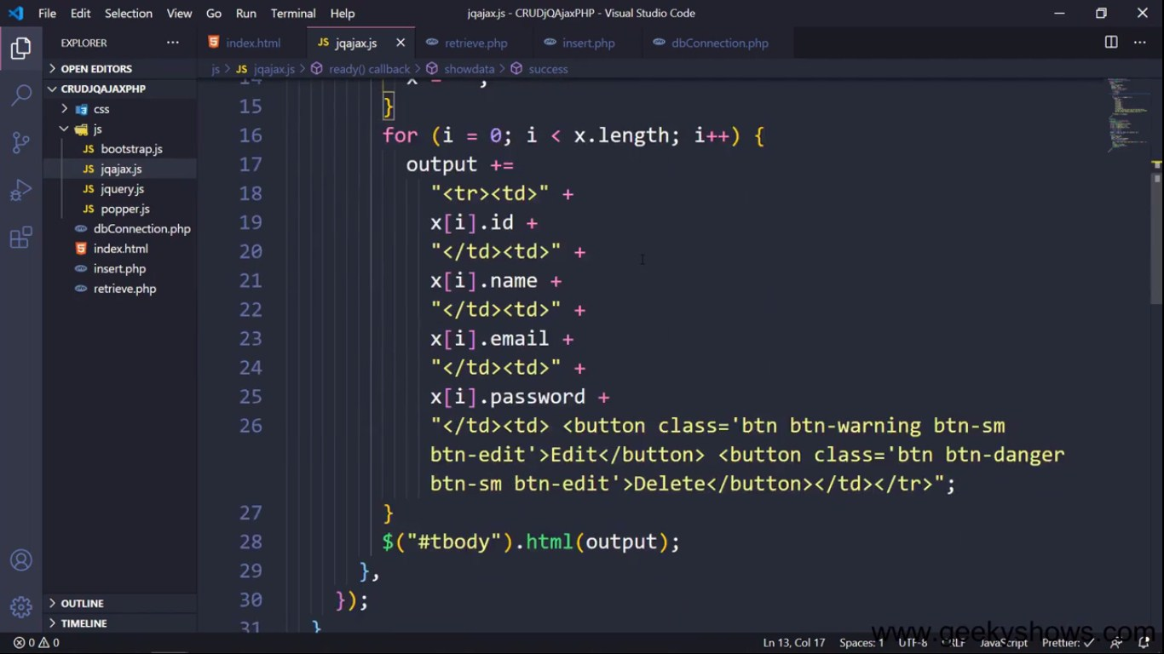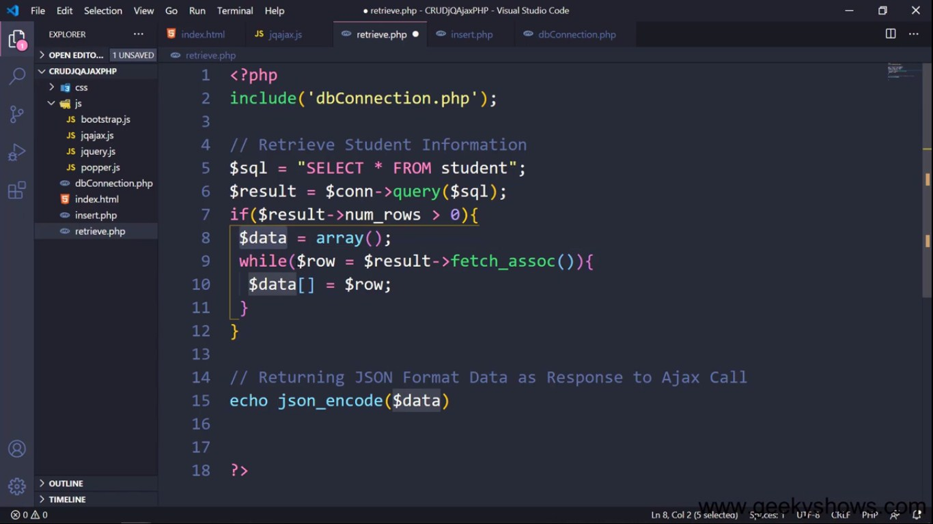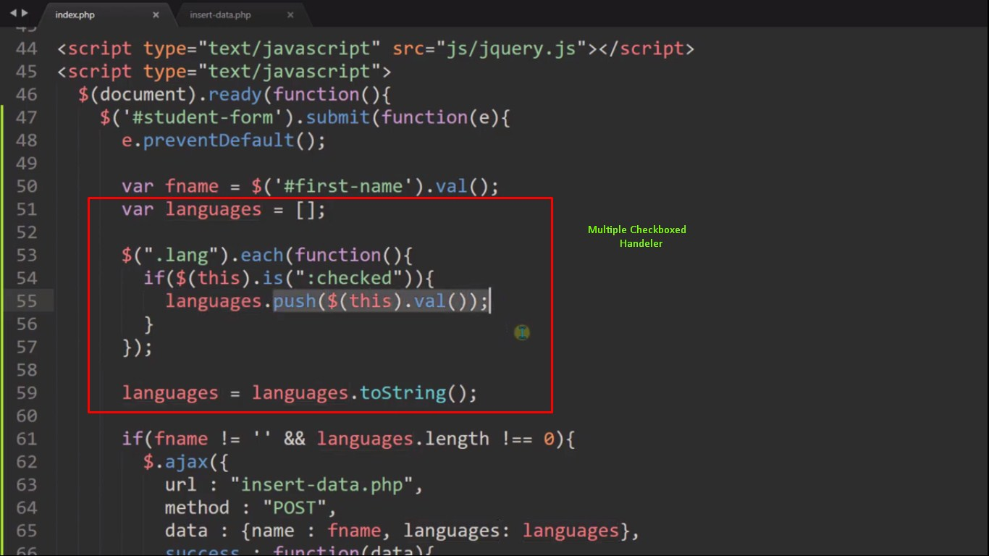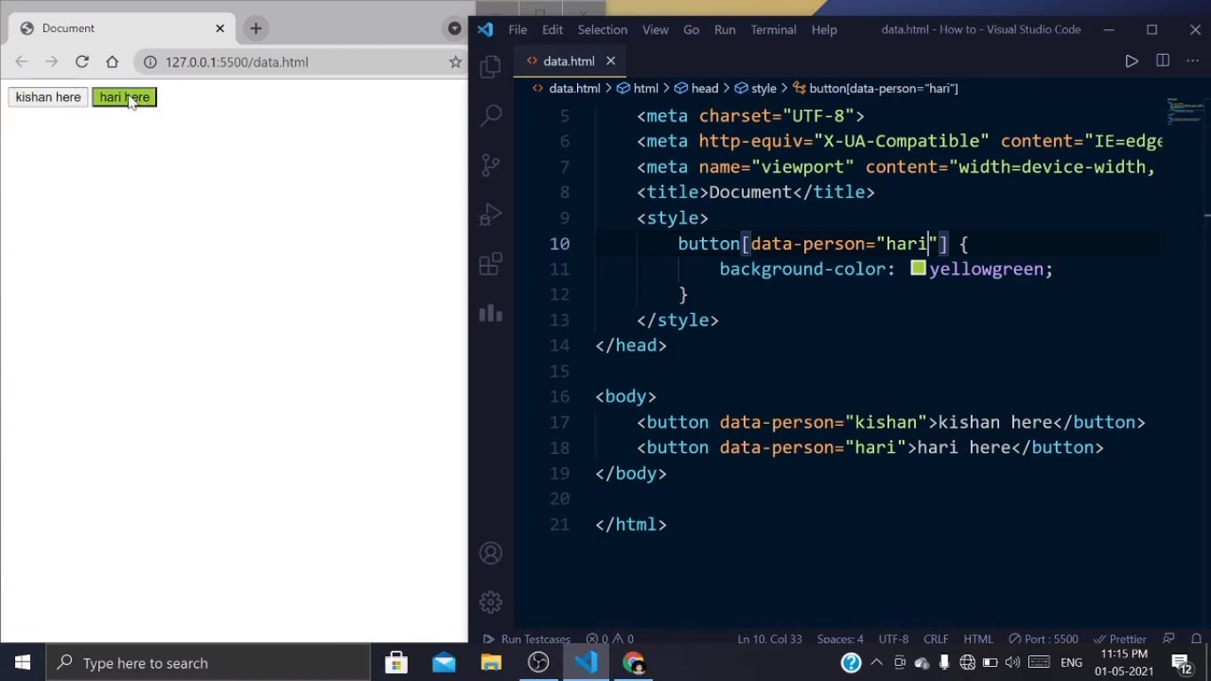

**Basic Gutenberg Block Development**

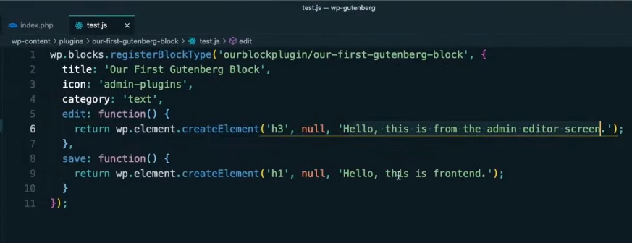

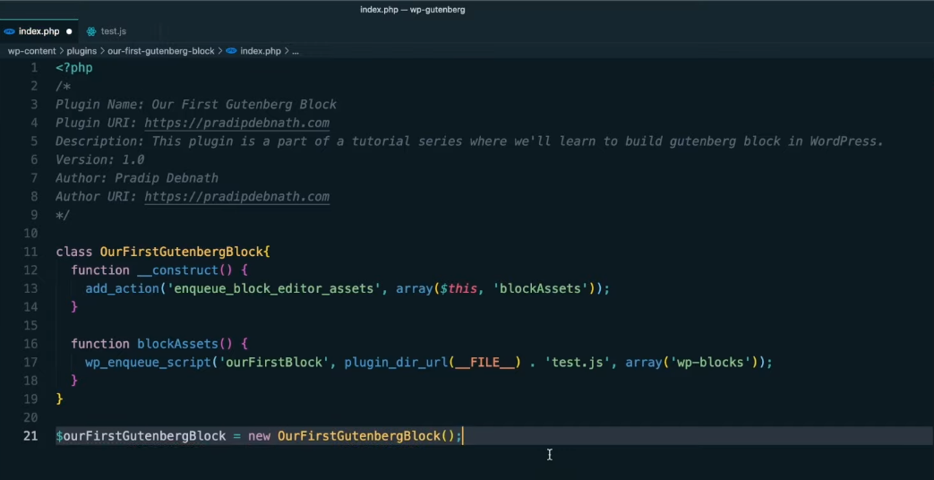

**Richtext Block**

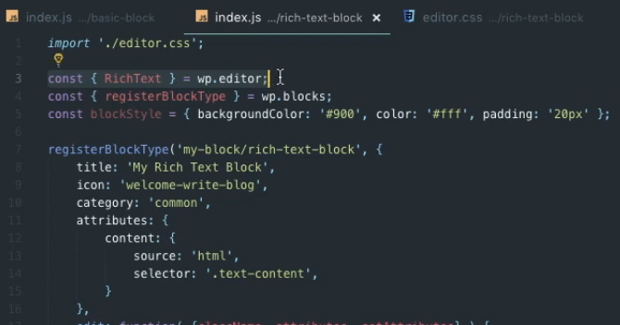

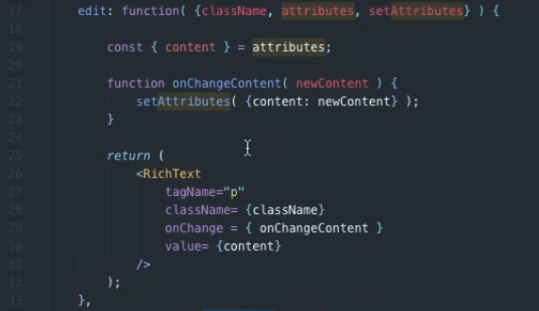

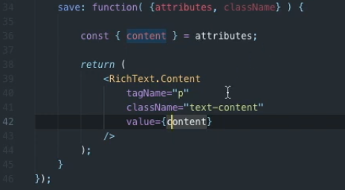

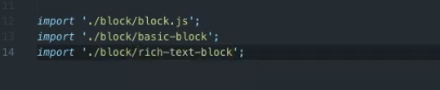

**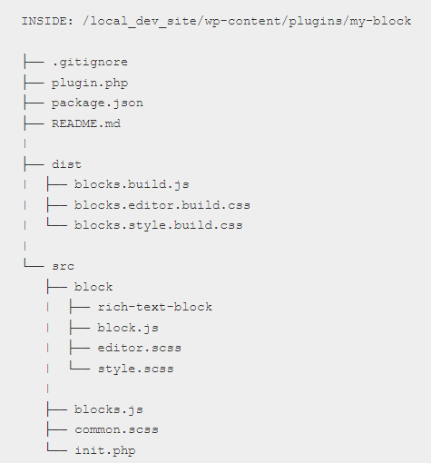**

**Another example**

**registerBlockType('namespace/richtext-block', {**

**title: \_\_('RichText Block'),**

**description: \_\_('A simple block using the RichText element'),**

**icon: 'shield',**

**category: 'common',**

**keywords: [**

**\_\_('richtext-block'),**

**\_\_('RichText Block'),**

**\_\_('RichText')**

**],**

**attributes: {**

**content: {**

**type: 'array',**

**source: 'children',**

**selector: 'h2',**

**},**

**},**

**edit: function ({ attributes, setAttributes, className, isSelected }) {**

**return (**

**<RichText**

**tagName="h2"**

**className={className}**

**value={attributes.content}**

**onChange={(content) => setAttributes({ content })}**

**placeholder={\_\_('Enter text...', 'custom-block')}**

**keepPlaceholderOnFocus={true}**

**/>**

**);**

**},**

**save: function( { attributes } ) {**

**return (**

**<RichText.Content tagName="h2" value={ attributes.content } />**

**);**

**}**

**});**

**Slider block**

**<?php**

**/\***

**Plugin Name: Custom Slider Block**

**Description: Custom Gutenberg Slider Block**

**Version: 1.0**

**Author: Your Name**

**\*/**

**// Enqueue your script and styles**

**function custom\_slider\_enqueue\_scripts() {**

**wp\_enqueue\_script(**

**'custom-slider-block',**

**plugins\_url('dist/block.js', \_\_FILE\_\_),**

**array('wp-blocks', 'wp-element', 'wp-editor'),**

**true**

**);**

**}**

**add\_action('enqueue\_block\_editor\_assets', 'custom\_slider\_enqueue\_scripts');**

**block.js code**

**import { registerBlockType } from '@wordpress/blocks';**

**import { InspectorControls } from '@wordpress/editor';**

**import { PanelBody, TextControl } from '@wordpress/components';**

**registerBlockType('custom-slider/slider-block', {**

**title: 'Custom Slider',**

**icon: 'slides',**

**category: 'common',**

**attributes: {**

**slides: {**

**type: 'array',**

**default: [],**

**},**

**},**

**edit: function (props) {**

**const { attributes, setAttributes } = props;**

**return (**

**<div className={props.className}>**

**<InspectorControls>**

**<PanelBody title="Slider Settings">**

**<TextControl**

**label="Add a slide"**

**value=""**

**onChange={(slide) => {**

**const newSlides = [...attributes.slides, slide];**

**setAttributes({ slides: newSlides });**

**}}**

**/>**

**</PanelBody>**

**</InspectorControls>**

**<div className="slider">**

**{/\* Render your slider here \*/}**

**{attributes.slides.map((slide, index) => (**

**<div key={index} className="slide">**

**{slide}**

**</div>**

**))}**

**</div>**

**</div>**

**);**

**},**

**save: function () {**

**// Save your slider content here**

**return null;**

**},**

**});**

**Card block Development**

**const { RichText, MediaUpload, PlainText } = wp.editor;**

**const { registerBlockType } = wp.blocks;**

**const { Button } = wp.components;**

**// Import our CSS files**

**import './style.scss';**

**import './editor.scss';**

**registerBlockType('card-block/main', {**

**title: 'Card',**

**icon: 'heart',**

**category: 'common',**

**attributes: {**

**title: {**

**source: 'text',**

**selector: '.card\_\_title'**

**},**

**body: {**

**type: 'array',**

**source: 'children',**

**selector: '.card\_\_body'**

**},**

**imageAlt: {**

**attribute: 'alt',**

**selector: '.card\_\_image'**

**},**

**imageUrl: {**

**attribute: 'src',**

**selector: '.card\_\_image'**

**}**

**},**

**edit({ attributes, className, setAttributes }) {**

**const getImageButton = (openEvent) => {**

**if(attributes.imageUrl) {**

**return (**

**<img**

**src={ attributes.imageUrl }**

**onClick={ openEvent }**

**className="image"**

**/>**

**);**

**}**

**else {**

**return (**

**<div className="button-container">**

**<Button**

**onClick={ openEvent }**

**className="button button-large"**

**>**

**Pick an image**

**</Button>**

**</div>**

**);**

**}**

**};**

**return (**

**<div className="container">**

**<MediaUpload**

**onSelect={ media => { setAttributes({ imageAlt: media.alt, imageUrl: media.url }); } }**

**type="image"**

**value={ attributes.imageID }**

**render={ ({ open }) => getImageButton(open) }**

**/>**

**<PlainText**

**onChange={ content => setAttributes({ title: content }) }**

**value={ attributes.title }**

**placeholder="Your card title"**

**className="heading"**

**/>**

**<RichText**

**onChange={ content => setAttributes({ body: content }) }**

**value={ attributes.body }**

**multiline="p"**

**placeholder="Your card text"**

**formattingControls={ ['bold', 'italic', 'underline'] }**

**isSelected={ attributes.isSelected }**

**/>**

**</div>**

**);**

**},**

**save({ attributes }) {**

**const cardImage = (src, alt) => {**

**if(!src) return null;**

**if(alt) {**

**return (**

**<img**

**className="card\_\_image"**

**src={ src }**

**alt={ alt }**

**/>**

**);**

**}**

**// No alt set, so let's hide it from screen readers**

**return (**

**<img**

**className="card\_\_image"**

**src={ src }**

**alt=""**

**aria-hidden="true"**

**/>**

**);**

**};**

**return (**

**<div className="card">**

**{ cardImage(attributes.imageUrl, attributes.imageAlt) }**

**<div className="card\_\_content">**

**<h3 className="card\_\_title">{ attributes.title }</h3>**

**<div className="card\_\_body">**

**{ attributes.body }**

**</div>**

**</div>**

**</div>**

**);**

**}**

**});**

**Custom Block" with a simple text field to the Gutenberg editor.**

**Create a Plugin Directory**:

Create a directory for your custom Gutenberg block plugin in the **wp-content/plugins/** directory of your WordPress installation. Name it something like **custom-gutenberg-block**.

**Inside your plugin directory, create the main PHP file (e.g., custom-gutenberg-block.php) and add the following code**:

**<?php**

**/\***

**Plugin Name: Custom Gutenberg Block**

**Description: A simple custom Gutenberg block example.**

**\*/**

**// Register the block script and style.**

**function custom\_gutenberg\_block\_enqueue() {**

**wp\_enqueue\_script(**

**'custom-gutenberg-block',**

**plugin\_dir\_url(\_\_FILE\_\_) . 'block.js',**

**array('wp-blocks', 'wp-editor'),**

**filemtime(plugin\_dir\_path(\_\_FILE\_\_) . 'block.js')**

**);**

**wp\_enqueue\_style(**

**'custom-gutenberg-block',**

**plugin\_dir\_url(\_\_FILE\_\_) . 'style.css',**

**array('wp-edit-blocks'),**

**filemtime(plugin\_dir\_path(\_\_FILE\_\_) . 'style.css')**

**);**

**}**

**add\_action('enqueue\_block\_editor\_assets', 'custom\_gutenberg\_block\_enqueue');**

We enqueue the JavaScript and CSS files needed for our custom block. The JavaScript file (**block.js**) will define the block's behavior, and the CSS file (**style.css**) will provide styling.

**Create the JavaScript File (block.js)**:

Inside your plugin directory, create a **block.js** file with the following code:

**<script>**

**(function() {**

**var el = wp.element.createElement;**

**var registerBlockType = wp.blocks.registerBlockType;**

**var TextControl = wp.components.TextControl;**

**var RichText = wp.editor.RichText;**

**registerBlockType('custom-gutenberg-block/custom-block', {**

**title: 'Custom Block',**

**icon: 'shield',**

**category: 'common',**

**attributes: {**

**content: {**

**type: 'string',**

**default: 'Hello, Custom Block!'**

**}**

**},**

**edit: function(props) {**

**return el(**

**'div',**

**{},**

**el(**

**TextControl,**

**{**

**value: props.attributes.content,**

**onChange: function(newContent) {**

**props.setAttributes({ content: newContent });**

**},**

**placeholder: 'Enter your custom content here...'**

**}**

**)**

**);**

**},**

**save: function(props) {**

**return el(RichText.Content, {**

**tagName: 'p',**

**value: props.attributes.content**

**});**

**}**

**});**

**})();**

**</script>**

This JavaScript code registers a custom block named "Custom Block" with a text field for entering content.

**Create the CSS File (style.css)**:

Inside your plugin directory, create a **style.css** file to add custom styling for your block.

**Activate the Plugin**:

In the WordPress admin dashboard, navigate to the "Plugins" section and activate your "Custom Gutenberg Block" plugin.

**Use the Custom Block**:

In the Gutenberg editor, you should now see a "Custom Block" in the "Common" category. Add the block to your post or page and use the text field to enter your custom content.

**Custom Gutenberg block in JSX procedure**

Creating a custom Gutenberg block in JSX involves several steps, as Gutenberg block development primarily relies on JavaScript, especially JSX, which is a JavaScript syntax extension often used with React. Here's a step-by-step procedure to create a custom Gutenberg block in JSX:

**Prerequisites:**

1.You should have a development environment set up with Node.js and npm installed.

2.Familiarity with JavaScript, React, and JSX is beneficial.

**Procedure:**

1. **Create a WordPress Plugin Directory**:

Start by creating a new directory for your custom Gutenberg block plugin in the **wp-content/plugins/** directory of your WordPress installation. Name it something like **custom-gutenberg-block**.

1. **Inside your plugin directory, create the main PHP file (e.g., custom-gutenberg-block.php) and add the following code**:

**<?php**

**/\***

**Plugin Name: Custom Gutenberg Block**

**Description: A custom Gutenberg block developed with JSX.**

**\*/**

**// Enqueue the JavaScript file containing your block.**

**function enqueue\_custom\_block() {**

**wp\_enqueue\_script(**

**'custom-gutenberg-block',**

**plugin\_dir\_url(\_\_FILE\_\_) . 'build/index.js',**

**array('wp-blocks', 'wp-editor'),**

**filemtime(plugin\_dir\_path(\_\_FILE\_\_) . 'build/index.js')**

**);**

**}**

**add\_action('enqueue\_block\_editor\_assets', 'enqueue\_custom\_block');**

we're enqueuing the JavaScript file (**index.js**) that contains our custom block.

**Set Up Your JavaScript Development Environment**:

You'll need a development environment to write and compile JSX into JavaScript. You can use tools like Webpack and Babel for this purpose. Create a **src** directory in your plugin folder for your JavaScript source files.

**Create a JSX File for Your Block**:

Inside the **src** directory, create a JSX file for your custom block (e.g., **custom-block.js**). Here's a simplified example:

**const { registerBlockType } = wp.blocks;**

**const { TextControl } = wp.components;**

**registerBlockType('custom-gutenberg-block/custom-block', {**

**title: 'Custom Block',**

**icon: 'shield',**

**category: 'common',**

**attributes: {**

**content: {**

**type: 'string',**

**default: 'Hello, Custom Block!',**

**},**

**},**

**edit: function (props) {**

**return (**

**<div>**

**<h2>Custom Gutenberg Block</h2>**

**<TextControl**

**label="Enter custom content"**

**value={props.attributes.content}**

**onChange={(newContent) => props.setAttributes({ content: newContent })}**

**/>**

**</div>**

**);**

**},**

**save: function (props) {**

**return <p>{props.attributes.content}</p>;**

**},**

**});**

This JSX code registers a custom block that includes a simple text input field.

**Compile JSX to JavaScript**:

Use a build tool like Webpack and Babel to compile your JSX code into JavaScript. You'll need to configure your build process to output the compiled JavaScript file into a directory like **build**. Ensure that your compiled JavaScript file is named **index.js**.

**Activate the Plugin and Use the Block**:

In your WordPress admin dashboard, activate the "Custom Gutenberg Block" plugin. You can then use the "Custom Block" in the Gutenberg editor.

**Custom Gutenberg block development Node Js procedure**

Creating custom Gutenberg blocks in WordPress allows you to extend the functionality of the Gutenberg block editor by adding your own custom blocks with unique features. Here is a step-by-step procedure for developing a custom Gutenberg block:

**Step 1: Set Up Your Development Environment**

1.A local or remote WordPress installation.

2.A code editor for writing JavaScript, CSS, and PHP code.

3.Node.js and npm (Node Package Manager) installed on your computer.

**Step 2: Create a New WordPress Plugin**

Custom Gutenberg blocks are typically packaged as WordPress plugins. Create a new directory for your plugin inside the **wp-content/plugins/** directory of your WordPress installation. Name it something unique and descriptive, like "my-custom-gutenberg-block."

Inside your plugin directory, create a main PHP file, e.g., **my-custom-gutenberg-block.php**. This file will serve as the entry point for your plugin.

**Step 3: Initialize Your Plugin**

In your main PHP file (**my-custom-gutenberg-block.php**), start by defining the basic plugin information and initializing it. Here's a minimal example:

**<?php**

**/\*\***

**\* Plugin Name: My Custom Gutenberg Block**

**\* Description: A custom Gutenberg block for WordPress.**

**\* Version: 1.0**

**\* Author: Your Name**

**\*/**

**// Initialize your plugin here.**

**Step 4: Set Up the Block Development Environment**

To build and manage your custom Gutenberg block, you'll need to set up a development environment using npm and the WordPress scripts package. Open your terminal, navigate to your plugin's directory, and run the following commands:

**npm init -y**

**npm install @wordpress/scripts --save-dev**

Create a **src** directory inside your plugin directory to store your block's JavaScript files.

**Step 5: Create the Block JavaScript File**

Inside the **src** directory, create a JavaScript file for your block, e.g., **my-custom-block.js**. This file will contain the JavaScript code for your block.

**Step 6: Define Your Block**

In your block JavaScript file (**my-custom-block.js**), define your custom block using the WordPress block development API. Here's a simplified example of a custom block that displays a "Hello, Gutenberg!" message:

**// Import necessary dependencies**

**import { registerBlockType } from '@wordpress/blocks';**

**import { TextControl } from '@wordpress/components';**

**// Register the block**

**registerBlockType('my-custom-gutenberg-block/hello-gutenberg', {**

**title: 'Hello Gutenberg Block',**

**icon: 'smiley',**

**category: 'common',**

**attributes: {**

**message: {**

**type: 'string',**

**default: 'Hello, Gutenberg!',**

**},**

**},**

**edit: function(props) {**

**return (**

**<div>**

**<TextControl**

**label="Message"**

**value={props.attributes.message}**

**onChange={message => props.setAttributes({ message })}**

**/>**

**</div>**

**);**

**},**

**save: function() {**

**return null; // The block's content is saved on the server.**

**},**

**});**

* We import the necessary WordPress block development functions and components.
* We register the custom block using the **registerBlockType** function.
* The block has a title, icon, and is categorized under "Common."
* It has a single attribute named "message" for the block's content.
* The **edit** function defines the block's editing interface using JSX (React).
* The **save** function is empty because the block's content is saved on the server.

**Step 7: Build and Enqueue Your Block JavaScript**

Back in your terminal, run the following command to build your block JavaScript:

**npm run build**

This command generates a production-ready JavaScript file in the **build** directory of your plugin.

Next, enqueue the block JavaScript in your plugin's PHP file (**my-custom-gutenberg-block.php**). You can use the **wp\_enqueue\_script** function:

**function my\_custom\_gutenberg\_block\_enqueue() {**

**wp\_enqueue\_script(**

**'my-custom-gutenberg-block',**

**plugins\_url('build/my-custom-block.js', \_\_FILE\_\_),**

**array('wp-blocks', 'wp-components', 'wp-editor'),**

**filemtime(plugin\_dir\_path(\_\_FILE\_\_) . 'build/my-custom-block.js')**

**);**

**}**

**add\_action('enqueue\_block\_editor\_assets','my\_custom\_gutenberg\_block\_enqueue');**

This code enqueues your block's JavaScript and its dependencies for use in the Gutenberg editor.

**Step 8: Activate Your Plugin**

Activate your custom plugin through the WordPress admin dashboard.

**Step 9: Add Your Custom Block in Gutenberg**

After activation, you can add your custom block to any post or page using the Gutenberg block editor. Search for your block's title ("Hello Gutenberg Block" in this example) and add it to the content. You can then configure and customize the block as needed.

**Step 10: Further Development and Styling**

From here, you can further develop your custom Gutenberg block by adding additional attributes, settings, and styling using CSS. You can also integrate server-side functionality to save and retrieve block data

Top of Form

**Custom block for Elementor Pro**

Developing a custom block for Elementor Pro involves creating a custom widget that integrates seamlessly with the Elementor page builder. Elementor provides a framework for building custom widgets that you can use to add new elements or functionality to your pages. Below are the steps to develop a custom block for Elementor Pro:

**Step 1: Set Up Your Development Environment**

Before you start, make sure you have the following tools and environment set up:

\*WordPress installed with Elementor Pro.

\*A code editor for writing PHP, CSS, and JavaScript.

\*Access to your server's file system or an environment where you can create and upload files.

**Step 2: Create a Plugin for Your Custom Block**

To keep your custom block organized, it's a good practice to create a custom plugin for it. Create a new directory in your WordPress plugins folder (usually located at **wp-content/plugins/**) and give it a unique name. Inside this directory, create a PHP file to initialize your plugin.

For example, you can create a file named **custom-elementor-block.php** with the following content:

<?php

/\*

Plugin Name: Custom Elementor Block

Description: A custom Elementor Pro block.

Version: 1.0

Author: Your Name

\*/

// Define plugin functionality here.

**Step 3: Define the Custom Widget Class**

To create your custom block, you'll need to define a custom widget class that extends the **\Elementor\Widget\_Base** class. This class should be placed within your plugin file or a separate PHP file included by your plugin file.

Here's a basic example:

**class Custom\_Elementor\_Block\_Widget extends \Elementor\Widget\_Base {**

**public function get\_name() {**

**return 'custom-elementor-block'; // The name of your widget.**

**}**

**public function get\_title() {**

**return 'Custom Elementor Block'; // The title displayed in the Elementor editor.**

**}**

**public function get\_icon() {**

**return 'fa fa-code'; // The icon for your block (Font Awesome icon class).**

**}**

**public function get\_categories() {**

**return ['general']; // The category in which your block will appear.**

**}**

**protected function \_register\_controls() {**

**// Define your widget controls (settings) here.**

**}**

**protected function render() {**

**// Define how your block should be displayed on the front end here.**

**}**

**}**

**// Register the widget**

**\Elementor\Plugin::instance()->widgets\_manager->register\_widget\_type(new Custom\_Elementor\_Block\_Widget());**

This code creates a basic widget class with essential properties and methods. You will need to customize it to suit your specific block's functionality.

**Step 4: Define Widget Controls (Settings)**

In the **\_register\_controls** method of your widget class, define the settings (controls) for your custom block. These controls allow users to configure the block's appearance and behavior in the Elementor editor. Elementor provides various control types, such as text fields, color pickers, and image selectors. Here's an example of how to define a text control:

**protected function \_register\_controls() {**

**$this->start\_controls\_section(**

**'section\_content',**

**[**

**'label' => \_\_('Content', 'your-text-domain'),**

**]**

**);**

**$this->add\_control(**

**'custom\_text',**

**[**

**'label' => \_\_('Custom Text', 'your-text-domain'),**

**'type' => \Elementor\Controls\_Manager::TEXT,**

**'default' => \_\_('Hello, World!', 'your-text-domain'),**

**]**

**);**

**$this->end\_controls\_section();**

**}**

**Step 5: Define the Frontend Output**

In the **render** method of your widget class, define how your custom block should be displayed on the front end of the website. You can use PHP and HTML to generate the block's output. Here's a simple example:

**protected function render() {**

**$settings = $this->get\_settings\_for\_display();**

**echo '<div class="custom-elementor-block">';**

**echo '<p>' . esc\_html($settings['custom\_text']) . '</p>';**

**echo '</div>';**

**}**

**Step 6: Style Your Block**

To ensure your block looks good on the front end, you can add custom CSS styles using Elementor's built-in styling options or by enqueuing an external stylesheet.

**Step 7: Test Your Custom Block**

Activate your custom plugin, and you should be able to add your custom block to Elementor pages by searching for it in the Elementor editor's widget panel. Configure the block's settings, add it to your page, and preview it to ensure it works as expected.

**Step 8: Refine and Document**

Test your block thoroughly, make any necessary refinements, and document its usage and customization options for users or other developers.

This is a basic guide to creating a custom block for Elementor Pro. Depending on your requirements, you may need to implement additional features, such as dynamic content, dynamic tags, and advanced controls. Be sure to consult the Elementor developer documentation for detailed information on creating custom blocks and widgets: [Elementor Developers Documentation](https://developers.elementor.com/).

**WP-CLI**

**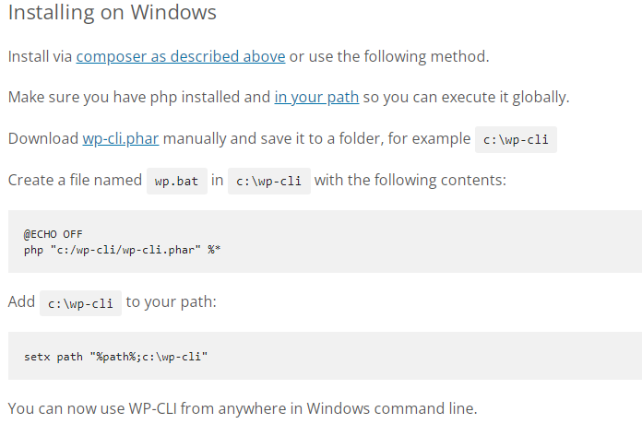**

**Environment variable path setting example:**

**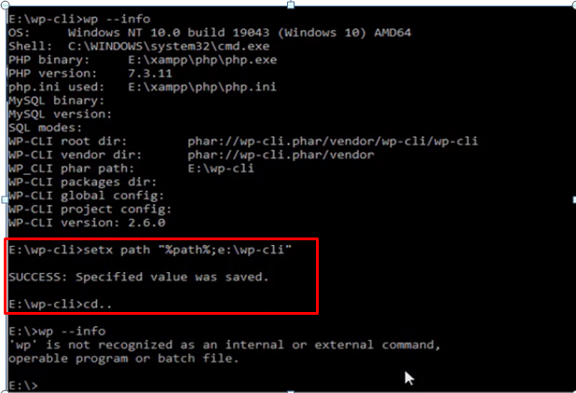**

**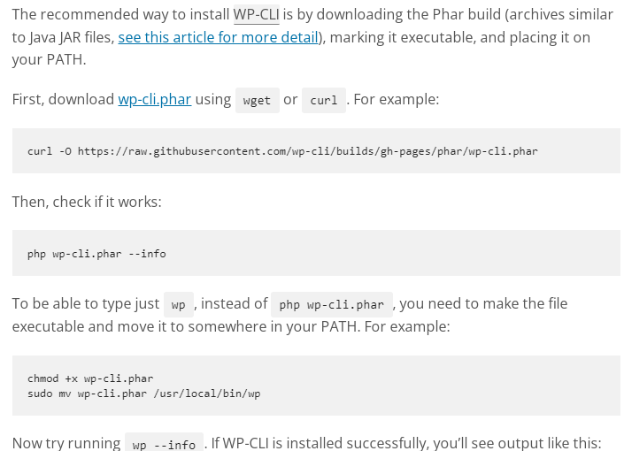**

**wp+ enter key (wp help command) for showing all command**

**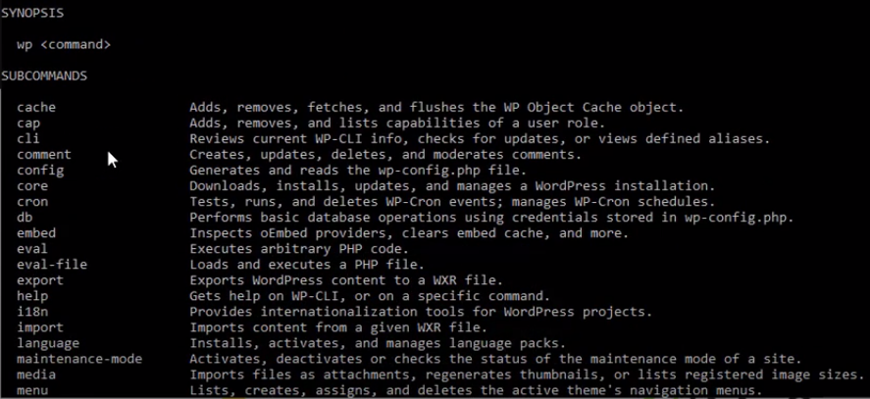**

**Sub command**

**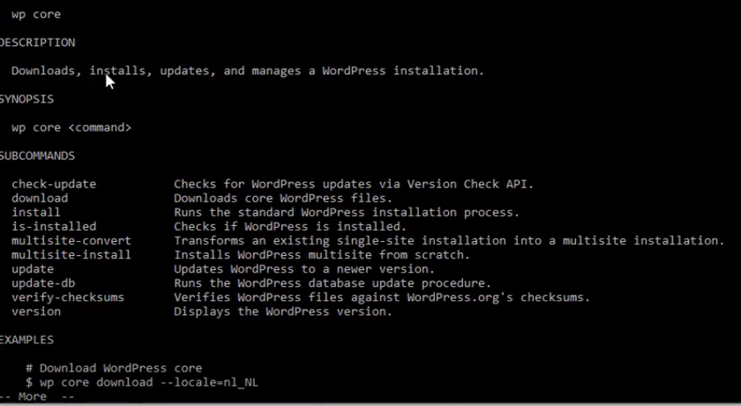**

**a**

**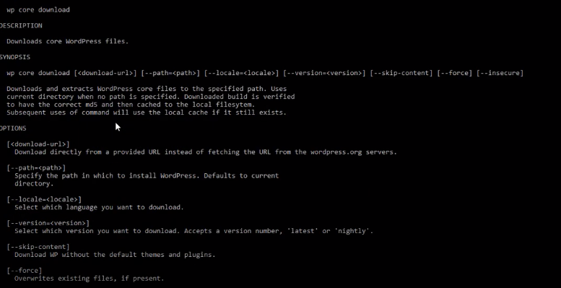**

**Downloading example**

**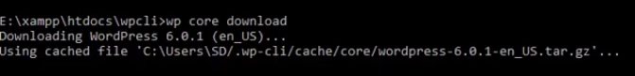**

**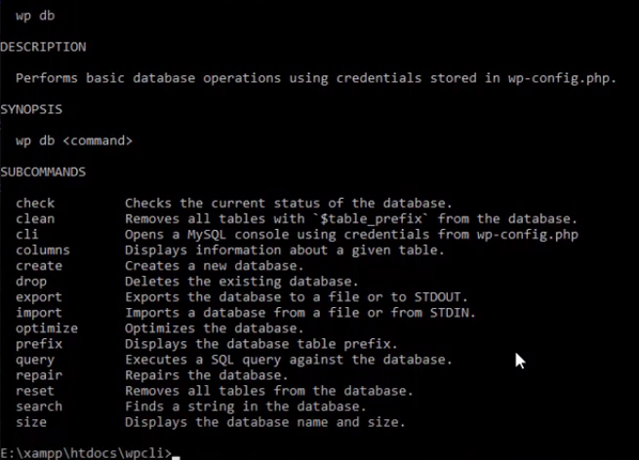**

**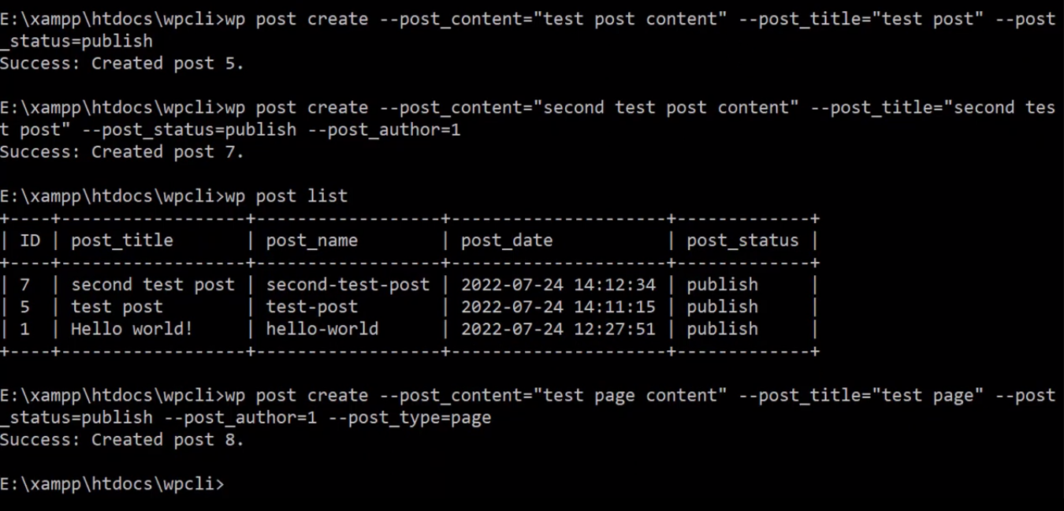**

**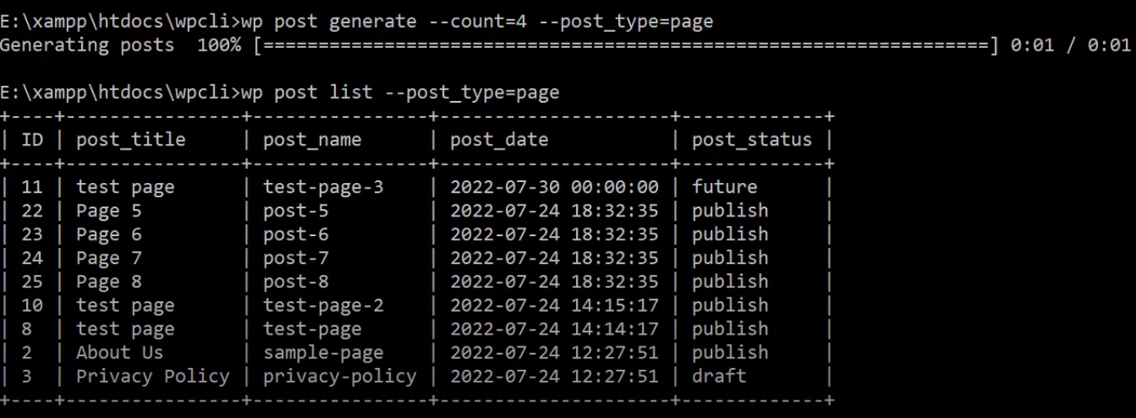**

**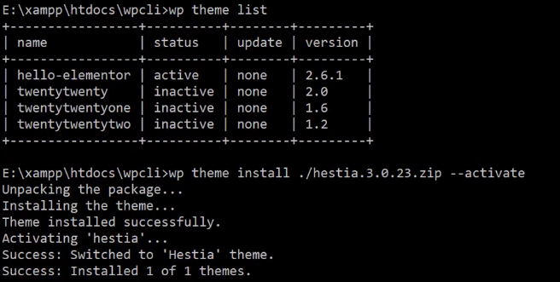**

**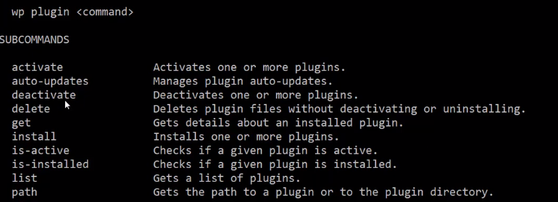**

**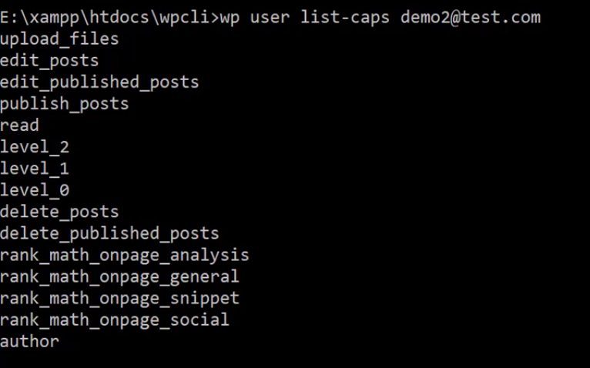**

**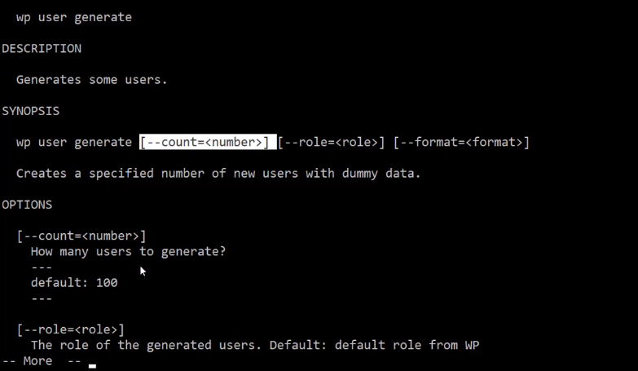**

**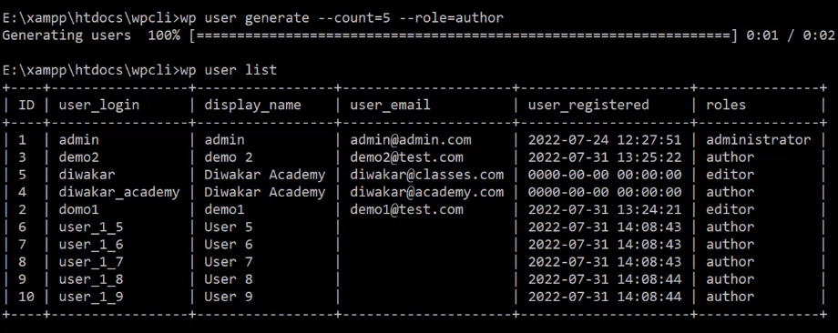**

**WP CLI several benefits for developers, site administrators, and anyone who works with WordPress:**

**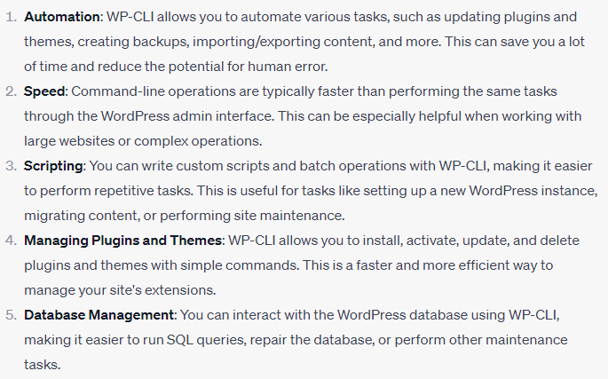**

**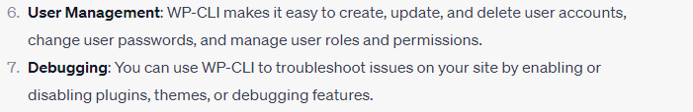**

**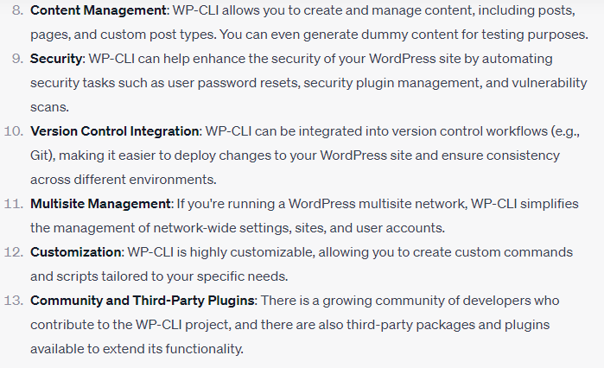**

**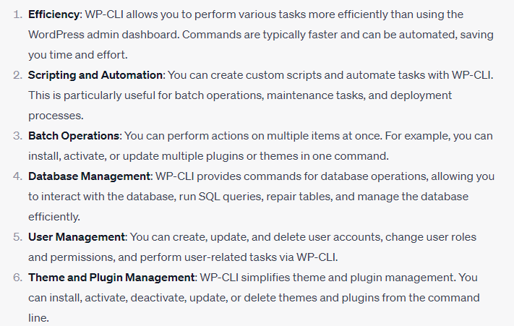**

**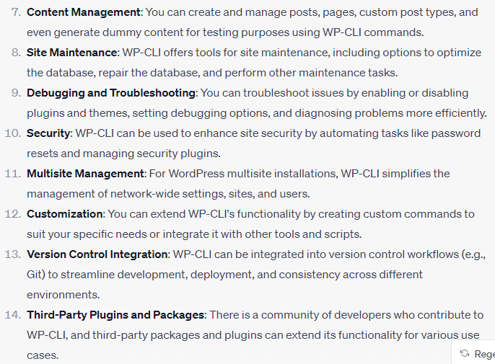**

**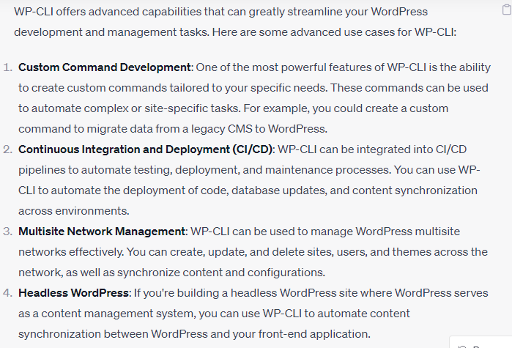**

**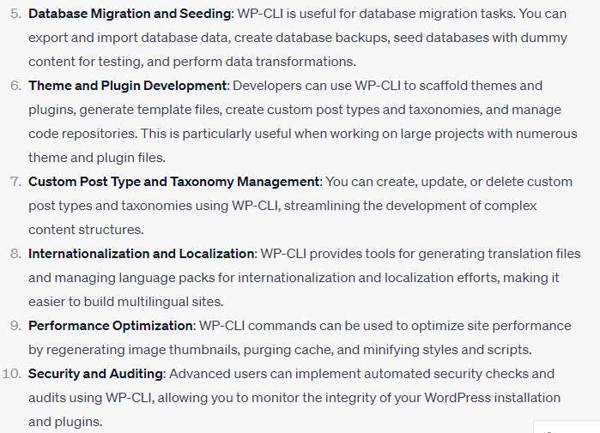**

**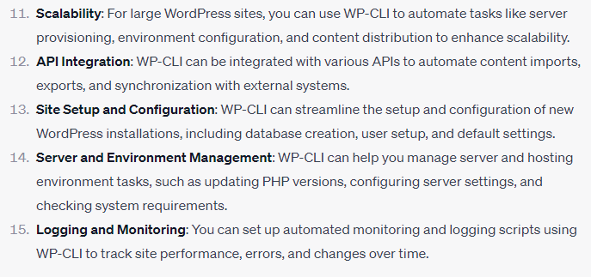**

**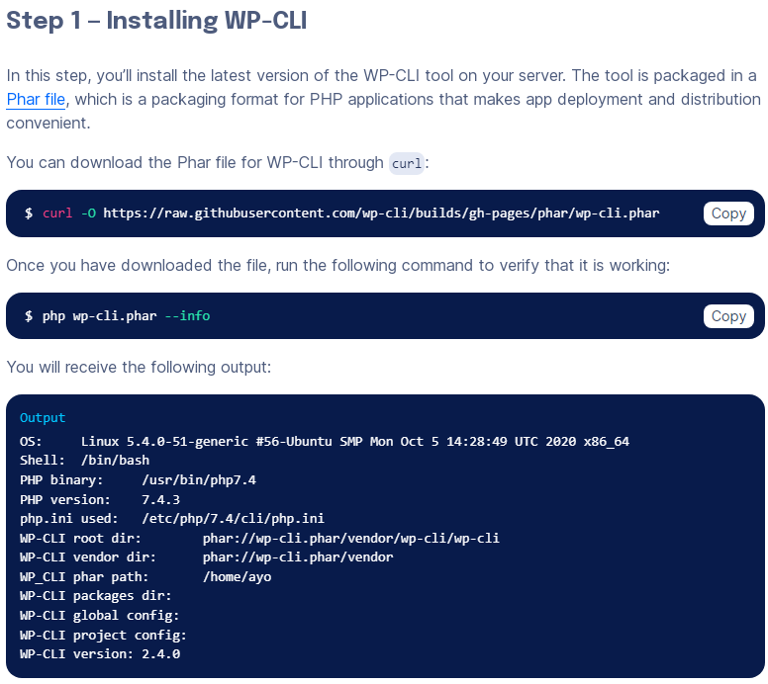**

**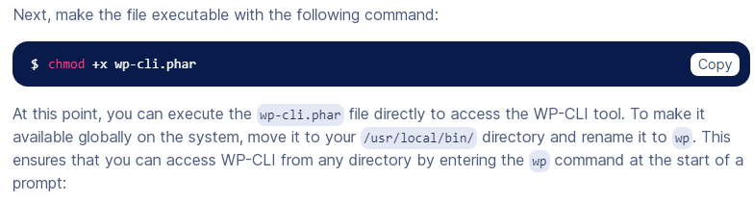**

**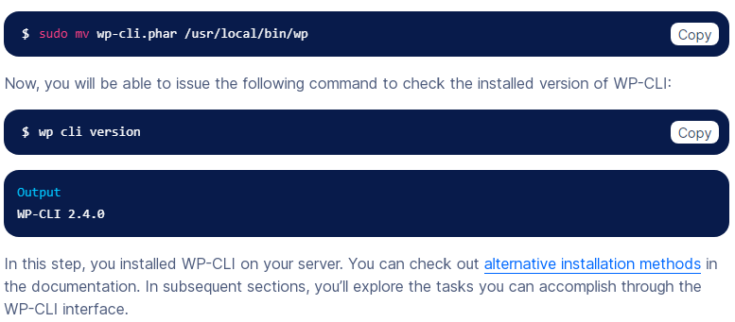**

**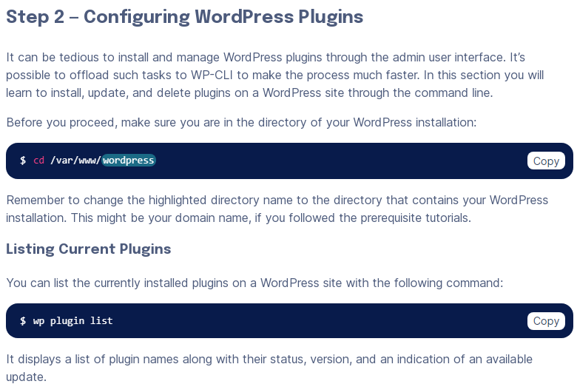**

**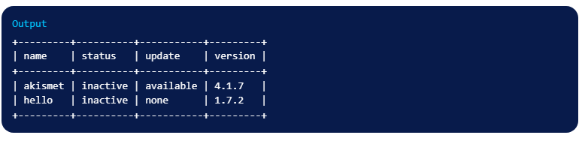**

**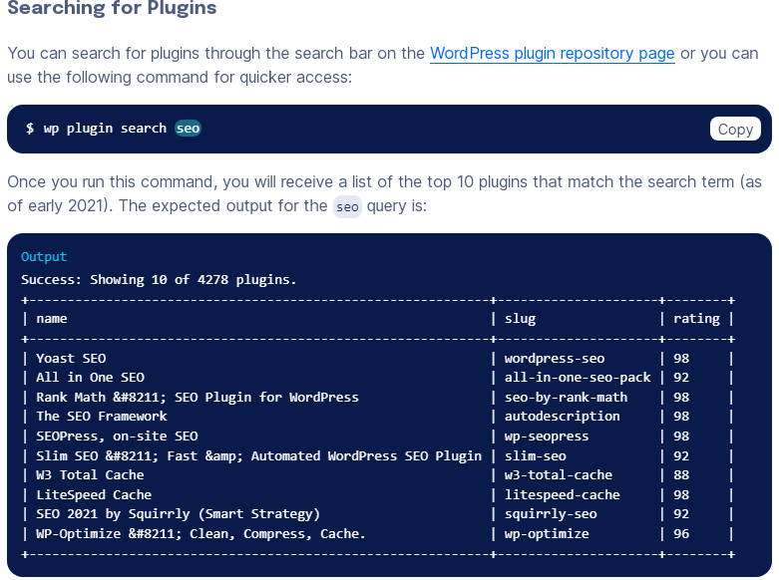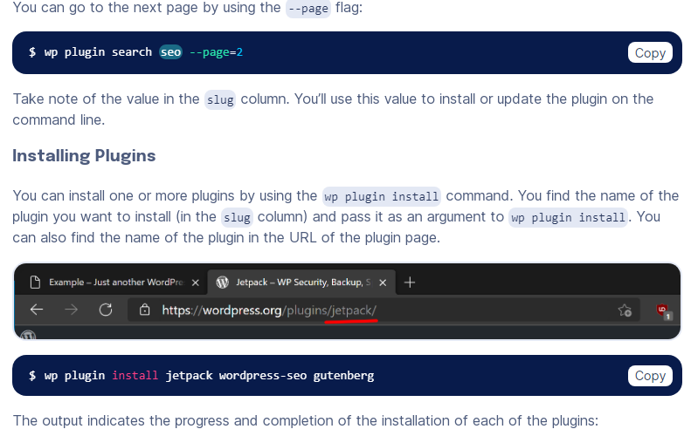**

**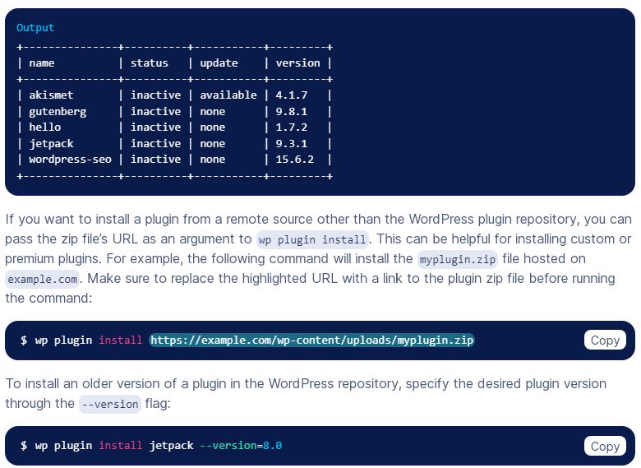 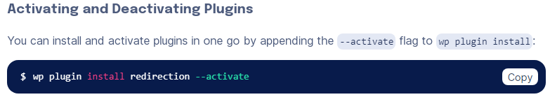 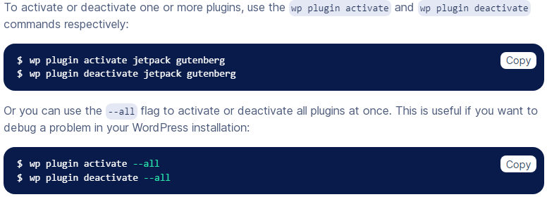**

**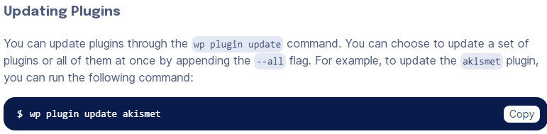 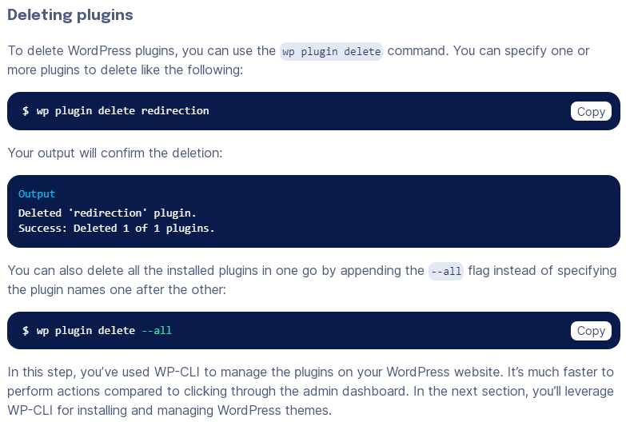 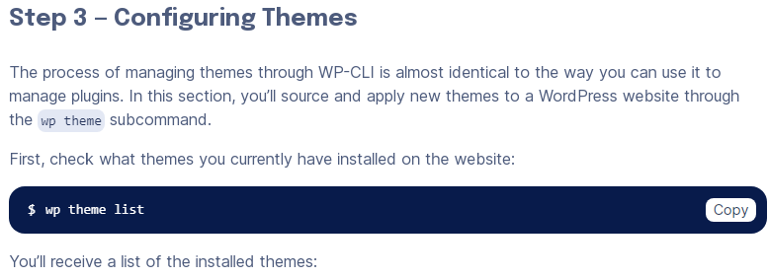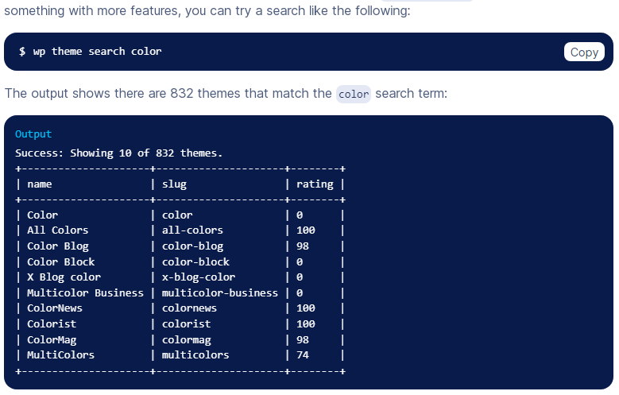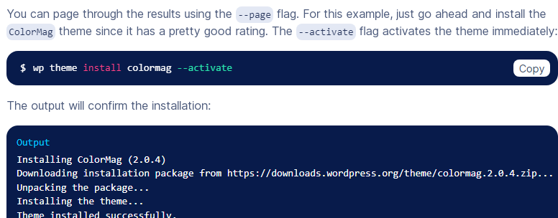**

****

**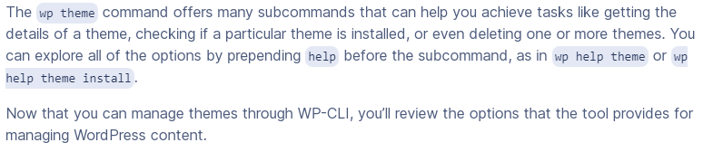**

**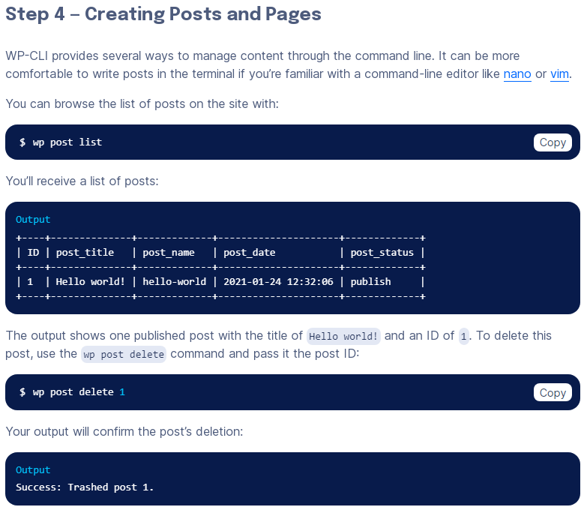 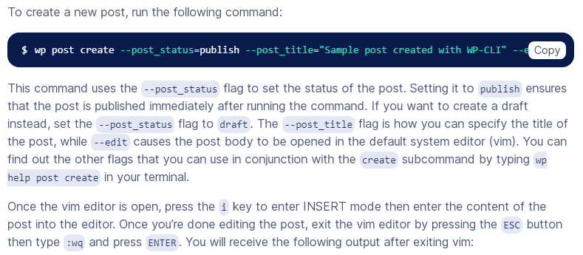 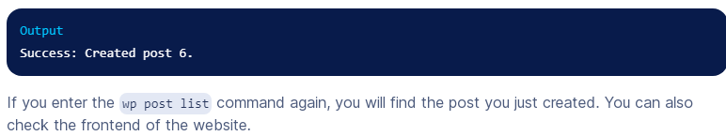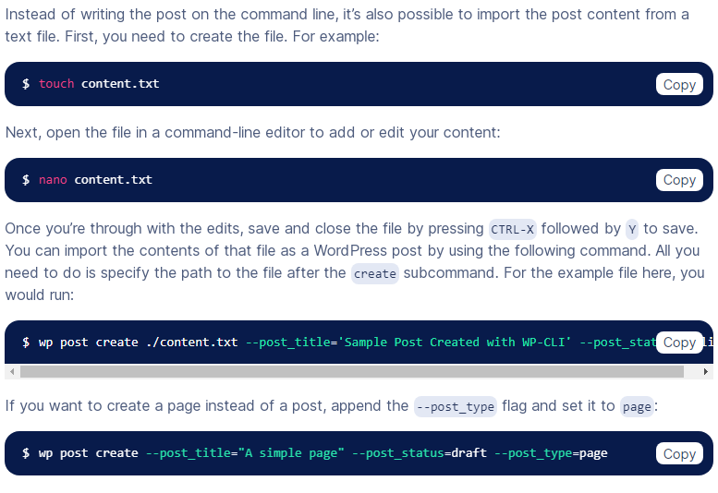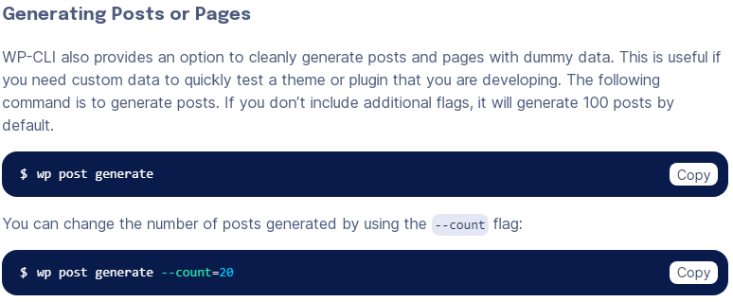**

**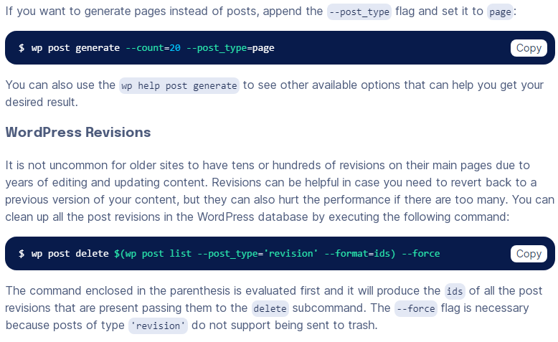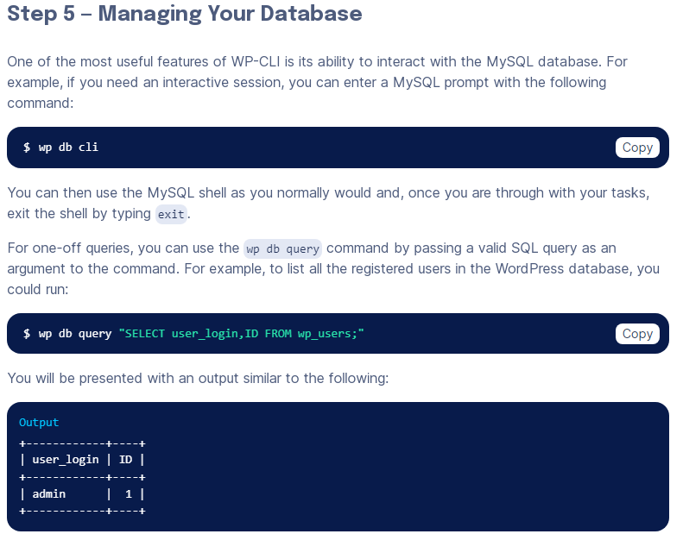**

****

**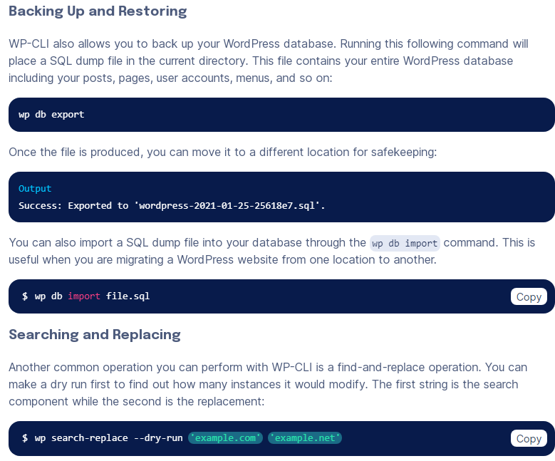**

**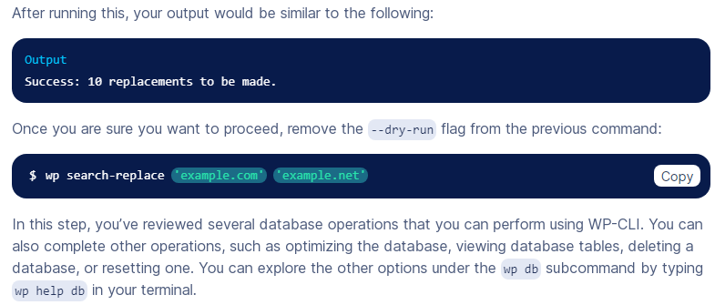**

**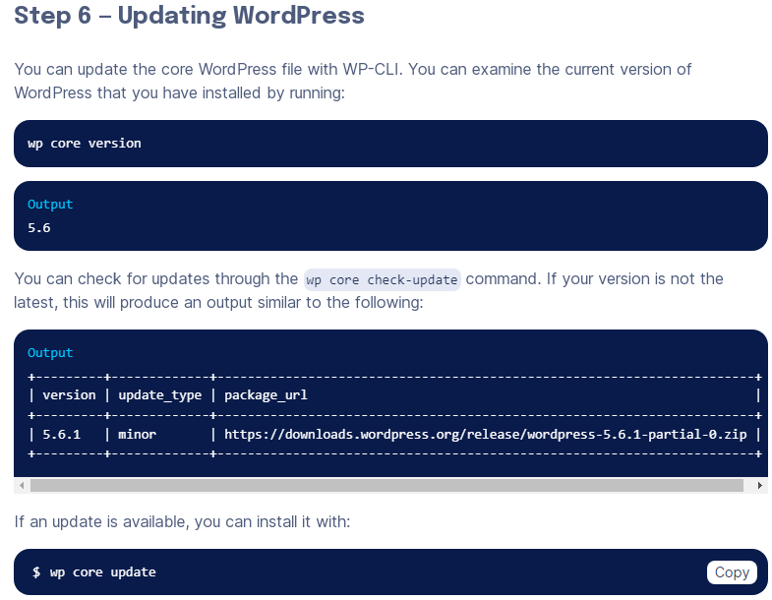**

**Dev OPS Another**

**

